**Embedded System by DV Gadre Sir (NPTEL)**

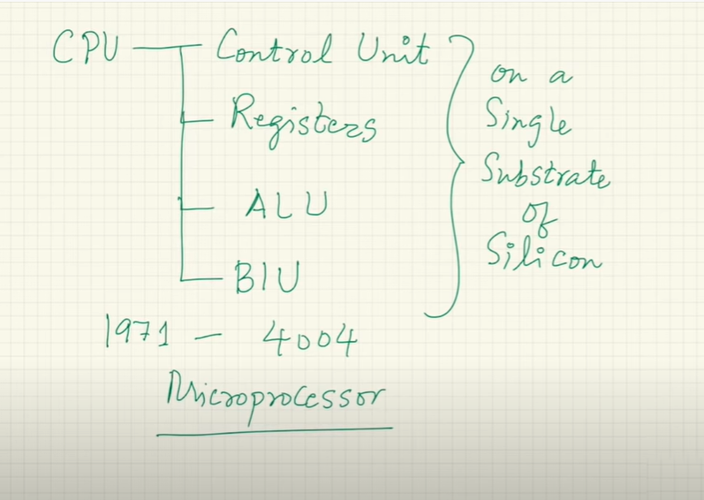

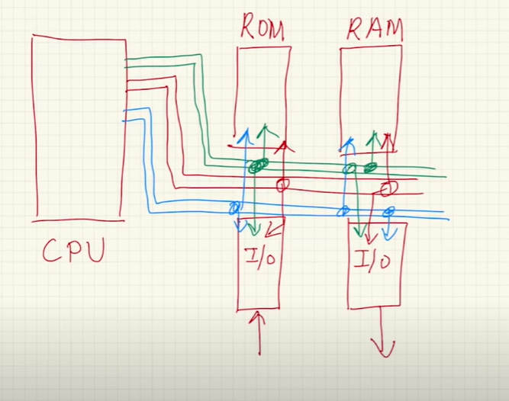

**World’s first microcontroller by TI (TMS1000) 4-bit uC**

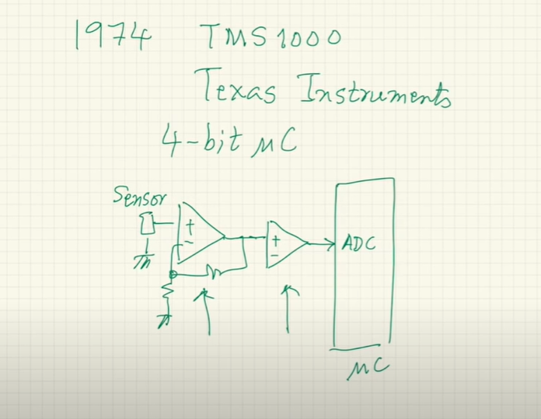

Additional hardware is required with the microcontroller

**Advancement in technology**

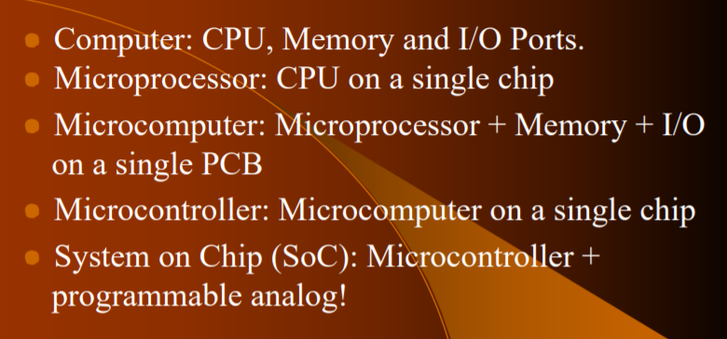

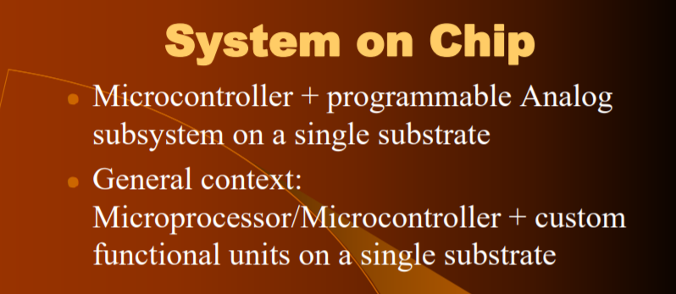

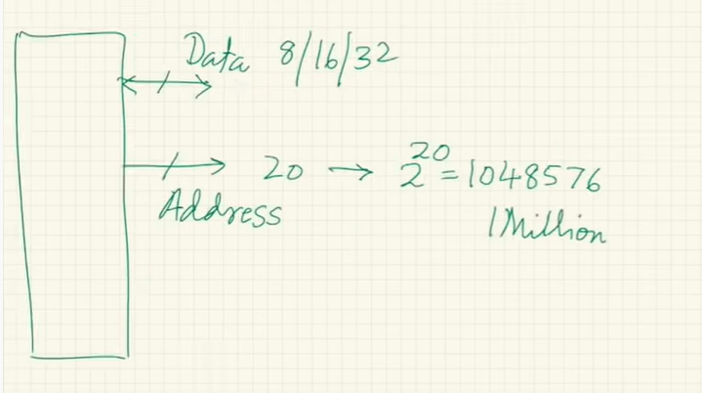

FSM 🡪 Controller to control the Data Processing Elements

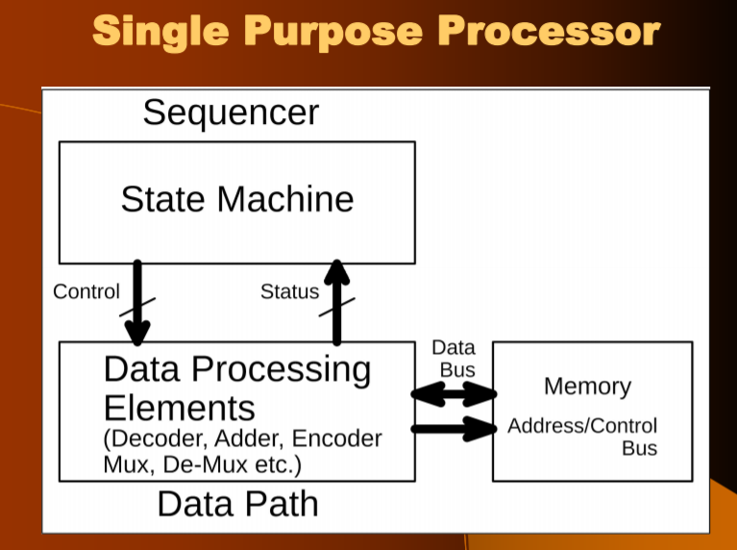

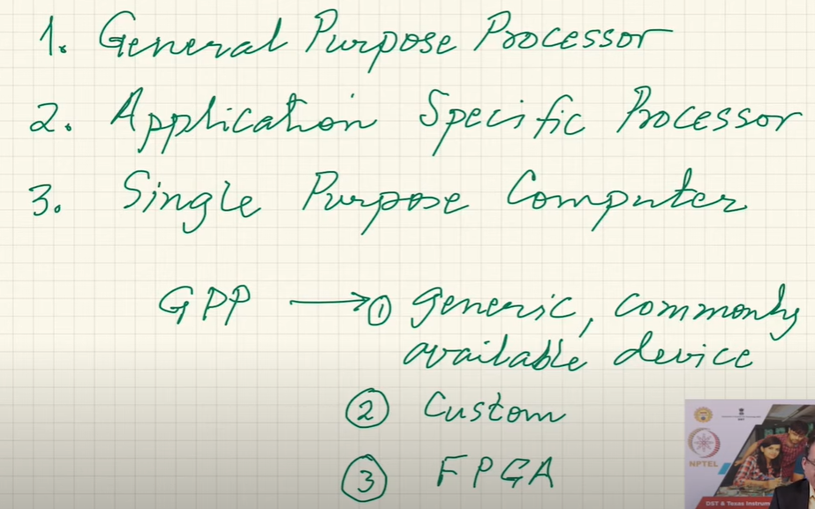

**ROM --- CS(Chip Select) OE(Output Enable)**

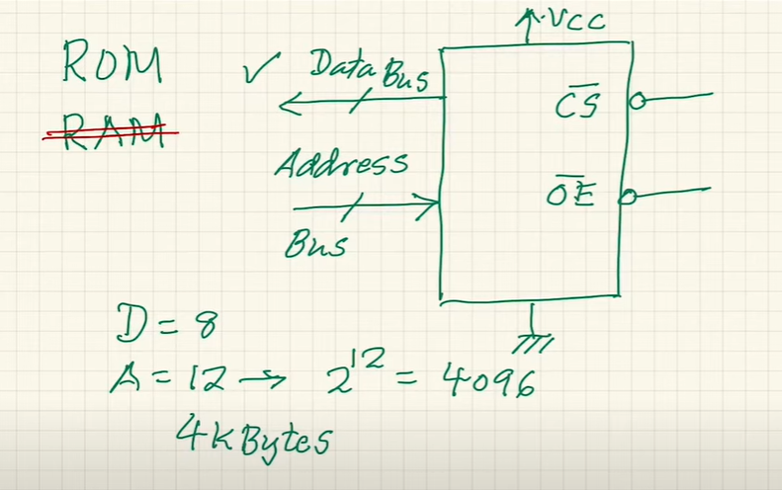



**TYPES OF ROM**

Programmable ROM , Erasable Programmable ROM(using UV light we can erase) , Electrically Erasable Programmable ROM(Flash type of EEPROM)

**RAM --- WR(Write) and OE(Output Enable) cannot be low at same time**

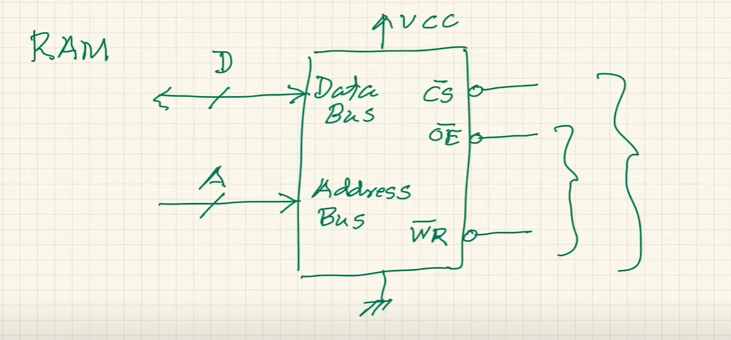

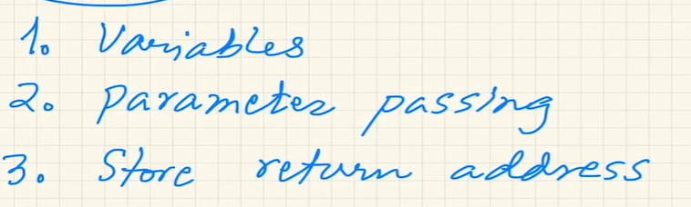

These are the main things which are performed by the RAM

Usually some microcontrollers have 0 RAM. They are usually of RISC category and have large number of registers which can be used. They also give us Hardware Stack to store the RET address of a sub-routine. But they have limited storage for this purpose.

**TYPES OF RAM**



**DRAM** – Dynamic RAM – Capacitors – More Efficient – Less Address Lines – Frequent Refreshing Required – More Dense – Using is complicated due to refreshing

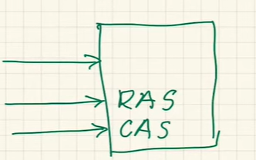

First provide ROW ADDRESS the COLUMN so the number of address bits are reduced

SRAM – Faster – Flip Flops – Static RAM

SRAM is an on-chip memory whose access time is small while DRAM is an off-chip memory which has a large access time. Therefore, **SRAM** is faster than DRAM. DRAM is available in larger storage capacity while SRAM is of smaller size. SRAM is expensive whereas DRAM is cheap.

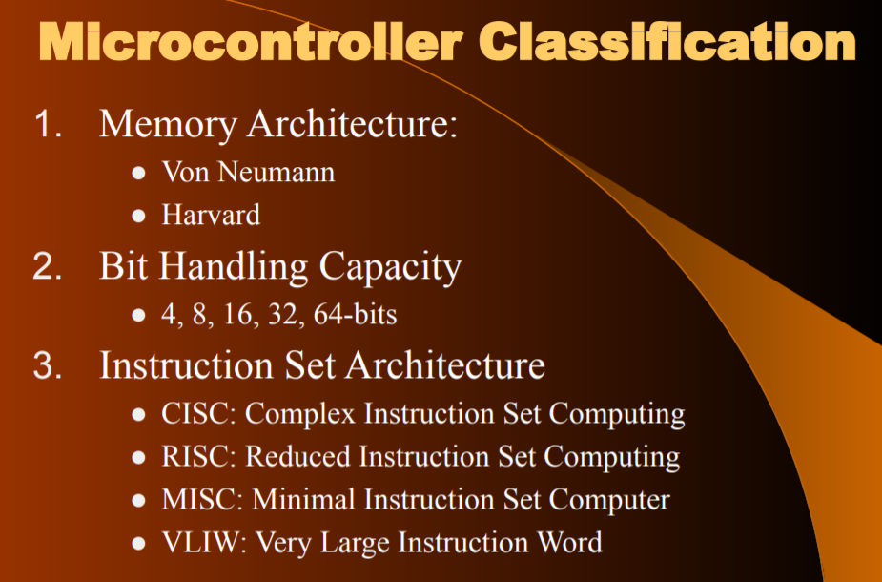

**Memory Access Architectures:-**

**VON-NEUMANN**

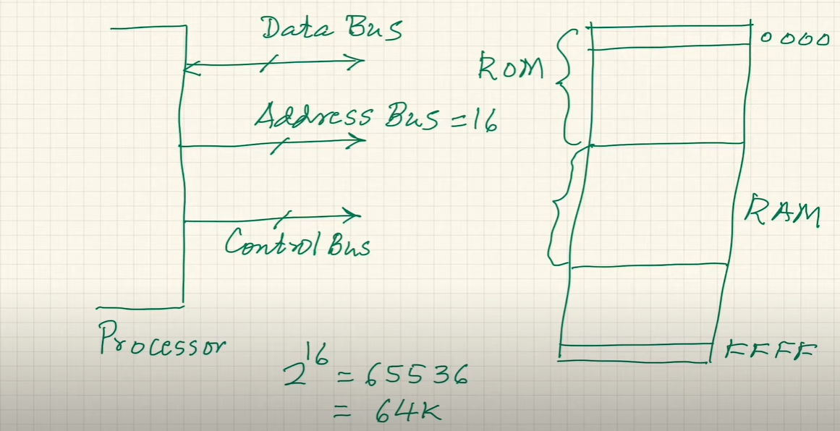

To provide parallelism and improve the performance (read instruction and store/write results from previous instructions) system in it we have another memory system (HARVARD).

**Advantage**

2 simultaneous operations can be performed

**Disadvantage**

Twice the number of pins are required on physical microprocessor in this case

Performance Size TRADE OFF

**HARVARD**

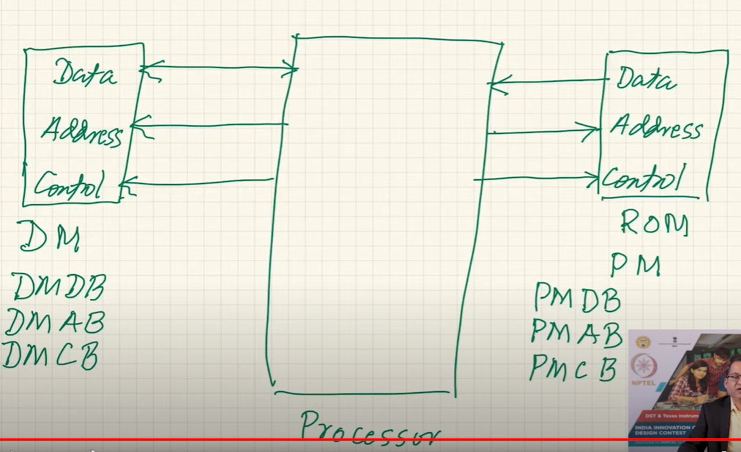

**PM – Program Memory**

**DM – Data Memory**

**INSTRUCTION SET**

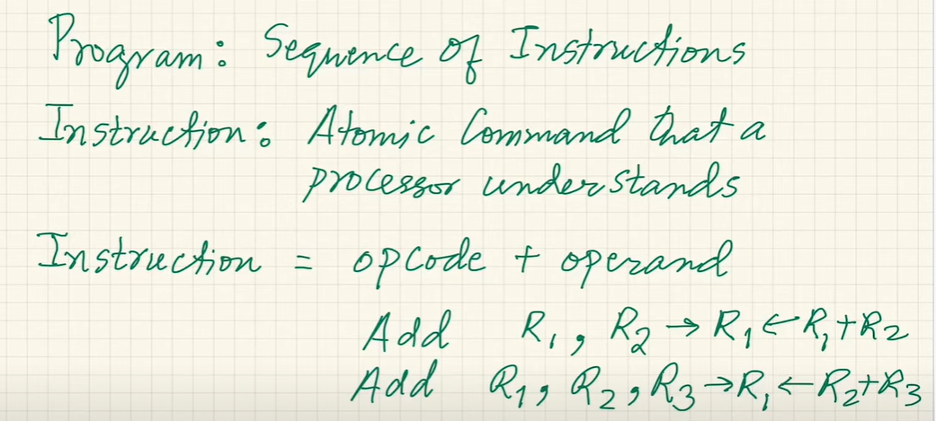

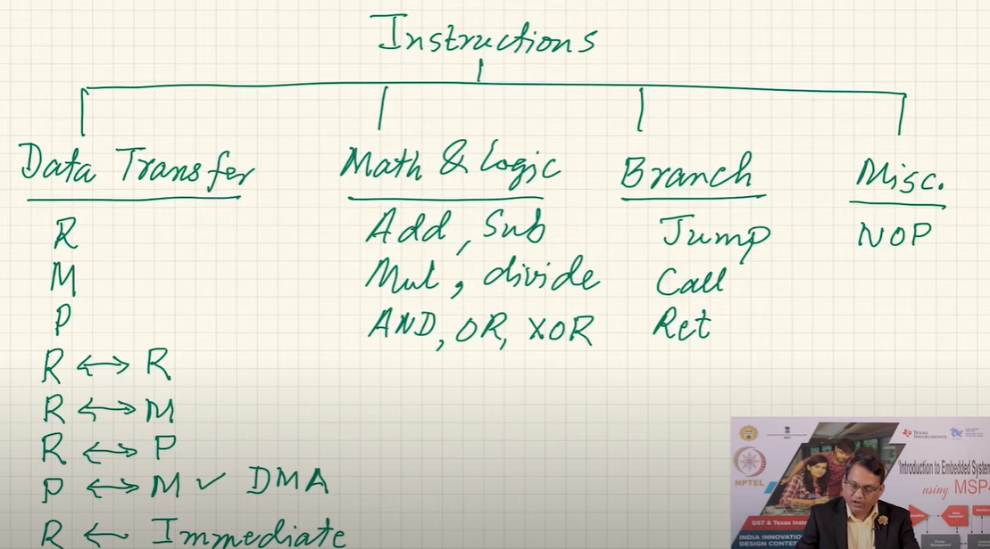

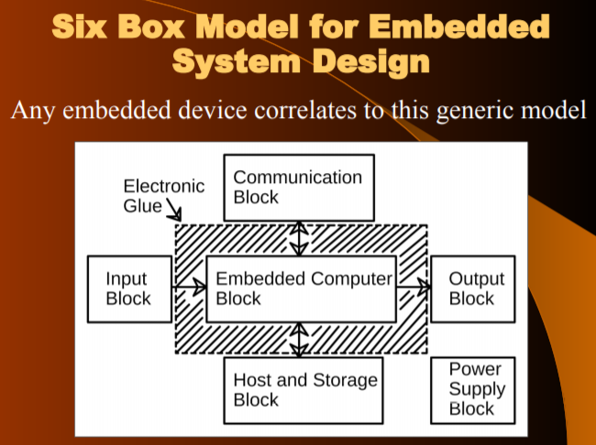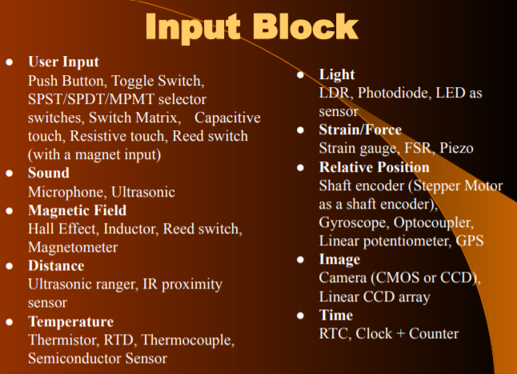

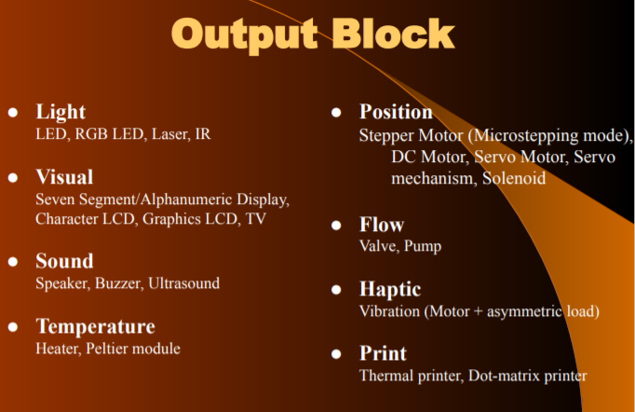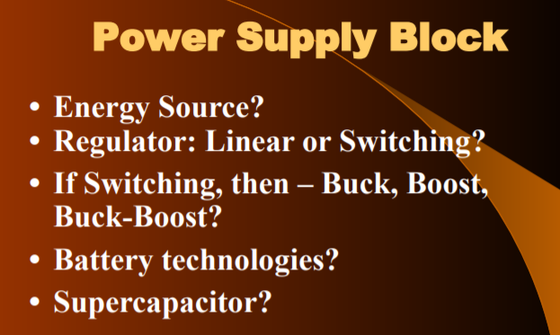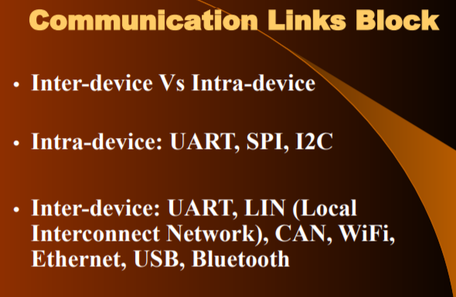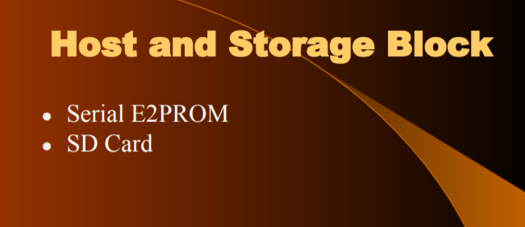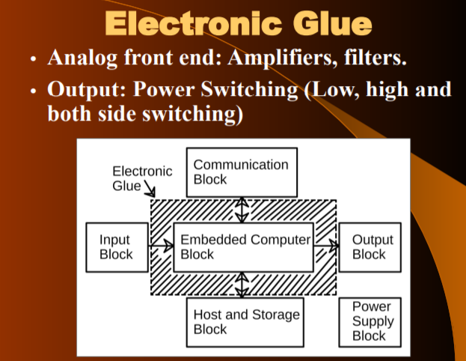

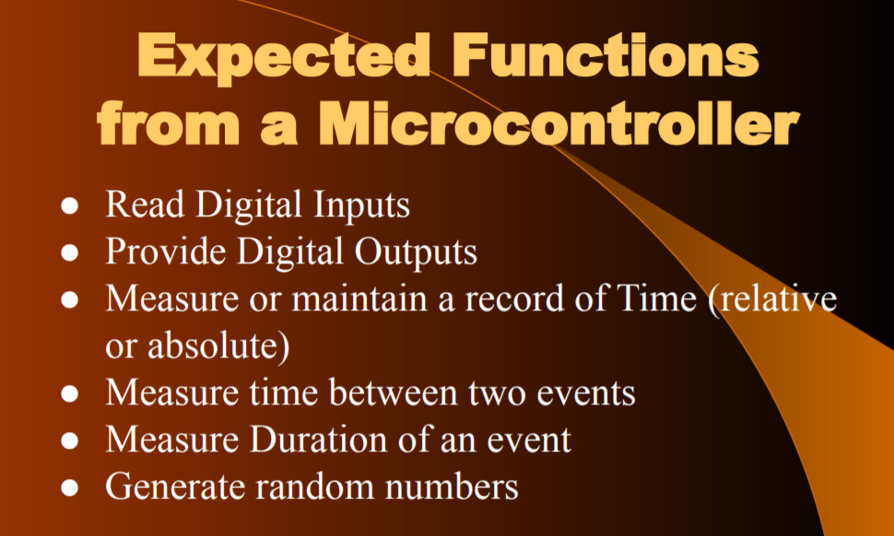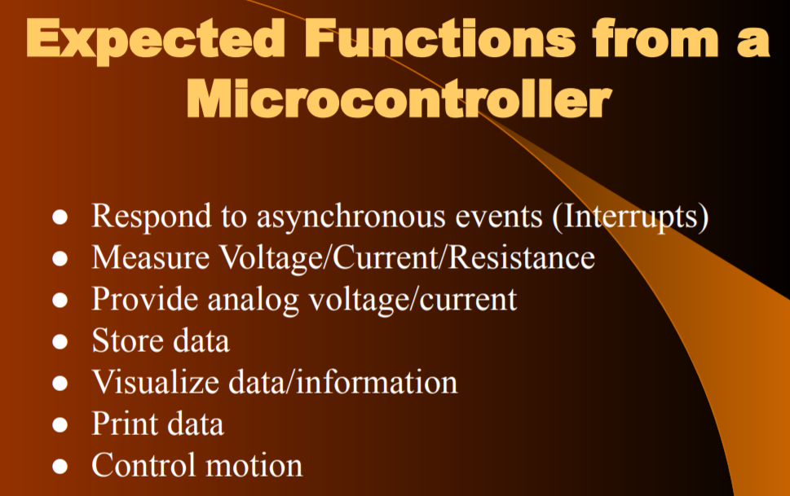

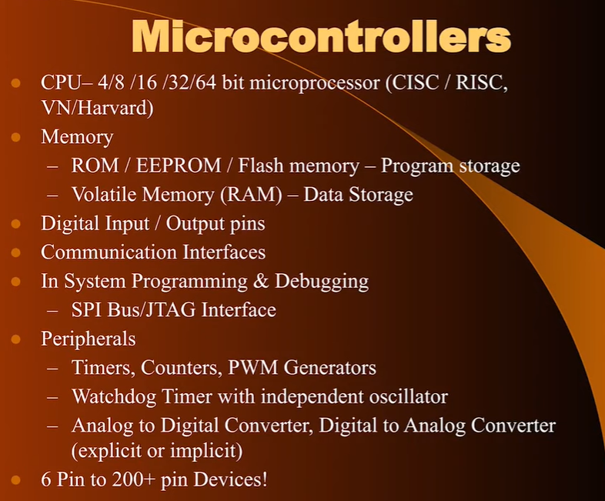

**Features of Modern Microcontrollers**

1. **Fully Programmable pins**
2. **Output pin 30-40ma of source/sink current**
3. **Input pin with weak and strong pull up (resistor R connected to Vcc as in buttons in Arduino if R is high it is weak and if R is low then it is strong) or tri-state capability**
4. **Each pin offers multiple functions of which one can be selected**

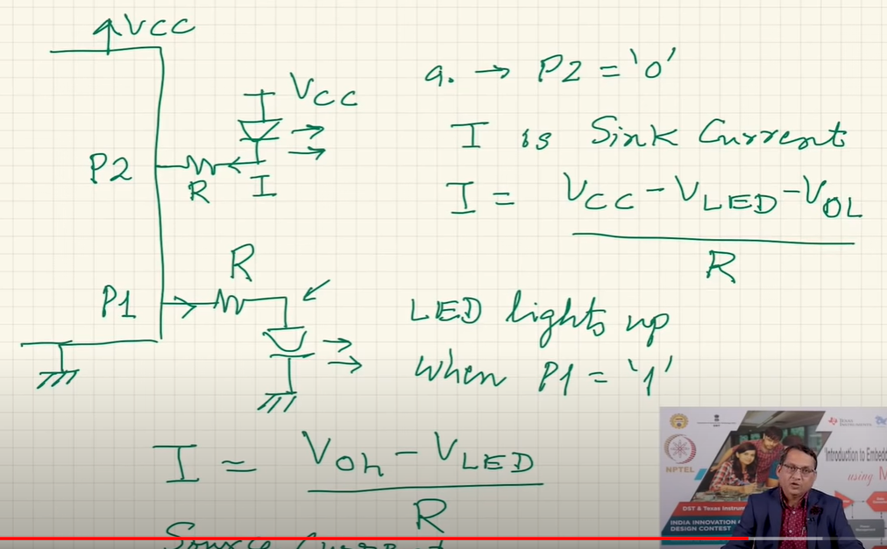

**GENERATING CLOCK PULSES USING NOT GATE(SCHMITT-INVERTER TYPE) :-**

Can integrate these features on the substrate of the microcontroller. But the value of R and C is affected by the temperature so clk time period will not be very accurate. So we can use the feature of internal RC to keep cost down

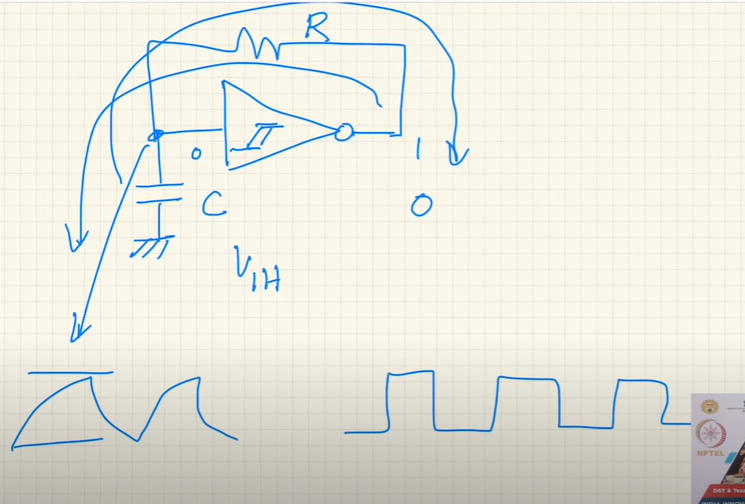

**Clock Scalability means the the frequency of the clock can be changed at run-time**

**Timer 🡪 counting of clock pulses is not by the timer for example a 16-bit timer can count 65536 clk pulses**

**TOTAL TIME :- Ts x 65536**



**Clock**

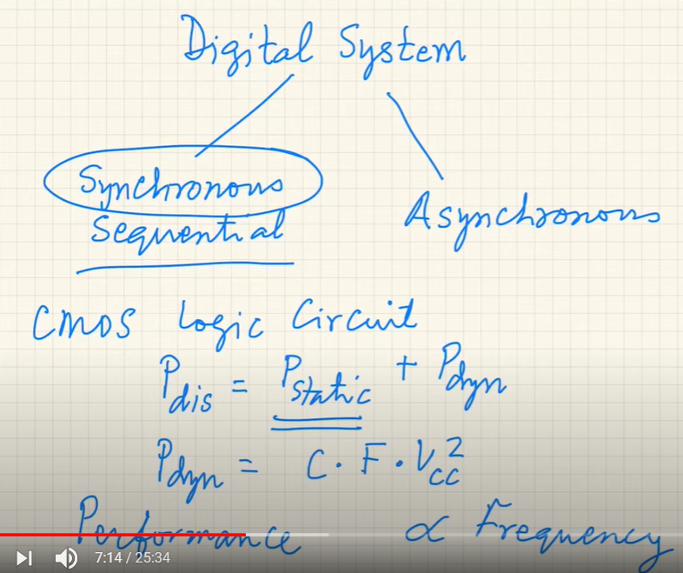

**Frequency of the clock should be low to avoid power dissipation but frequency of the system should be high to increase the performance of the microcontroller. There should be a balance between them.**

**Generation Clocks (3 External Generation methods are mentioned below)**

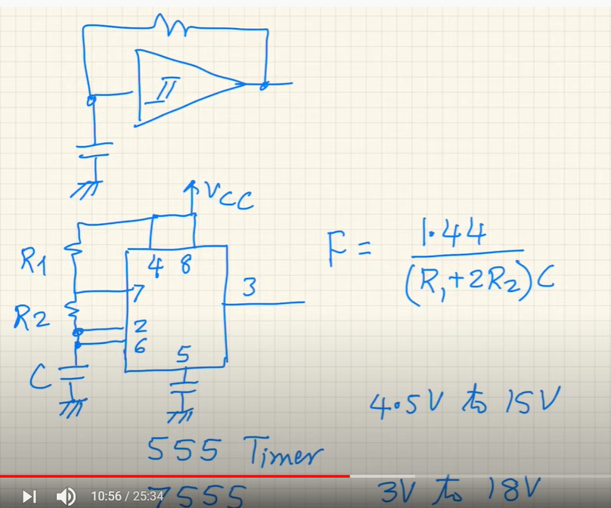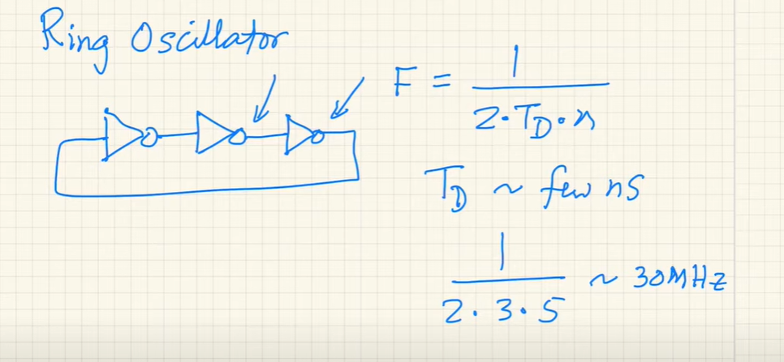

**If you don’t want to connect the external generated clock then use Quartz Crystal and Capacitors to make a crystal oscillator and generate clock otherwise connect the output of the above circuits to them.**

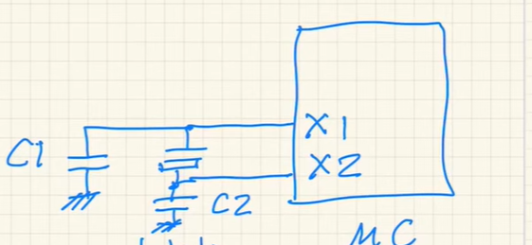

**Modern Microcontroller have built in Internal Oscillator is of type NOT GATE(Schmitt Inverter Type) which using R and C**

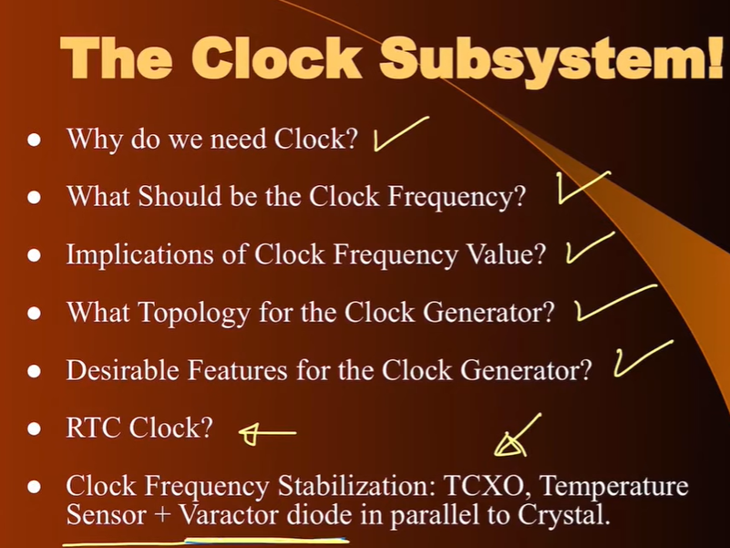

**RESET**

Program will do to its first instruction so that whenever power is applied to the microcontroller its starts with a known state each time every time not an arbitrary state. It is important to reset the microcontroller

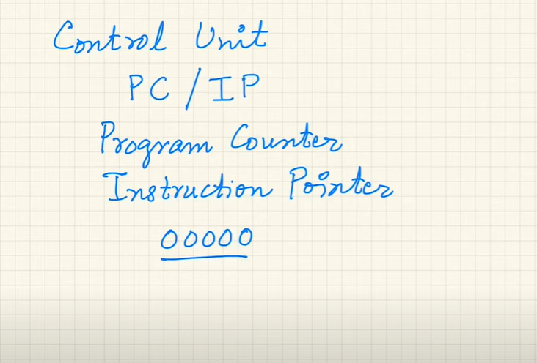

**Resets**

**WARM RESET**(Power is not switch off still we want to reset it)

**COLD RESET**(Power is off and then power is on micro gets reset)

**Sources of RESET**

1. **POR(Power on Reset)**
2. **User RESET** source there is a PIN

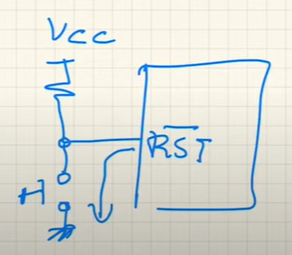

1. **BOD(Brown Out Detector)** It will hold micro in perpetual RESET till power supply level exceeds the threshold voltage of BOD

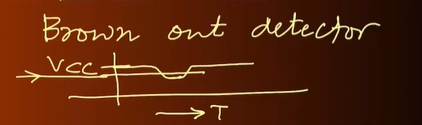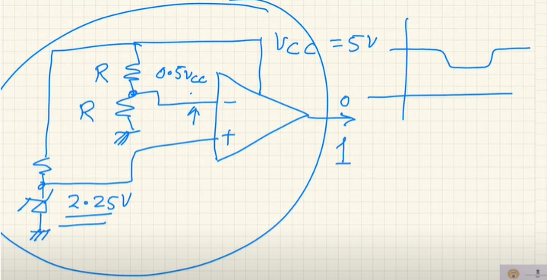

1. **Watch Dog** as a dog at home which starts barking if there is something unusual at home. Similarly, if program gets stuck WATCH DOG can be used to come out of that situation and start operation again.

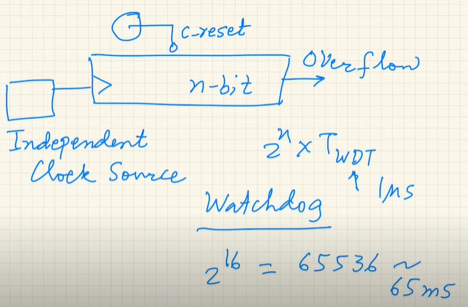

If within 65ms within which if we can reset the timer it will not reset for you. But if you forget to reset it, then it will overflow and give reset to the system.

**Program Download Capability**

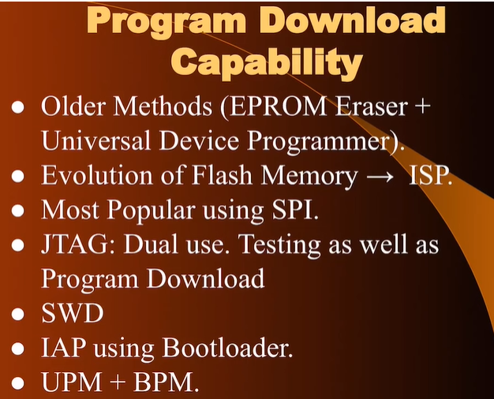

**NOTE:-**

Normal Glass absorbs UV Light so in older methods Quartz Glass Window (Expensive) was used in EPROM

To erase EPROM, we need UV Light

**Older Methods**

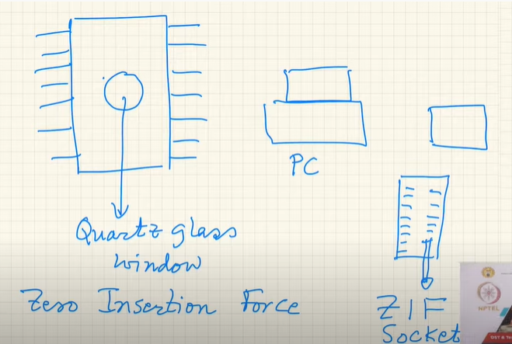

On socket you have a lever where in you pull the lever and it opens up the pin, then drop the EPROM into the pins of the socket and press the lever. It is a special socket known as ZIF(Zero Insertion Force) socket. Rigid and rugged and take several insertions and removal of IC , BURN the EPROM with the code and put it back on uC

Then came **ISP** after evolution of FLASH MEMORY (in system programming)

**JTAG(Joint Test Action Group)**(in microcontroller) DUAL USE. Testing (on chip debugger) as well as Program Download

**SWD** for debugging

**IAP**(In Application Programming) using Bootloader

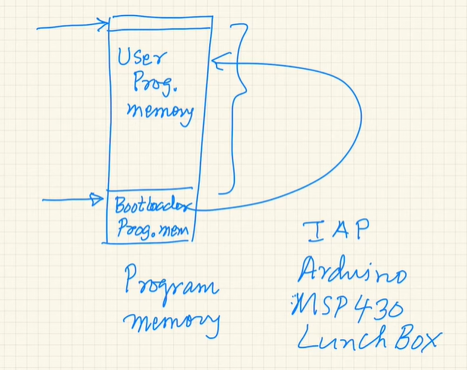

**POWER SUPPLY**

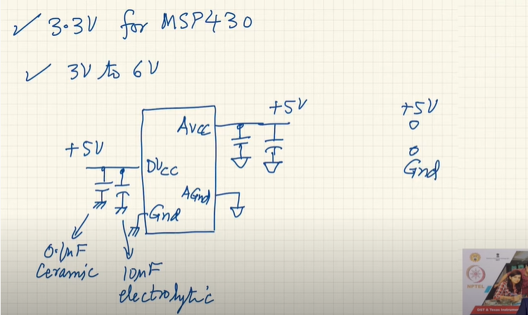

**Separate GND for Analog and Digital Vcc** **to achieve different routes**

(for isolation of noise generated in the power supply pins due to internal switching action)

**POWER SUPPLY**

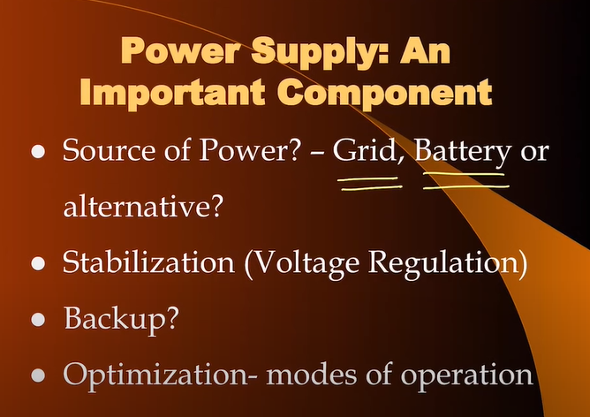

Grid is the power from the wall socket. Battery is power supply but for a finite duration of time(depends on the battery – Replace or Rechargeable)

Stabilization is done using Voltage Regulator 🡪 Removal of Noise. Should not be fluctuating should be stable for proper working of our components



Using **voltage divider using 2 capacitors** rather than 2 resistors which are reactive components so no power dissipation is there. After that use rectifier and use its output in the microcontroller. They are low cost and not bulky better than case of transformer.But such a power supply is not isolated. Human interaction needs to be stopped.

**Switching Mode Power Supply** very common. Takes the AC voltage and rectifies it right away. NO step down transformer is used in this case. Gives rectified voltage then power a small electronic circuit which produces a switching waveform which is in the high frequency domain. Size of the transformer is inversely proportional to the frequency so a very tiny and small transformer will be used in this case. And use of transformer isolated the mains from DC power supply. Example include Phone Charger etc

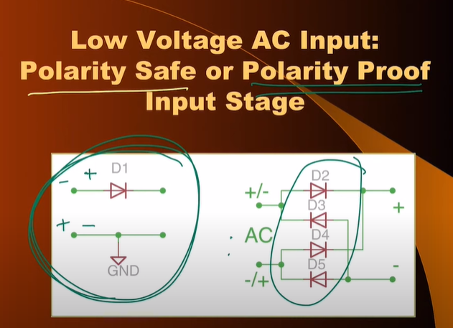

Reverse Bias if reverse polarity POLARITY SAFE

POLARITY PROOF continues to work even if reverse polarity is there -> Bridge Recitifier Configuration

**Stabilization of Voltage**

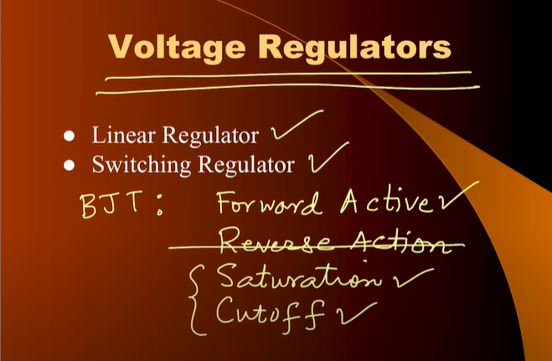

BJT in Forward Active 🡪 Linear regulator

BJT in Saturation and Cut-off 🡪 Switching Regulator

LINEAR

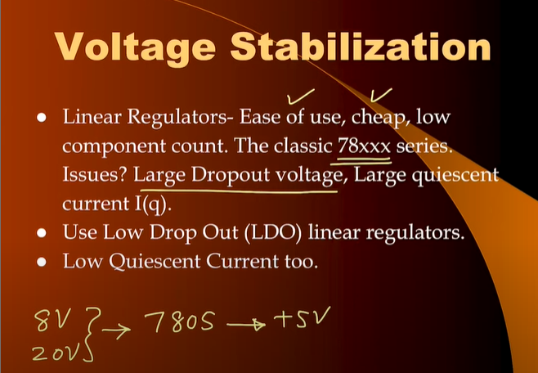

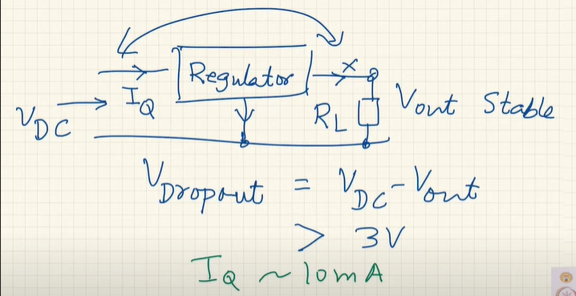

Wastage of Voltage (around 3V) in Linear Regulators(78xx series) in order to operate

Even if No Load is connected then too Iq(10mA) current flows in the regulator

So (3 x 10 = 30mW) of power is needed just to keep the regulator working

Use of LDO should be preferred as 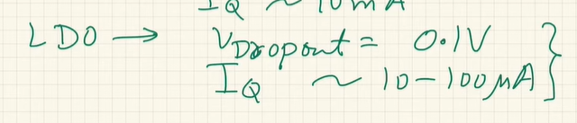

GRID 🡪 Lower the level 🡪 Rectify and Filter 🡪 Regulator

Basic Diagram of Linear Regulator

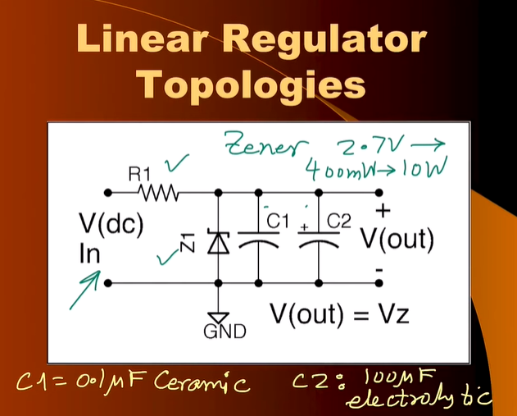

Disadvantage

Zener in reverse bias. Gives variations

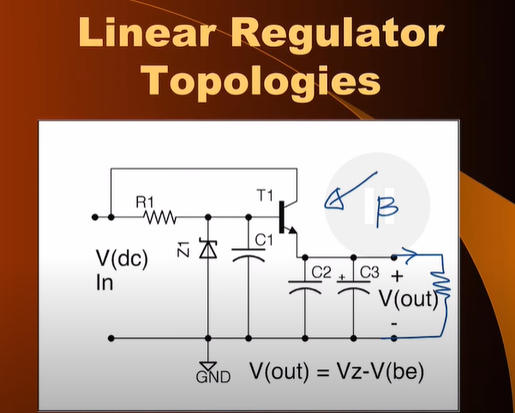

Using Series Pass Transistor

MSP430 – Mixed Signal Processor

CPU + Digital Blocks and also has support for Analog Circuits that is why it is called mixed signal processor. 16 bit Processor (Address Bus 16 bit and 16 bit Data Bus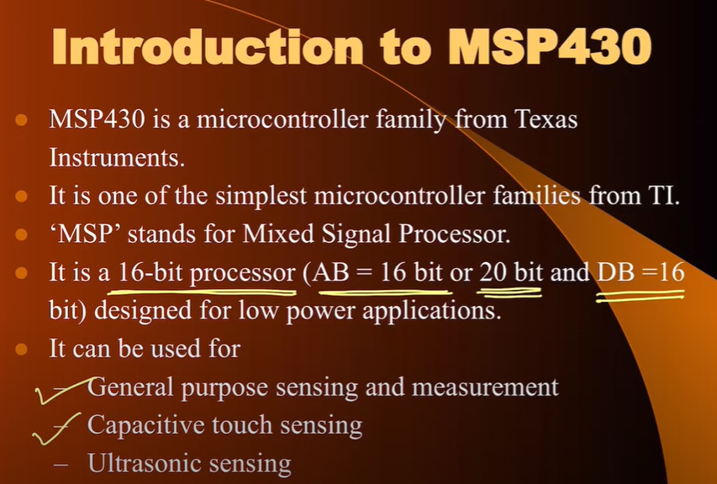)

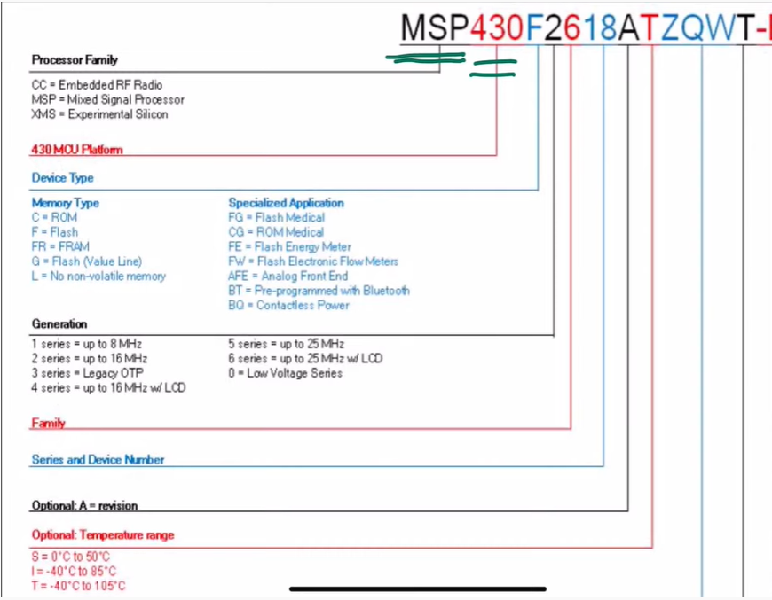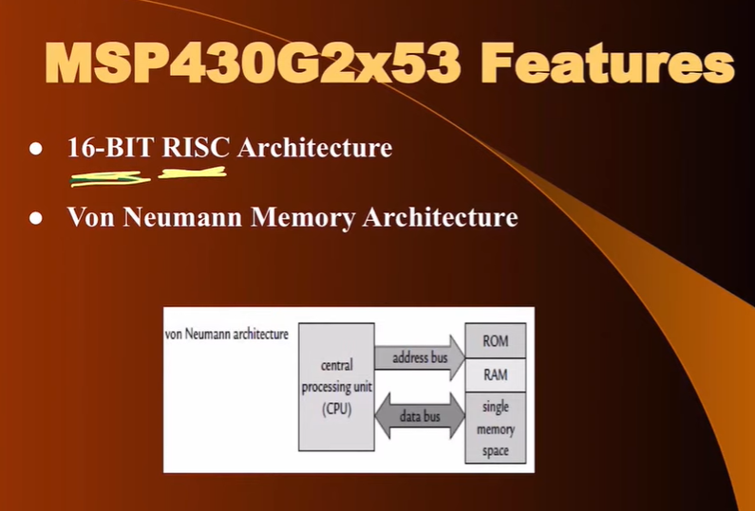

**VON-NEUMAN – Single set of memory map (using a single set of address bus and data bus)** 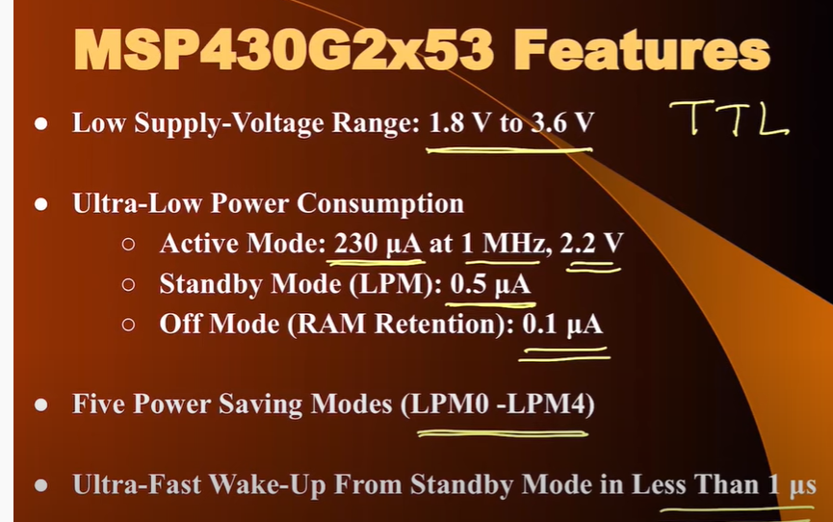

**For 16Mhz clock frequency which is standard clock for MSP430**

**Clock Period is 62.5 us**

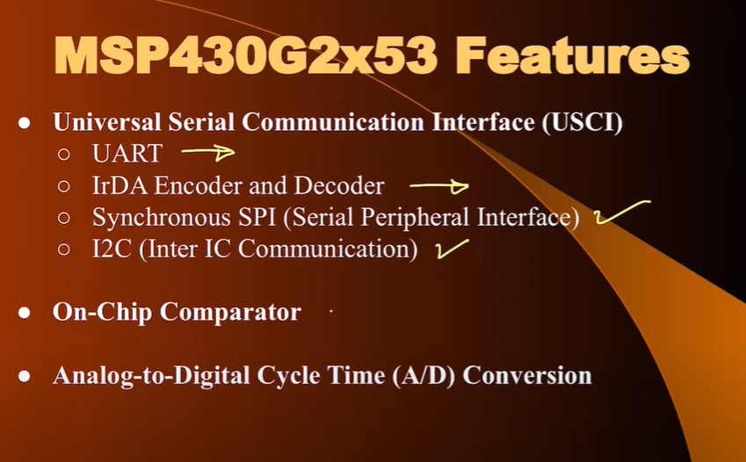

UART(Universal Asynchronous Receiver Transmitter)

IrDA(Bidirectional Infra-Red Communication)

INTRA COMMUNICATION PROTOCOLS – SPI and I2C

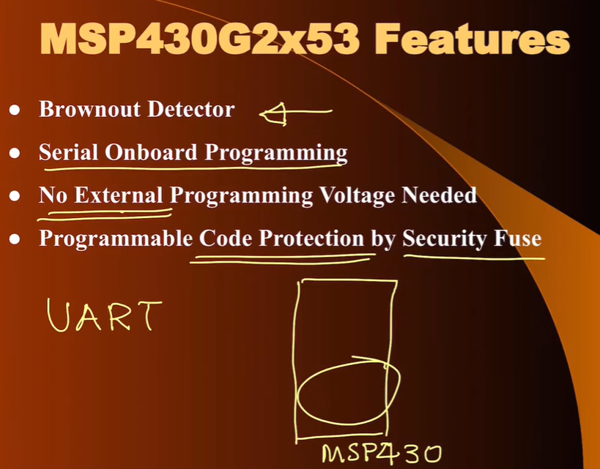

Bootloader uses UART to communicate with the computer and then gives the information to the memory. Security of Code which is pre-done

**Downloading the Program in MSP430 Microcontroller**

**SBW is 2 wire JTAG System**

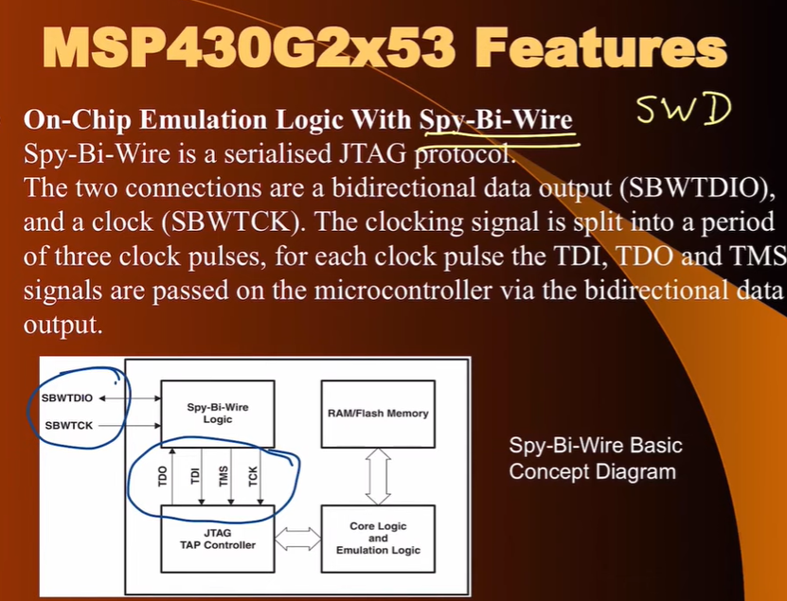

For the implementation of JTAG instead of using 4 pins which are generally used. MSP430 makes use of Spy-Bi Wire (given by TI) to reduce the number of pins and make it simply to use (it uses just 2 pins SBWTCK and SBWTDIO)

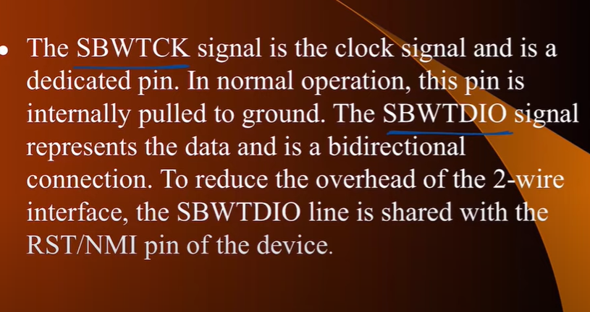

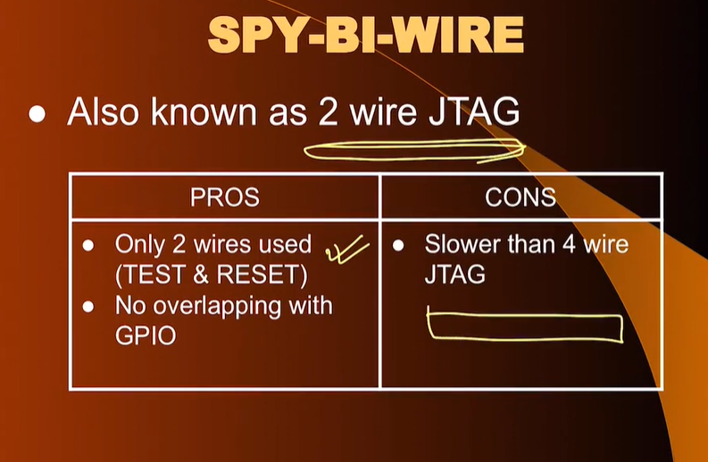

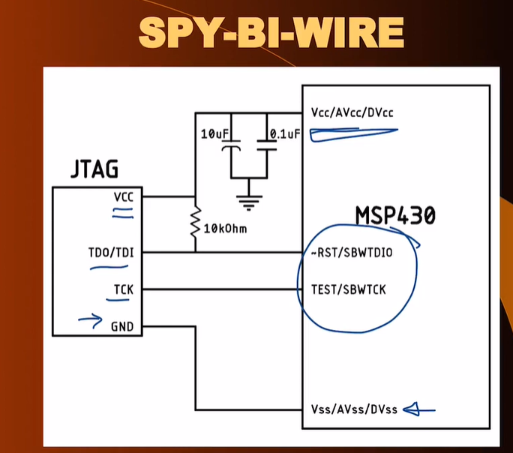

**2. Original JTAG System**

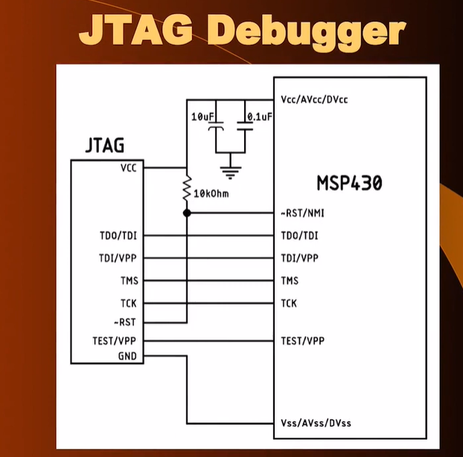

**3. Using Bootloaders (Very much practical and we will use this)** 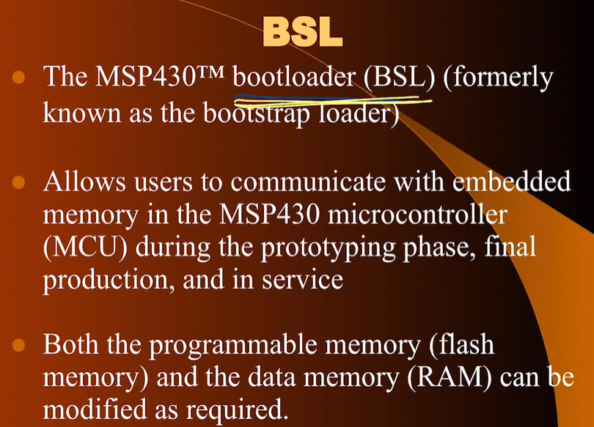

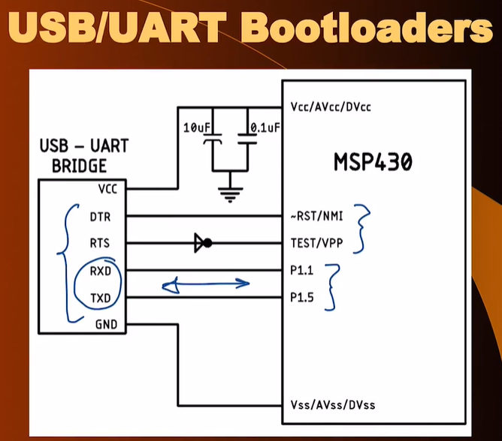

**Lecture 12**

**Experimenting with the low power modes in MSP430 using Lemon Battery**

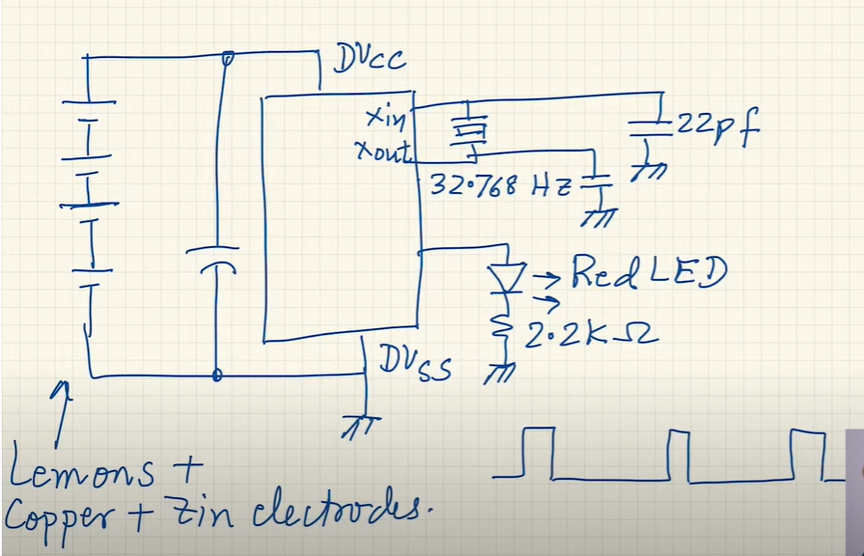

CPU is in Low Power State and Only Timer is working. Achieving using PWM (Led is ON for short and OFF for rest of the time)

**PIN DIAGRAM**

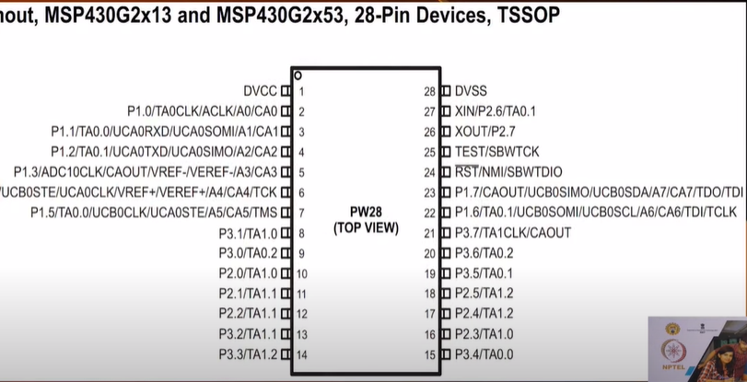

**1,28:** Power Supply

**27,26:** External Crystal

**3 ports (P1, P2, P3)**

**RST and TEST =>** acting as SBYWIRE(JTAG)

**3,4:** Dealing with UART

**6:** V-ref for ADC (on-chip)

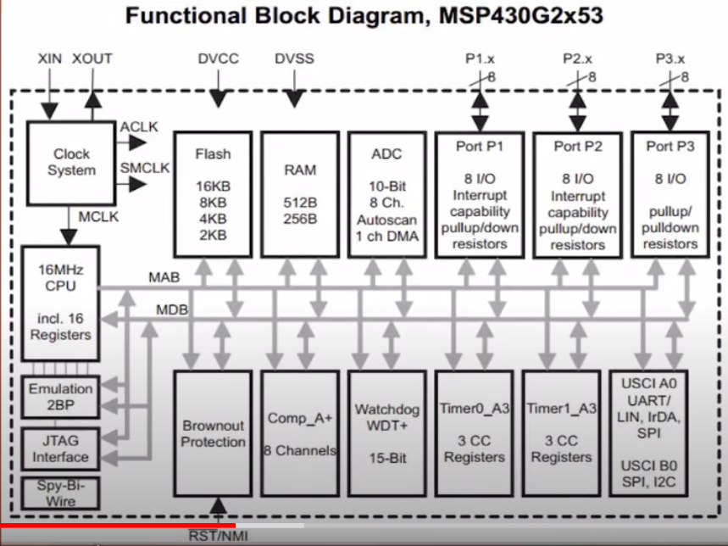

1. **SMCLK** will be System Clock
2. **ACLK** will be used by the peripherals
3. **MCLK** will be used to power the CPU

**Each port (P1 P2 P3) has 8 pins will pullup/pulldown registers**

**P1 and P3 has Interrupt Capability.**

**Bottom Right** we can make a lot of combinations with the two channels in the combinations (1st has USCI/UART/LIN/IrDA/SPI and 2nd channel USCI/SPI/I2C)

**Two 16-bit Timer + 1 Watch Dog Timer (15-bit) for doing RESET**

**Comparator(8-bit) + Brownout Protection**

**JTAG for Programming using all 4 pins (TCK, TCLK, TMS, TDI) or we can use SBWTDIO/SBWTCK(Only 2 pin are used)**

**RISC Architecture (27 basic type of instructions reduced instruction set and 7 addressing modes)**

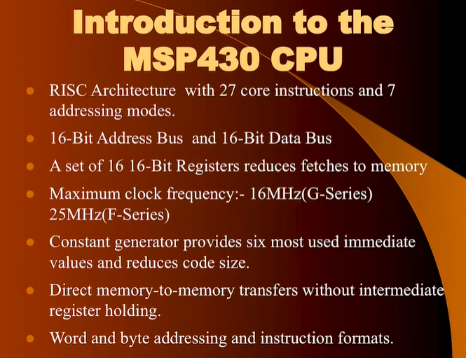

**WORD – 2 bytes**

**Von – Neumann Architecture (unified memory map – program memory and data memory and access to special which controls the input output peripherals of MSP430)**

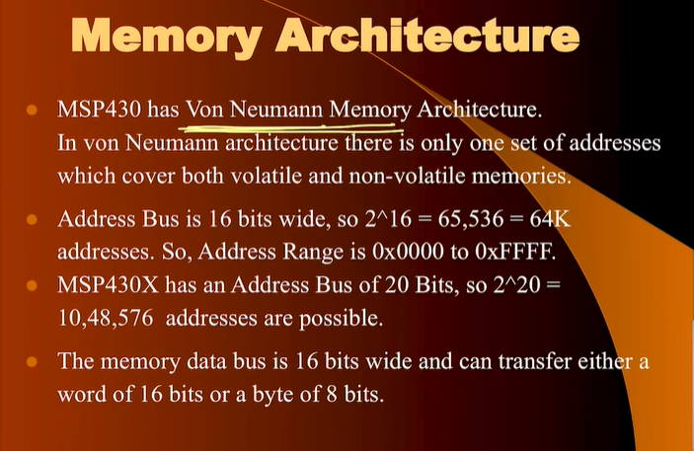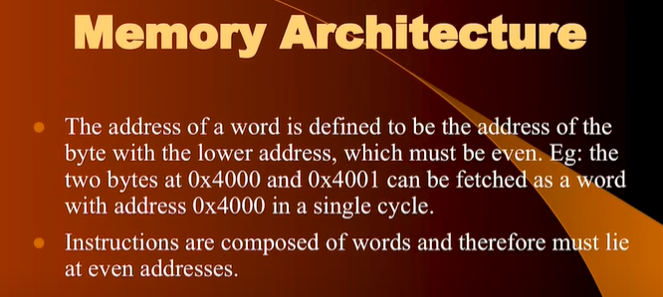

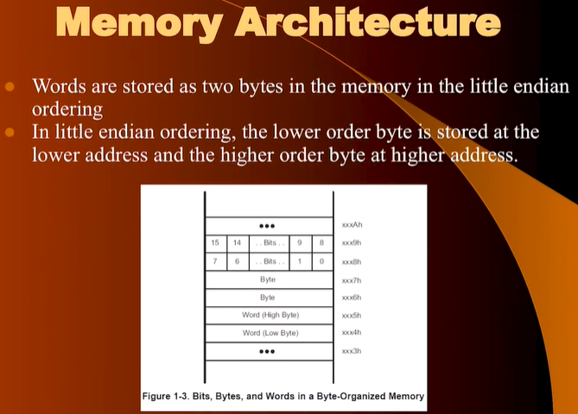

**Little Endian – Lower address lower Byte(LSB) and Higher Address higher byte(MSB) reverse of the above is Big Endian** 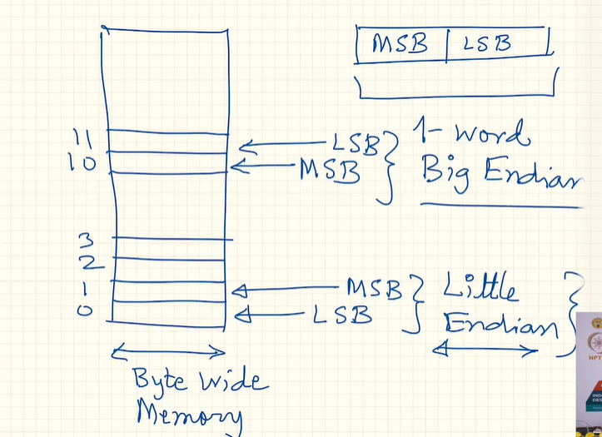

**Each Memory Location can have 8 bits. MSP430 implies Little Endian Rule**

**Information Memory is also FLASH memory and is used to store user data which you do not want to be lost if power is switched off**

**MEMORY DIVISON**

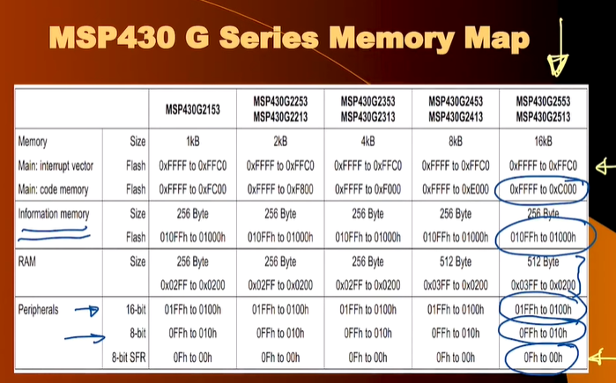

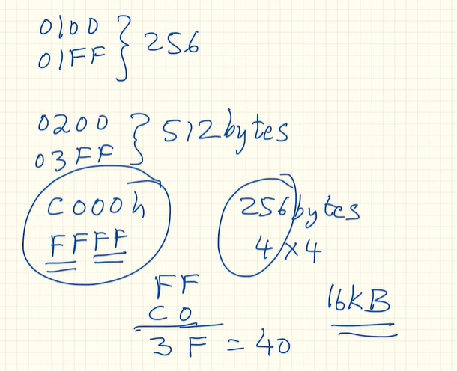 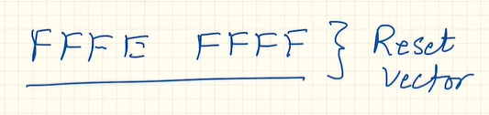

**It goes to this value of memory whenever there is a RESET and reads the value and jumps to Memory location which is in the Code Memory Region and starts the fetching interpreting and execution process from first instruction**

**Lecture 13**



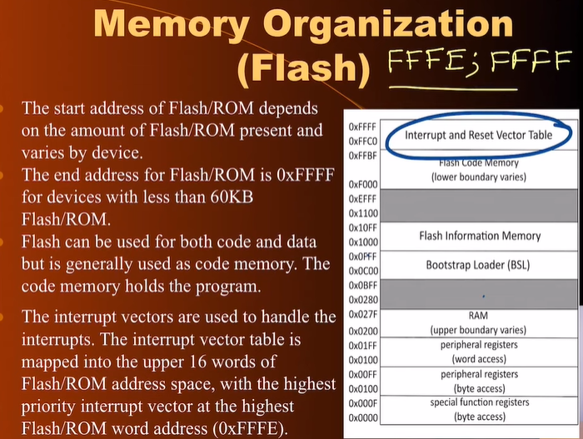

**MSP430G2553** supports 32- interrupts. We store the address and each address is of 16-bits (2 bytes) total memory = 32 x 2 = 64 memory locations to store.

At top 0xFFFE we have the RESET vector

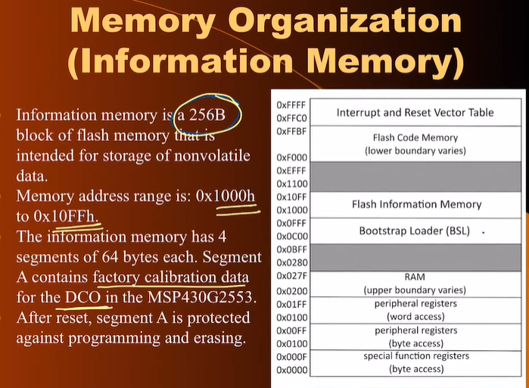

Segment A contains the factory calibration data for DCO which uses the RC Oscillator. Segment A is protected memory after RESET we cannot overwrite the information here.

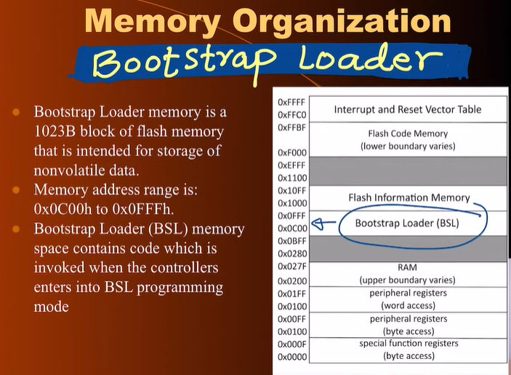

MSP430 come with a pre-programmed bootstrap loader. We just need to provide an ecosystem so that it is compatible to work with the bootstrap loader mechanism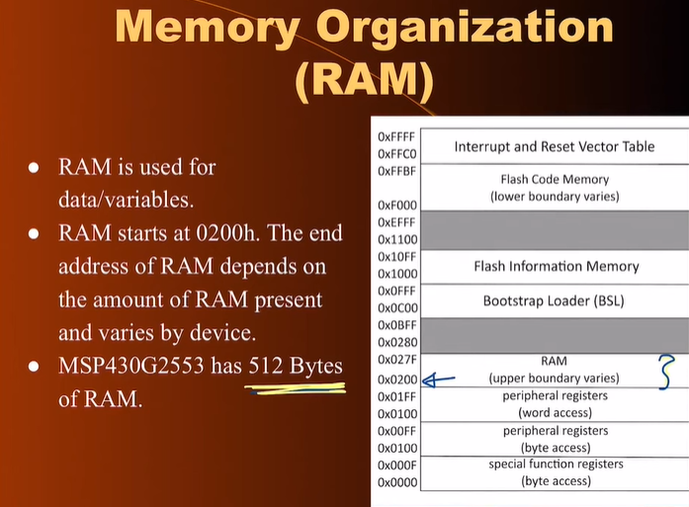

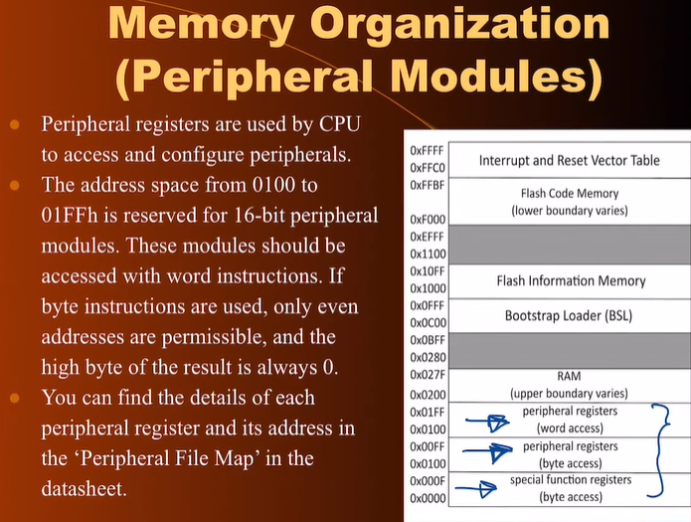

**ARCHITECTURE(CONTINUED)**

16 Registers in total (R0 to R15) of 16 bit

4 are Special Purpose and rest 12 are GPR

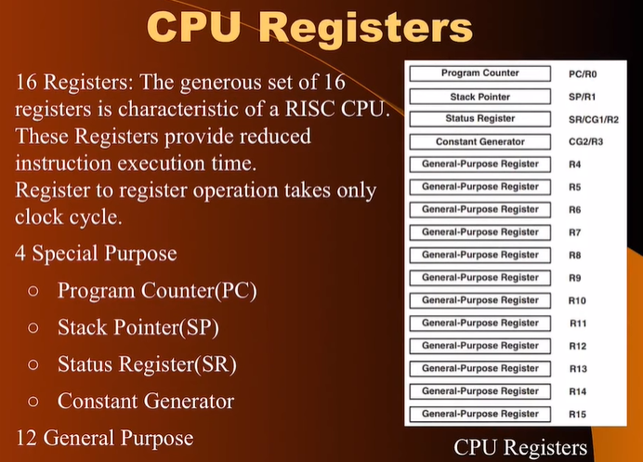 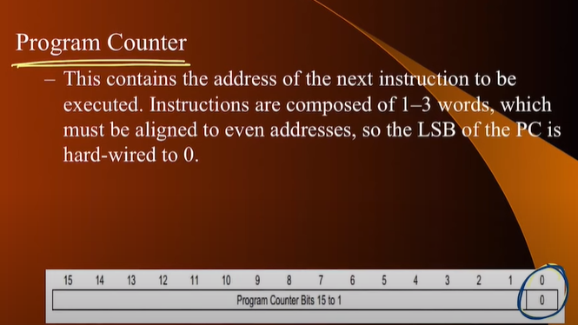 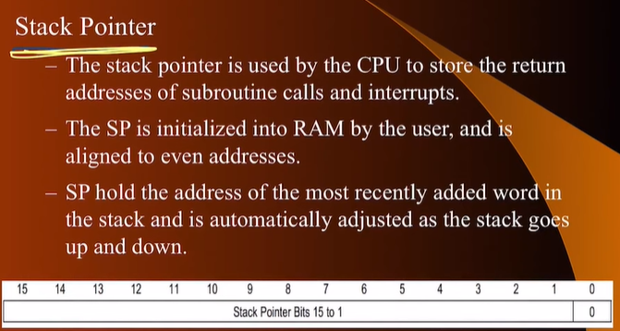 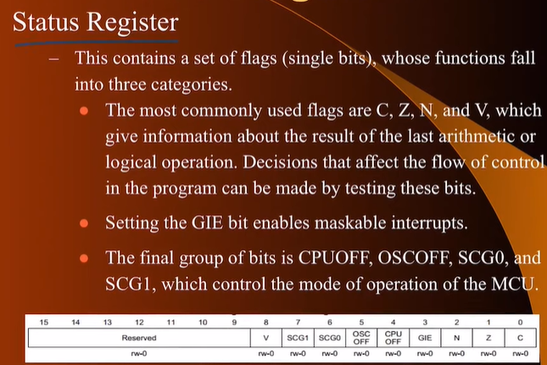 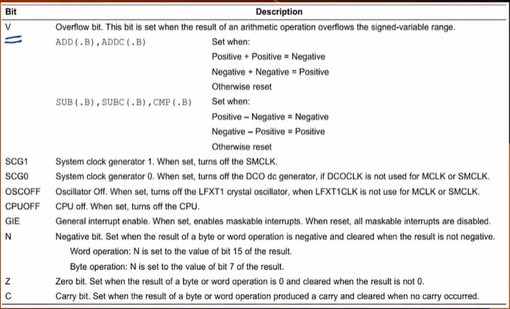

Flags – V(Overflow) , N(Negative) , Z(Zero) , C(Carry) 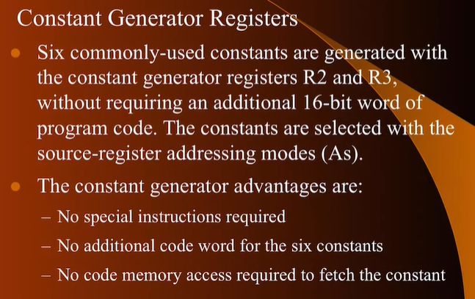 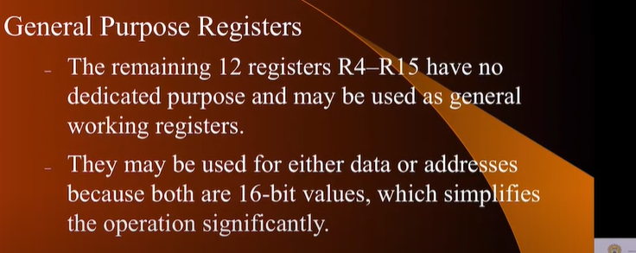

**Some Instructions in MSP430 – RISC** 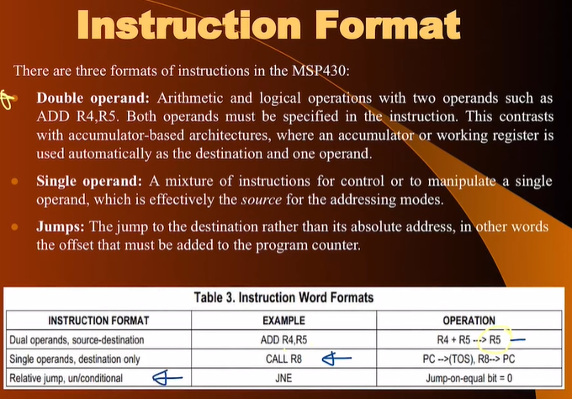 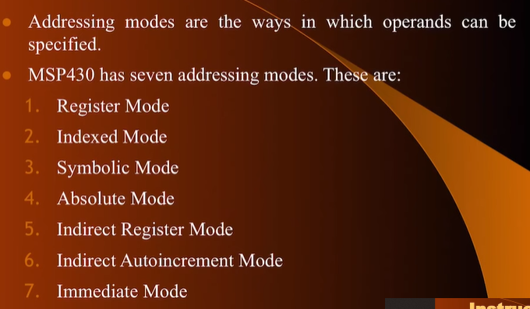

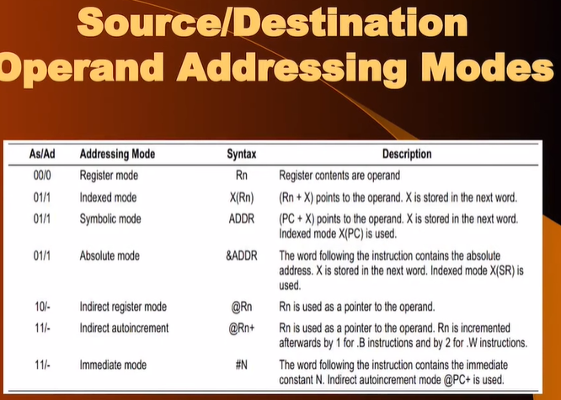

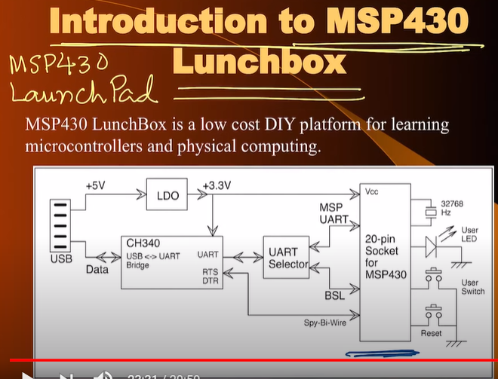

**USB is not supported in MSP430 so we need a BRIDGE(IC – CH340) to convert the USB to UART so that programme written by the developer can be downloaded easily using IAP(In Application Programming) Bootstrap Loader which is pre-defined in MSP430 by TI.**

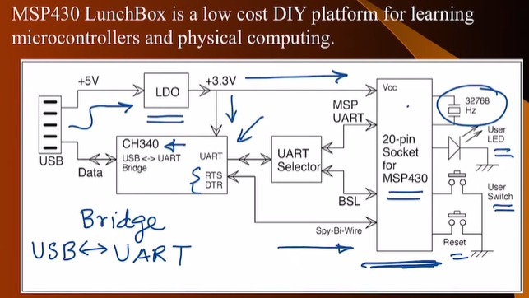

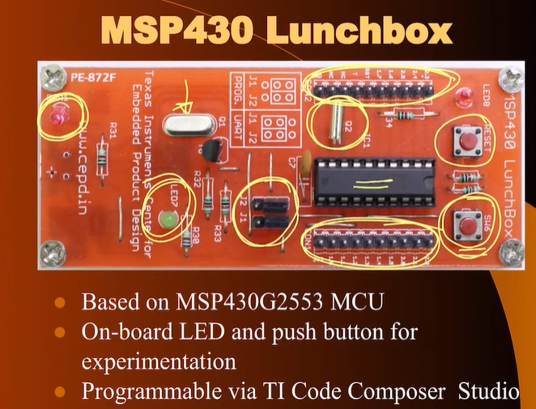

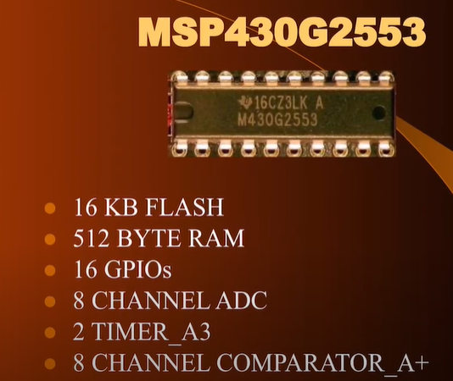

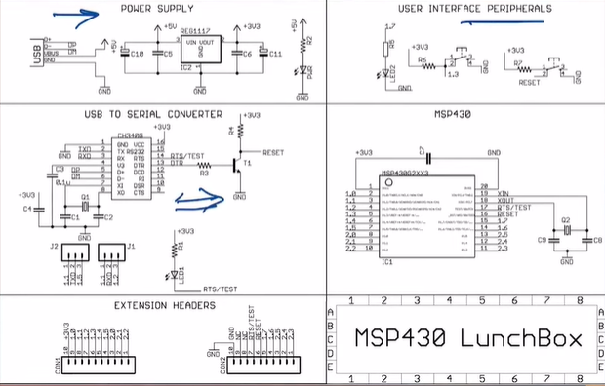

**WEEK - 5**

**Physical Interfacing – I**

**Single Pole Single Throw and like that**

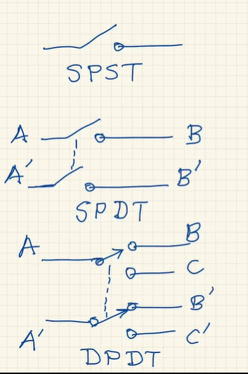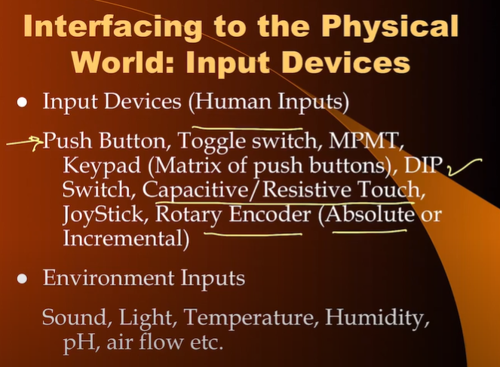

**Reed Switch ->** enclosed in a glass tubing magnetic field must be brought near it to enable it

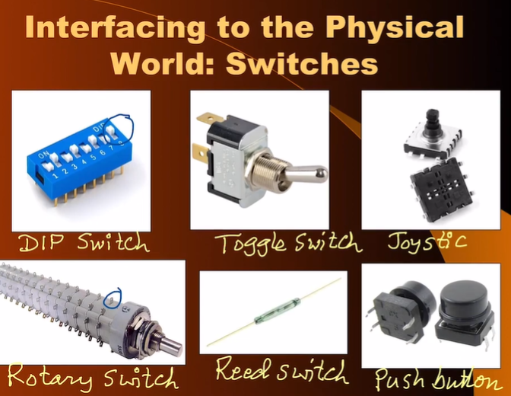

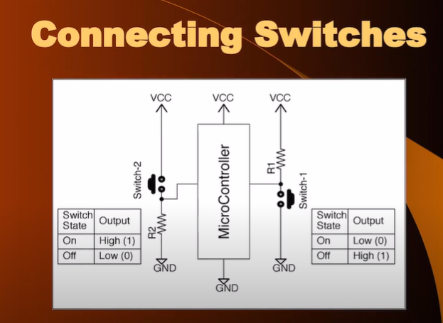

**R1 is PULL-UP RESISTOR** and **R2 is PULL-DOWN RESISTOR**

**Calculating the value of resistors in switches**

1. **For Pull-Up Resistor**

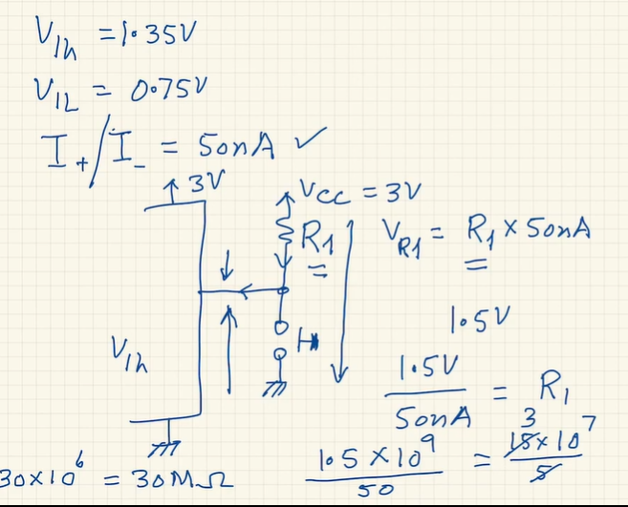

These inputs interfacing from DATASHEET of MSP430

**Vih** (for logic 1 we need minimum of 1.35V and Vcc = 3V)

**Vil** (for logic 0 we need maximum of 0.75V and Vcc = 3V)

**I+/I-**

are taken from Data Sheet of MSP430

1. **For Pull-Down**

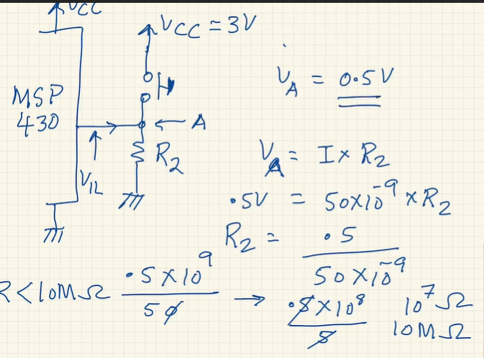

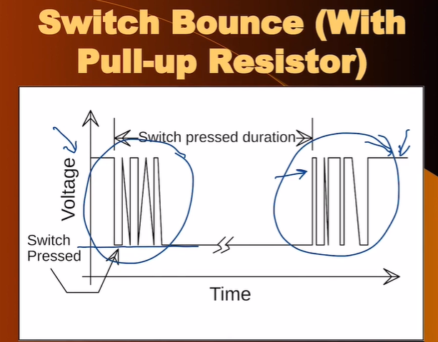

**Removal of the bounce of the switch is known as Debounce**

1. **Hardware Option (LPF – Low Pass Filter made with combination of R and C)**
2. **Software (Execute a delay subroutine to overcome this condition)**

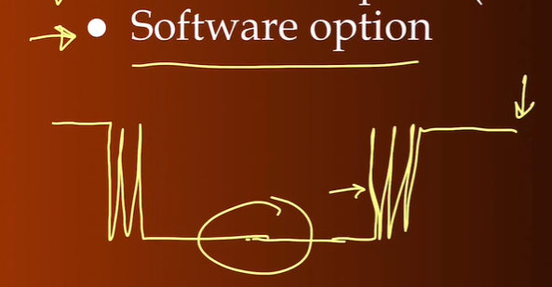

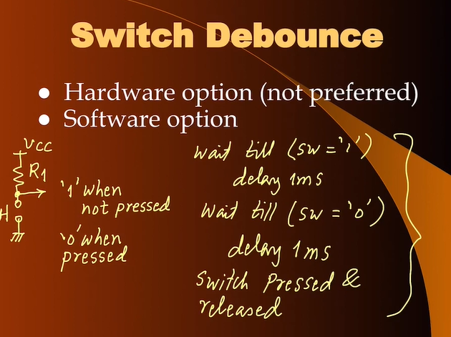

**Connecting Multiple Switches at the same time**

**SWITCH MATRIX**

1. **Column coming from Microcontroller**
2. **Row – Pull Down resistor and goes to the input**
3. **At junction of each row and column we will connect a switch**

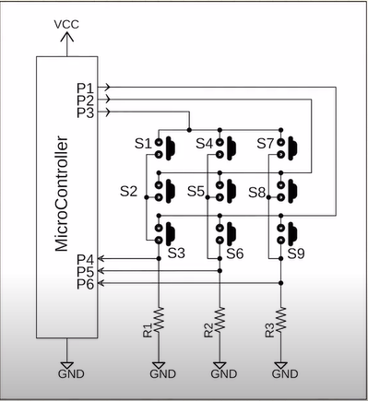

**P1 P2 P3 are output pins**

**P4 P5 P6 are input pins**

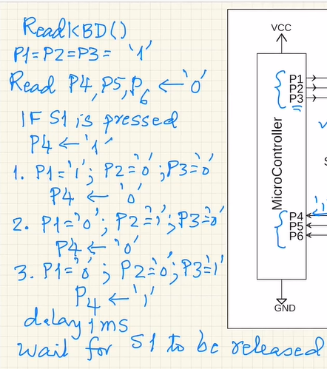

Then again delay to prevent Bounce for released

Subroutines are of 2 types: -

**BLOCKING** and **NON-BLOCKING**

A **blocking subroutine** will return only if the activity is detected. For example, in case of Keypad it will return only if a key is pressed and will return a SWITCH CODE. Blocks the operation of the main program.

A **non-blocking subroutine** will have 2 return values. First being TRUE or FALSE and second value being the SWITCH CODE. The subroutine will wait for the user to press a switch for a given duration of time and if no switch is pressed then timeout and one of the values will be done as FALSE. If false then the program will ignore the SWITCH CODE. If TRUE then it will understand which switch was pressed

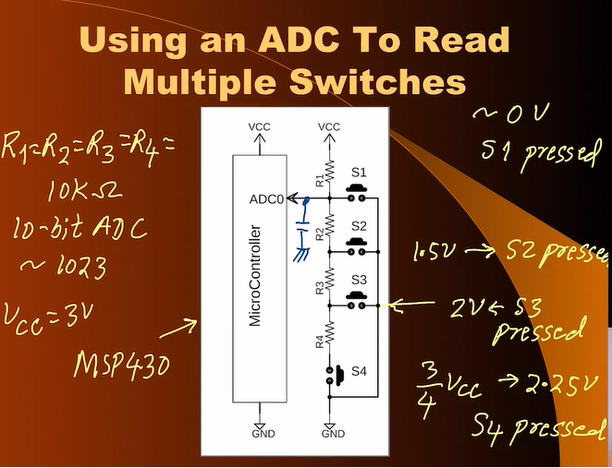

Using multiple switches with a single pin of the micro-controller. That pin should be able to read analog values. MSP430 has 10-bit ADC so it can read values from (0 to 1023) and can be utilized for connecting multiple switches and voltage at the ADC0 will be used to detect which switch is being pressed. 3V range has a count from 0 to 1023 in the above case. As we increase the number of switches then range will get smaller. Using equal value resistors, we get non-linear counts. Appropriately use the value of resistors. One must use the technique for at max 8-9 switches.

**ROTATRY ENCODER**

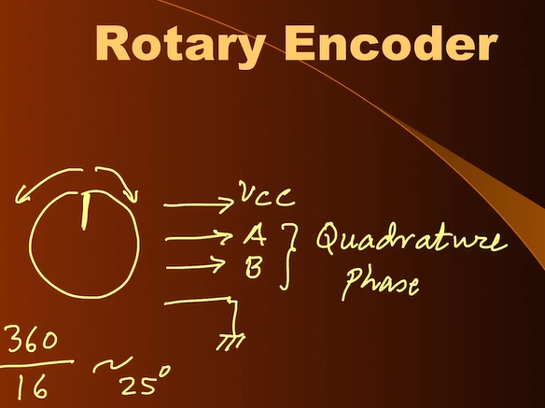

**16 – bit.** How fast/ slow we move pulses are being generated. A and B are used to tell the direction of rotation of the knob. Angle moved is calculated by counting the number of pulses

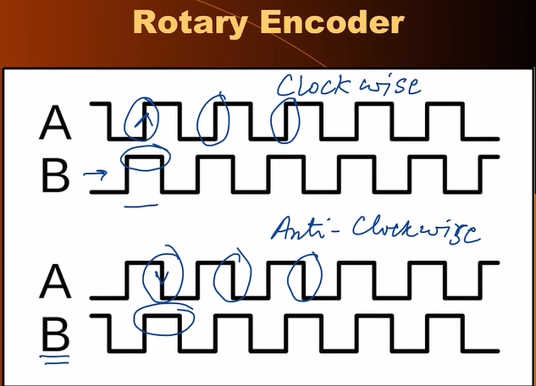

**OUTPUT INTERFACING** 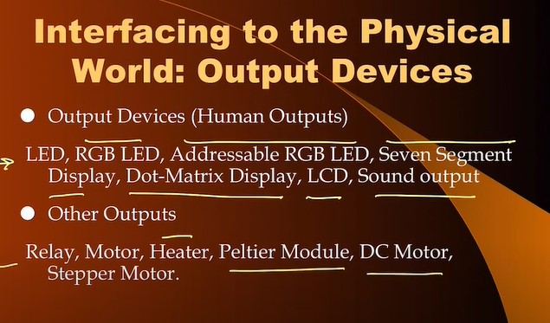

**LED and RGB LED**

There are 4 ways in which we can connect the LED

**LED 1 and LED 2 are Active HIGH**

**LED 3 and LED 4 are Active LOW**

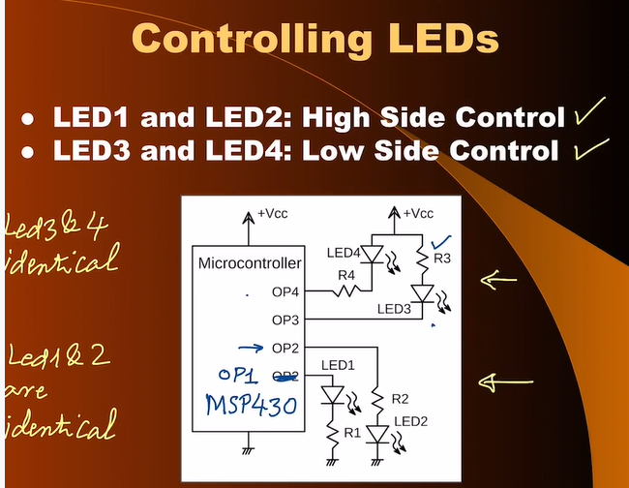

**Red** has lowest energy. So, the **voltage drop will be the lowest around 1.6V**

**Violet** has maximum energy. So, the **voltage drop will be the highest around 3V for blue.**

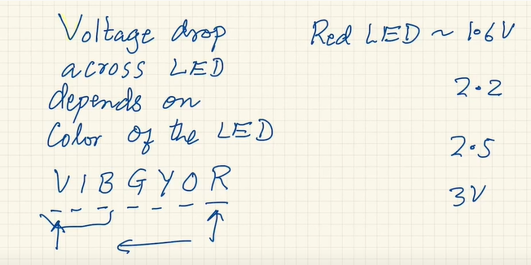

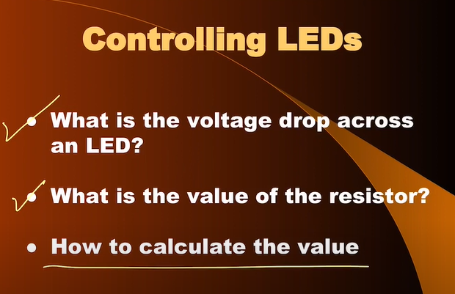

**For High Side Control calculating resistance**

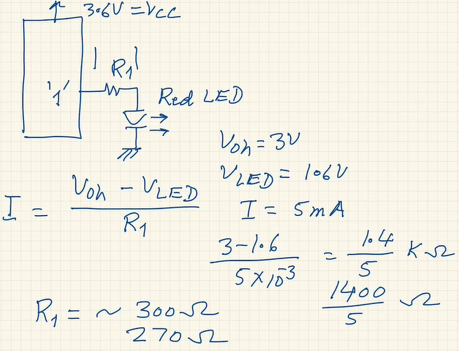

**For Low Side Control calculating resistance**

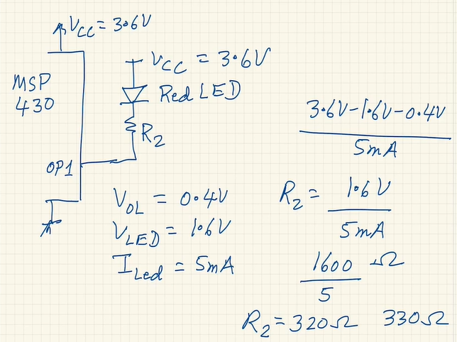

**7 Segment Display**

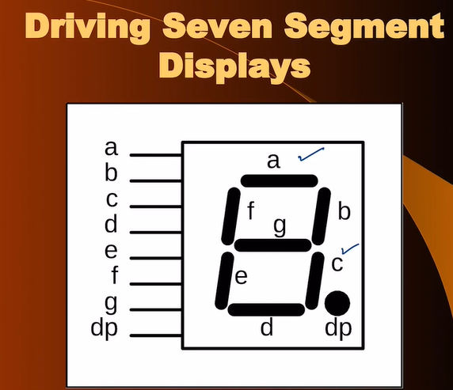

2 types

1. Common Cathode (Active High)
2. Common Anode (Active Low)

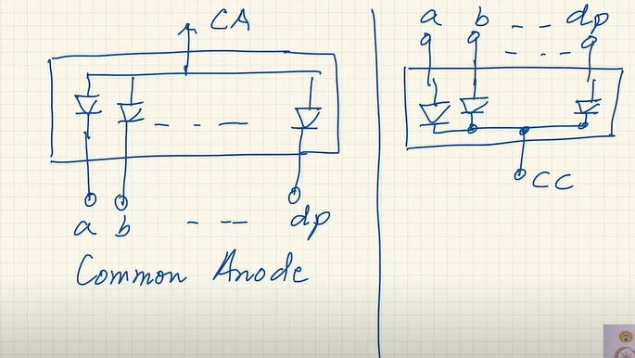

**COMMON CATHODE**

For common cathode value of the resistor will be calculated in the same manner as HIGH CONTROL LED

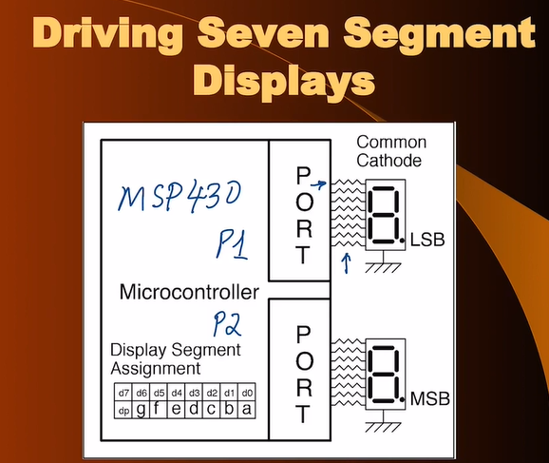

Using a Single Resistor, we will get unequal intensity. Intensity will vary for each of the number. NOT RECOMMENDED

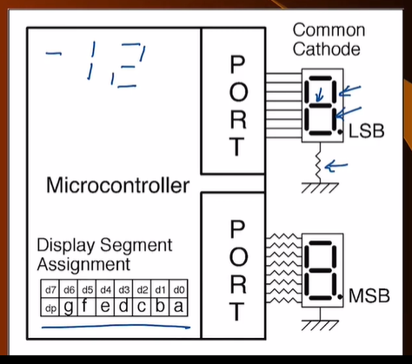

**COMMON ANODE**

For common anode value of the resistor will be calculated in the same manner as LOW SIDE CONTROL LED

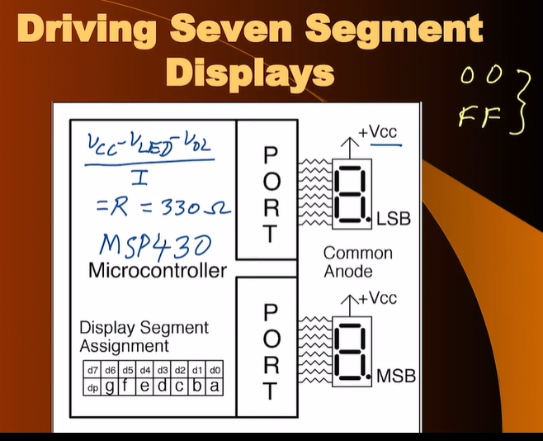

In order to increase the current through these LEDs of Seven Segment i.e. to increase their intensity

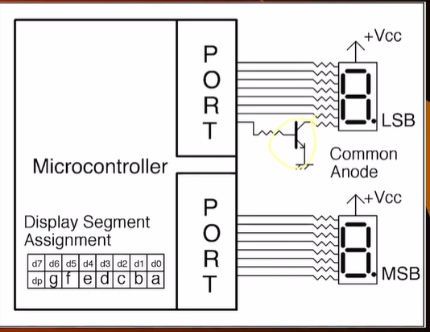

2 methods to do the above task

1. **To use more than 1 resistors for one LED**

For example, if we want 20mA of current through the LED (we know that each pin can have maximum of 6mA of current in MSP430) so using 4 pins each providing 5mA can be used to provide 20mA. We can even control the intensity of LEDs using this.

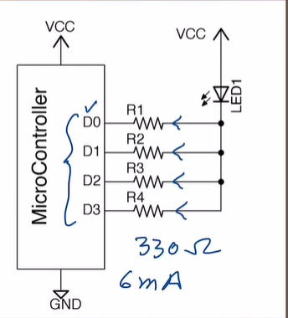

1. **Using a NPN Transistor**

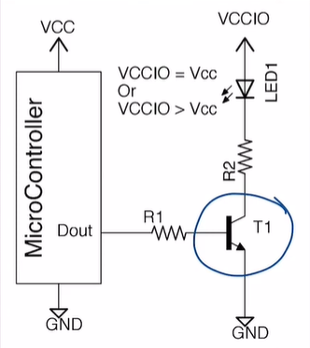

Microcontroller cannot provide 20mA to the LED so we can use transistor.

**Calculating R2 which is current limiting resistor at collector side**

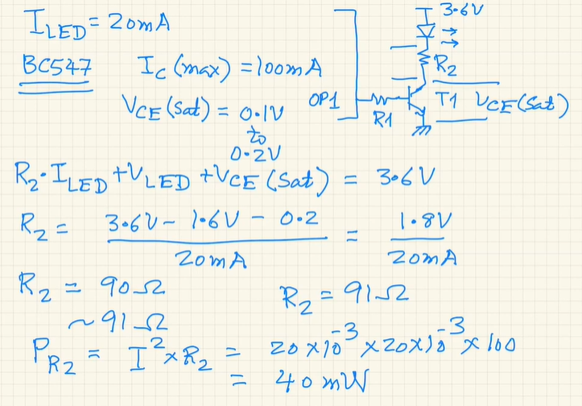

**(We have considered RED LED in this case so V drop is 1.6)**

**Calculating R1 which is resistor on the base side**

Find Voh from datasheet when the output is logic 1 at the pin.

We need that the transistor must be operating in SATURATION REGION. Find the value of R1 for the calculated IB and then divide it by factor of 2 or 5 so that we are deep in the Saturation mode.

See in the figure below we divided the value of R1 by 5 so that IB is much higher and we are deep in the saturation region.

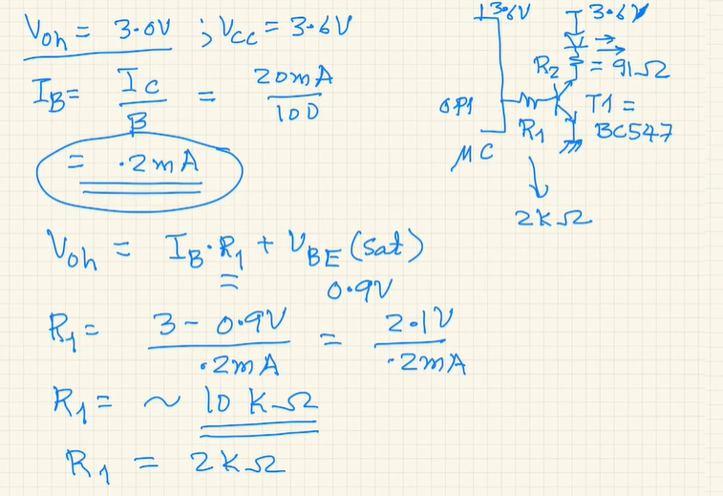

**WEEK 6**

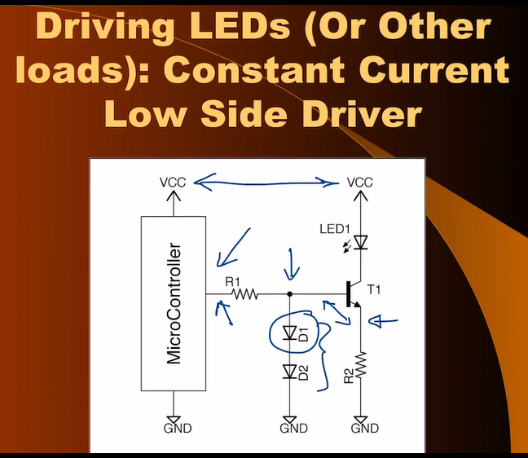

Transistor is operated in **Forward Active Region**

When Vcc is not constant i.e. it is battery driven to produce constant current through emitter and collector (if beta is large) we use this method

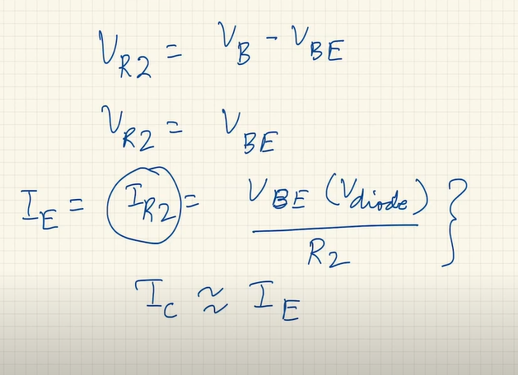

**Similarly we can do it above 2 methods for High Side Switch**

1. **Use of Resistors**
2. **Use of PNP Transistor**

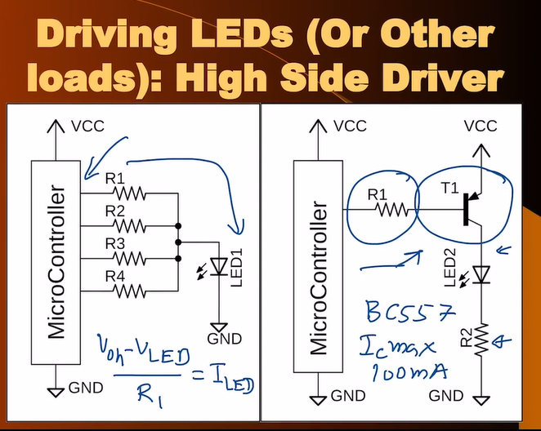

High Side using TRANSISTORS **(Calculating R2)**

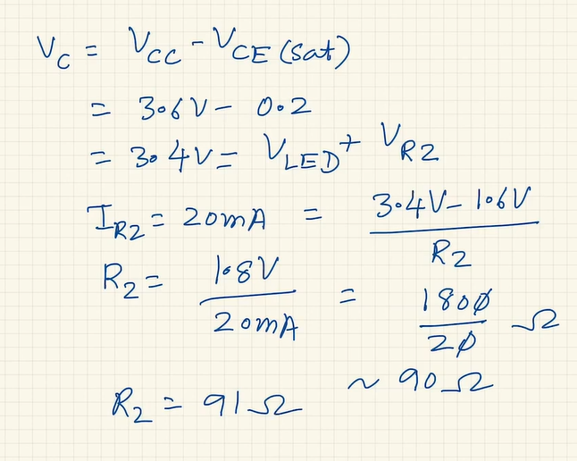

**(Calculating R1) – Deeply in Saturated Region Ib should be large enough than actual value**

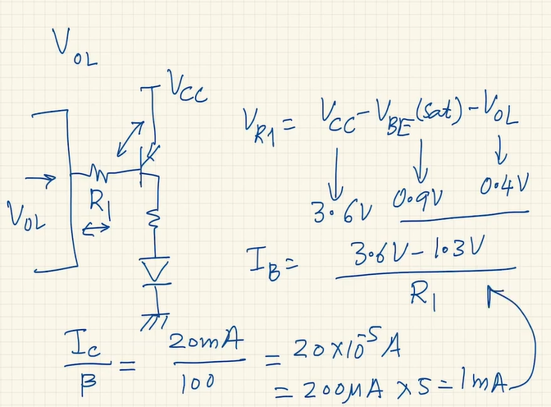

**When the V at LED is much more than Vcc of the microcontroller**

**WE NEED 2 TRANSISTORS IN THE CASE OF HIGH SIDE DRIVER**

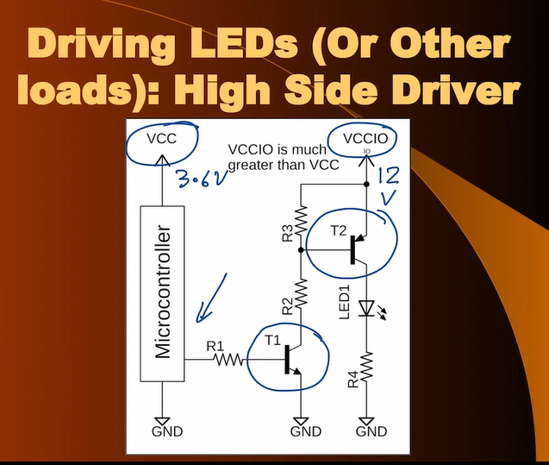

**When pin is at HIGH or logic 1**

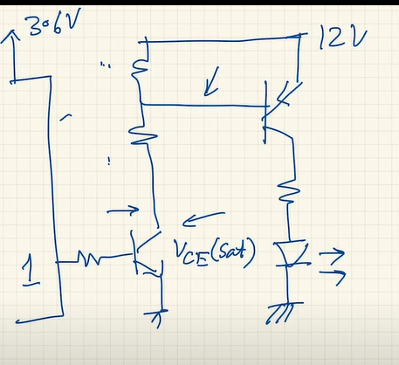

T1 is in saturation and due to the voltage divider at T2 to make the LED on

**When pin is at LOW or logic 0**

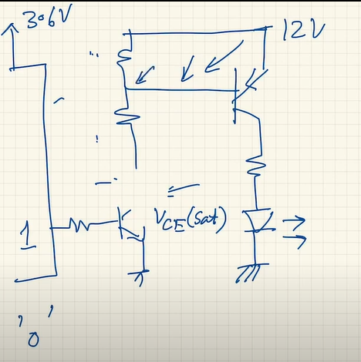

T1 is on cut-off and lower resistor od voltage divider is floating so the voltage at the base of the T2 will be same as the supply voltage so the transistor is not FB. LED OFF

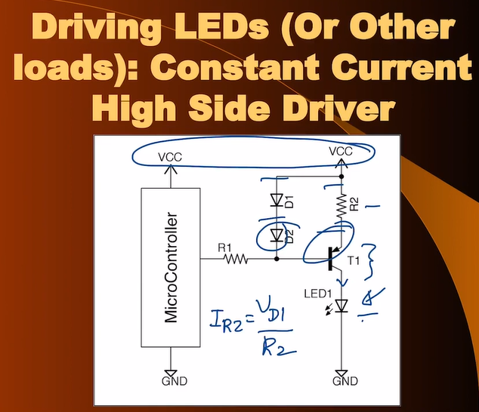

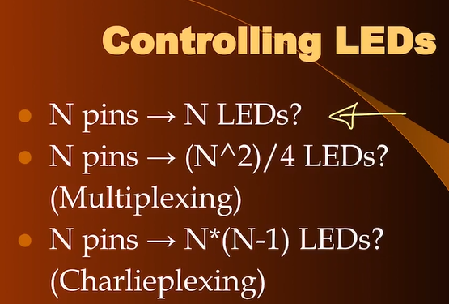

**DRIVING 4 7-SEGMENT DISPLAYS WITH MICROCONTROLLER**

Making use of 12 pins of the uC and with the use of persistence of vision we make sure that all the four digits are visible simultaneously to the human eye. More than 16 Hz frequency

**4 PNP and 8 NPN Normal Multiplexing is shown below:**

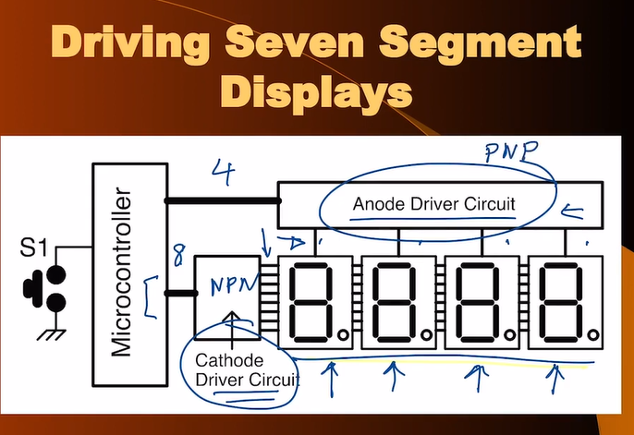

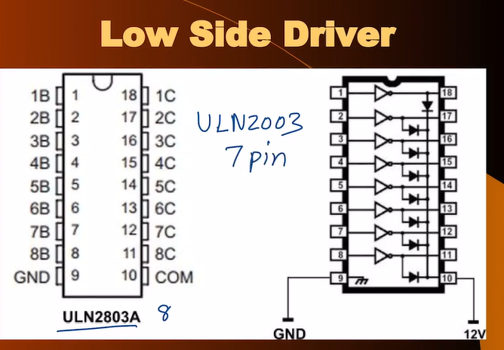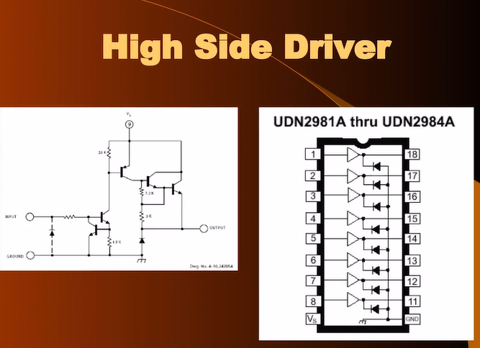

**CHARLIEPLEXING**

**As the value of N (pins) increases the intensity of the bulbs will decrease.** Makes use of persistence of vision of human eye as only one LED will be on at a time. 100hz can be used

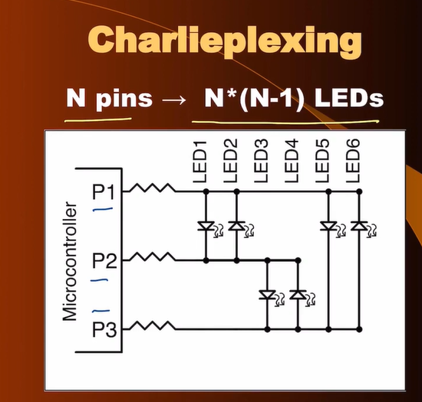

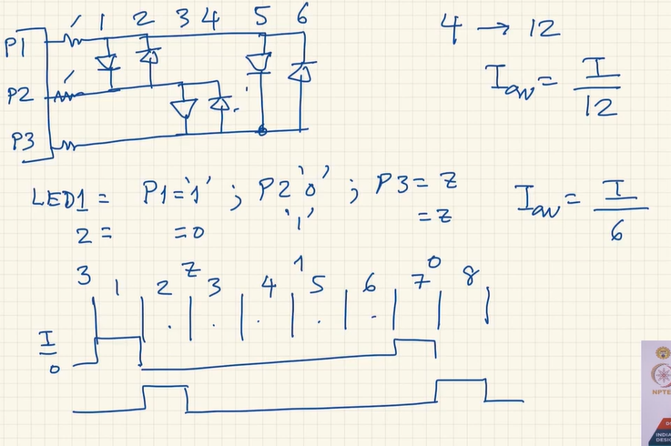

Not very scalable technique as if we increase the number of LEDs using a greater number of pins then intensity of LEDs keeps on reducing. N should be not more than 4 or 5.



**CALCULATION LOW SIDE DRIVING USING BC547(NPN)**

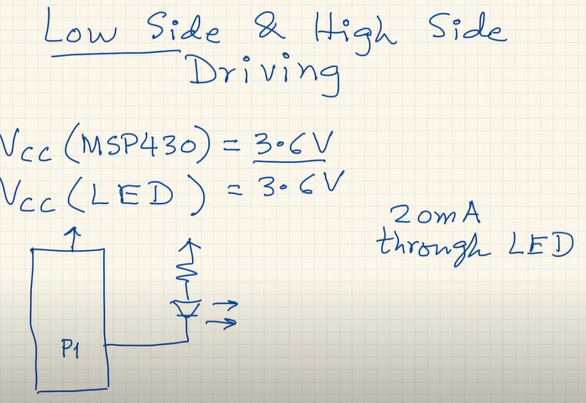

**From Data Sheet of BC457A**

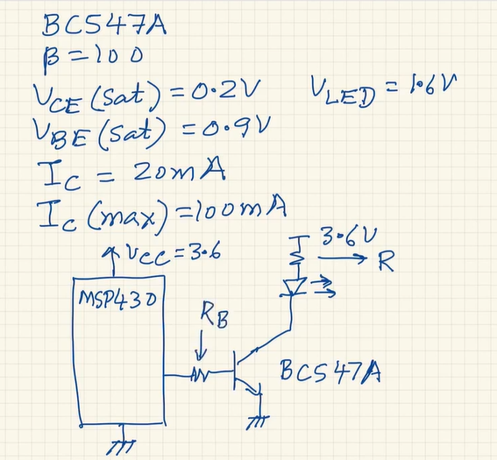

**Calculating Value of current limiting resistor**

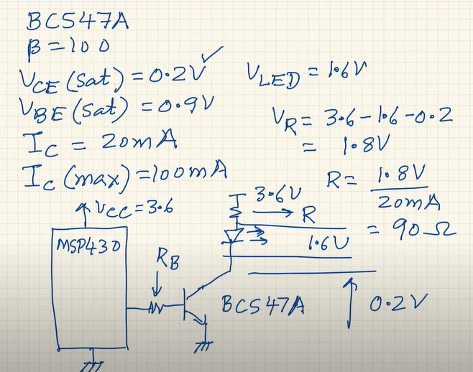

**Calculating Value of Rb**

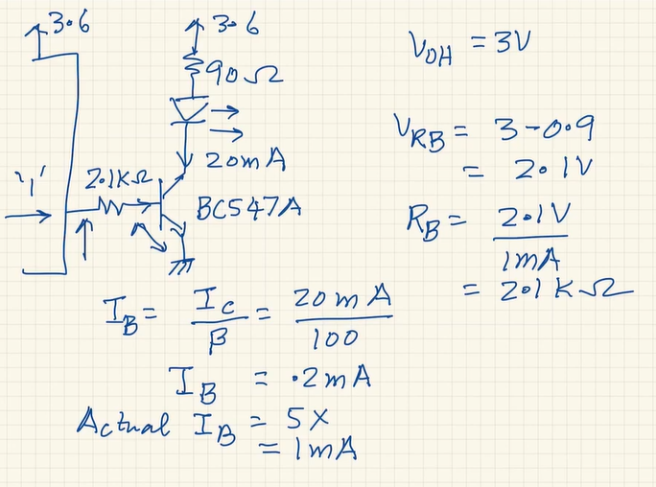

**LOW SIDE DRIVER**

**When the voltages are different Vcc of Transistor and Vcc1 of uC**

**(Vcc1 > Vcc)**

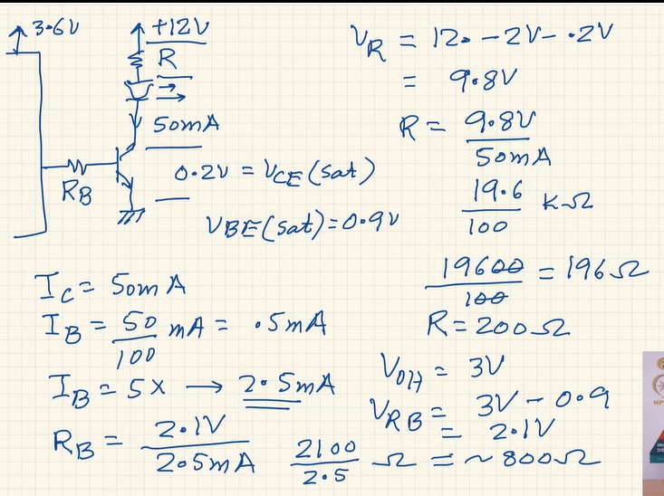

**CALCULATING HIGH SIDE DRIVING USING BC557(PNP)**

Same parameters as BC457

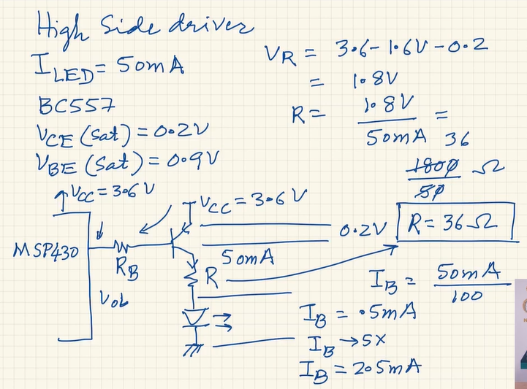 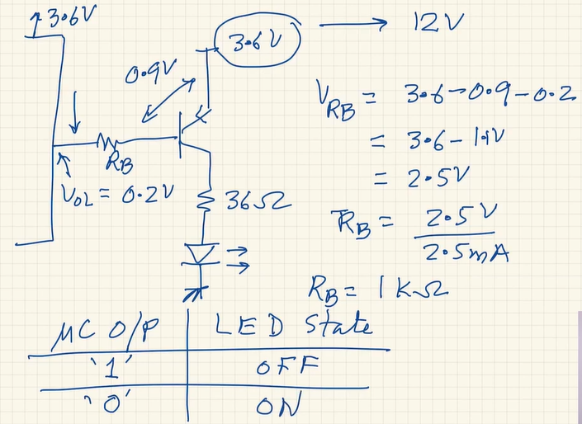

**HIGH SIDE DRIVER**

**When the voltages are different Vcc of Transistor and Vcc1 of uC**

**(Vcc1 > Vcc)**

**NOTE:** If we use only 1 transistor then in both the cases (logic 1 or logic 0) we will have the transistor in saturation and the LED will never turn off so we need 2 transistor configuration discussed earlier.

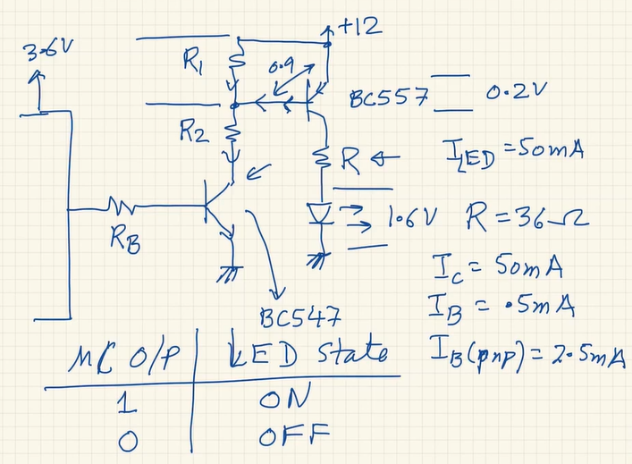

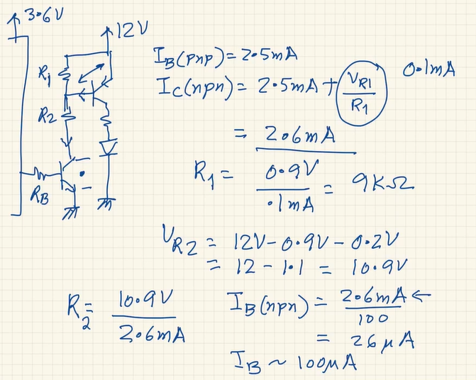

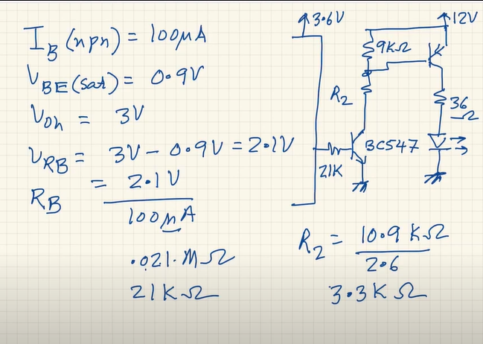

**WHEN WE NEED BOTH HIGH SIDE AND LOW SIDE CONTROL**

**In case of DC MOTOR we need both of control**

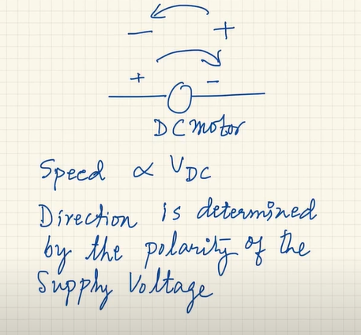

**HOW TO DO THIS? Achieved using PWM**

Time Period is constant and Amplitude is constant. Just the DUTY CYCLE keeps on changing

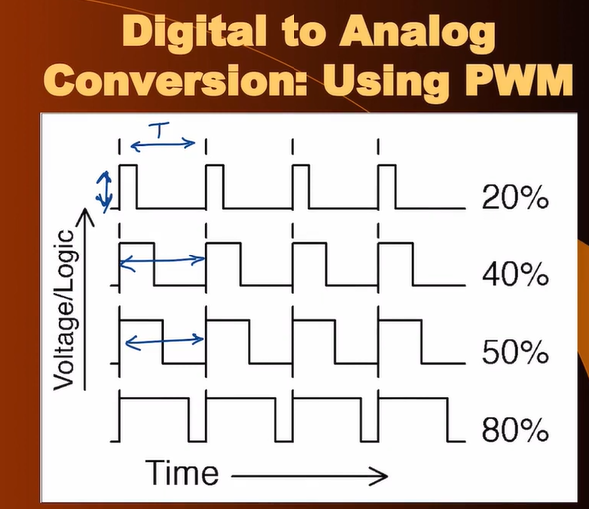

DC Motor behaviour is like LPF. As long as the frequency of the LPF is much higher than the BW of the DC motor then there is no need of the FILTER at all

For controlling the direction and voltage value of the DC motors we will be using **H-Bridge Structure** and giving PWM to one of the switch for one direction

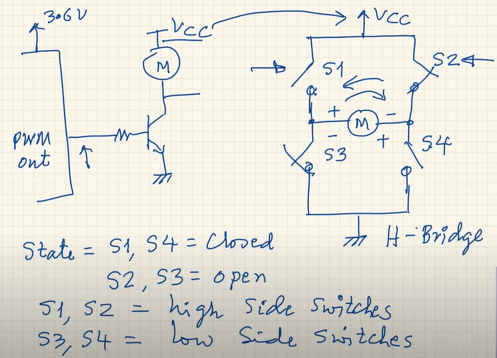

**INTERFACING RELAYS**

Relay is an electromagnetic switch which is used to turn on and off circuit by a low power signal or where several circuits must be controlled by one signal.

Has a coil and 3 pins are given. When it is energized then NO is connected to COM while when it is not energized then NC is connected to COM

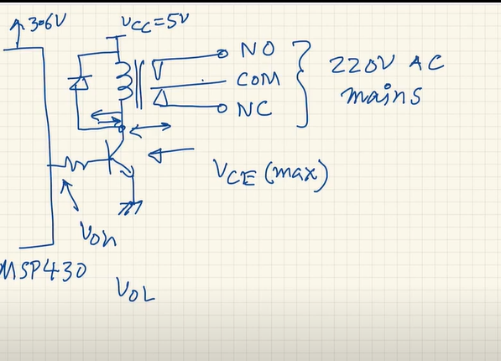

**WEEK 7**

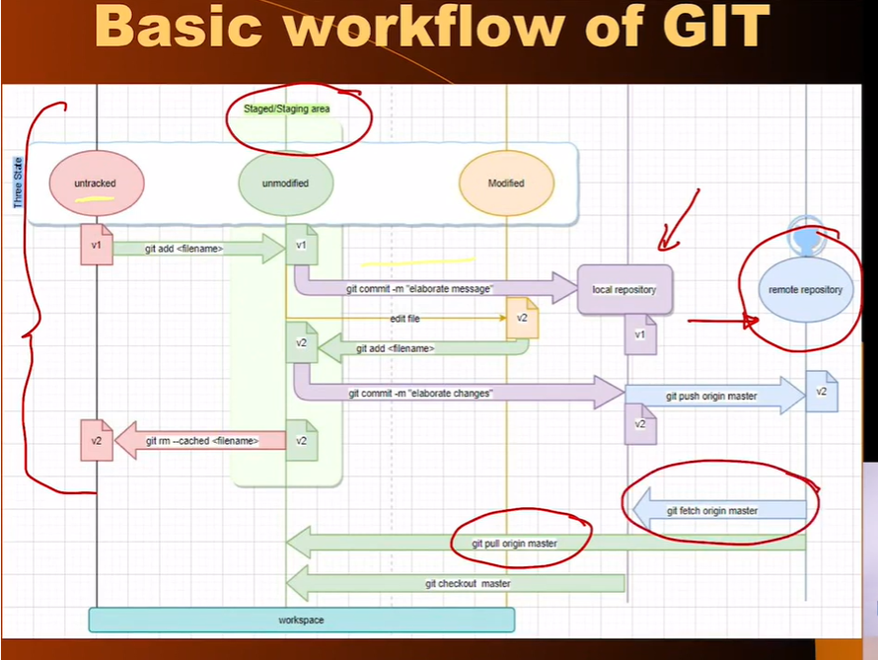

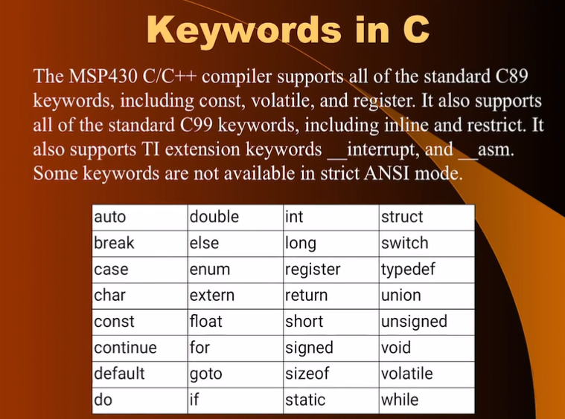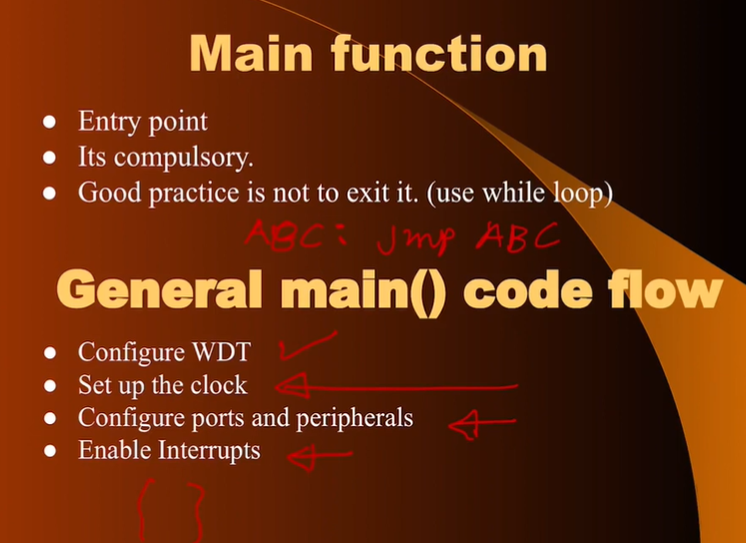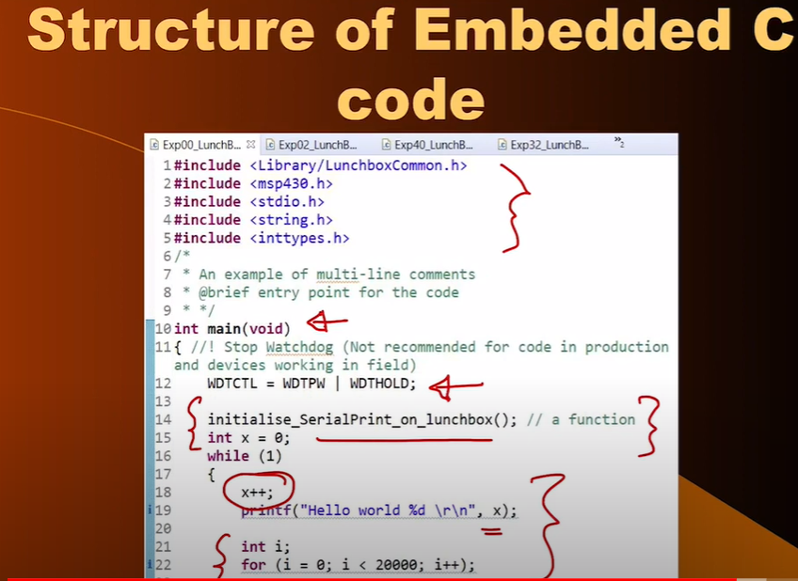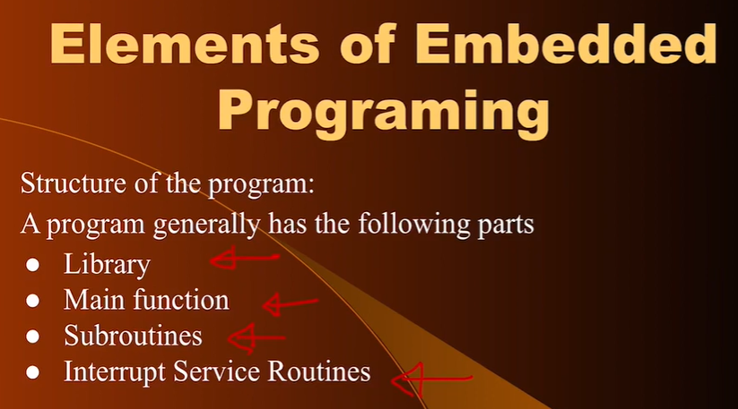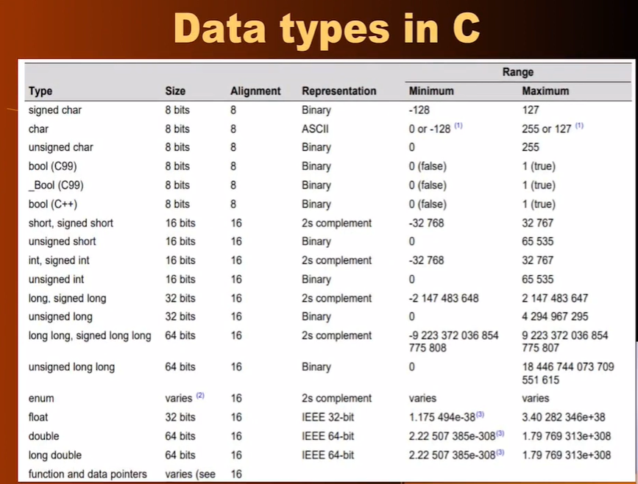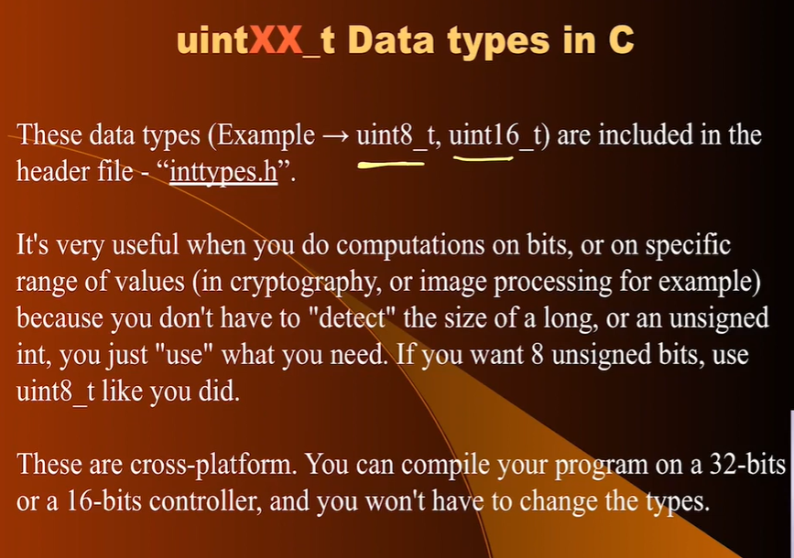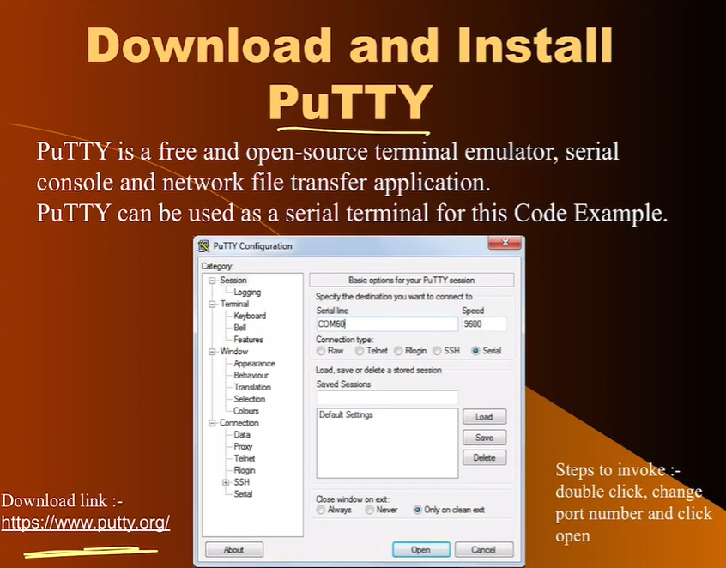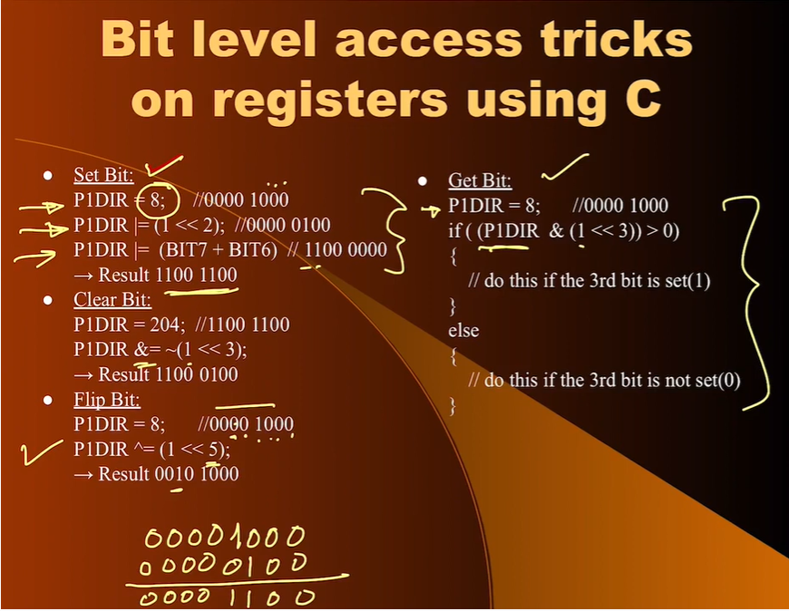

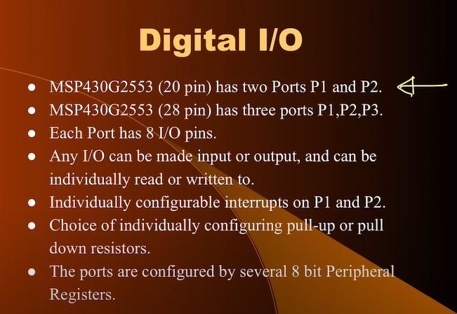

20 pin 🡪 DIP IC

28 pin 🡪 SMD Version

No need to external pullup or pulldown resistors in MSP430 we can just programming

**PORT PIN as Input or Output**

With the use of TRI STATE BUFFER

**Configuration of PIN as OUTPUT**

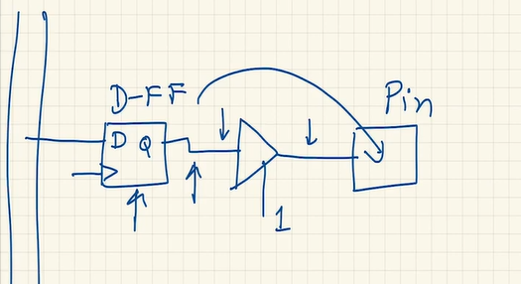

**Configuration of PIN as INPUT**

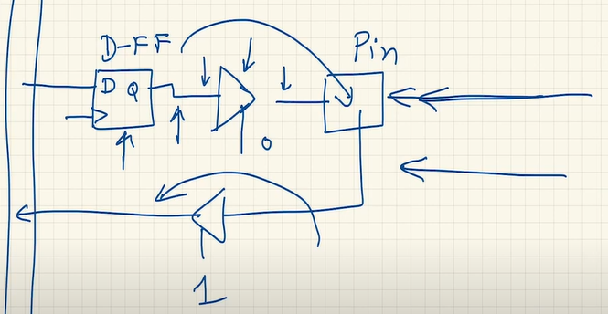Arrow in right represents the external voltage applied to PIN

**Each PIN is multi-functional in MSP430G255. Each PORT has 8 PINS**

**P1DIR – Direction register (input or output)**

**P1SEL and P1SEL2 – Select register**

**ADC register**

**CAPD – Capacitive sensing register**

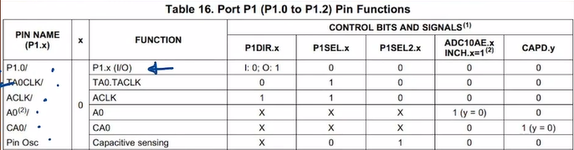

X – refers to PORT we are talking about 1 or 2 or 3

**PxREN – resistor pullup or pulldown whether it is pull up or pull down depends on PxOUT**

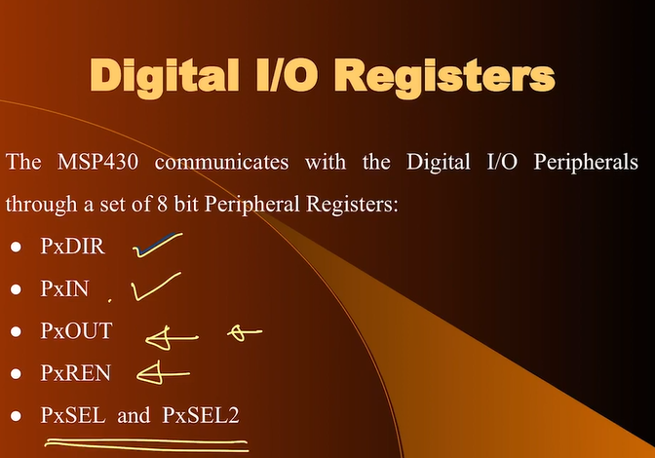

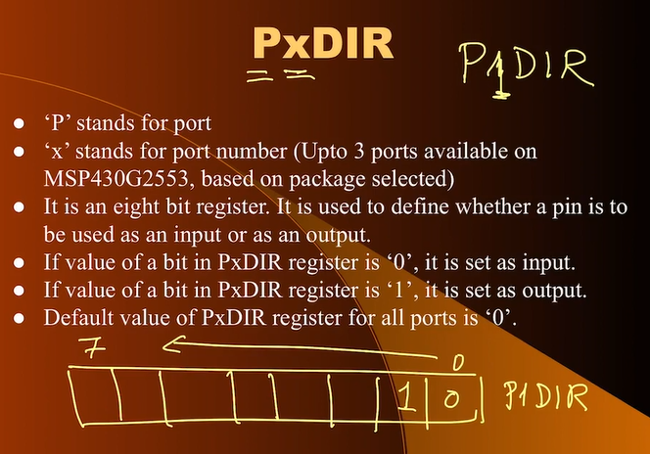

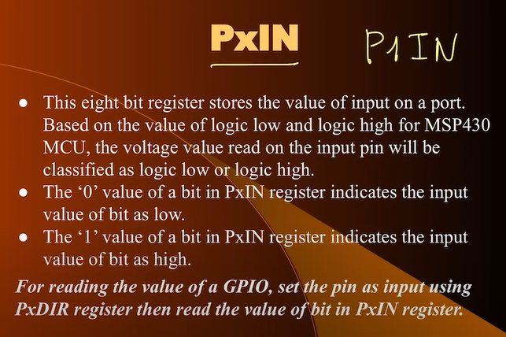

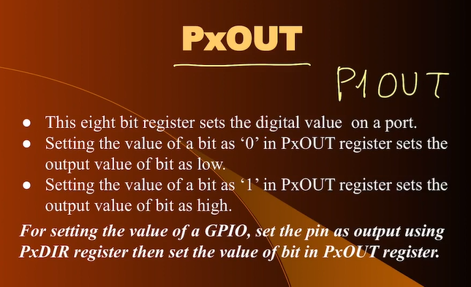

**Only those bits which are configured as output will be affected others will not be affected. Similarly for input configured pin**

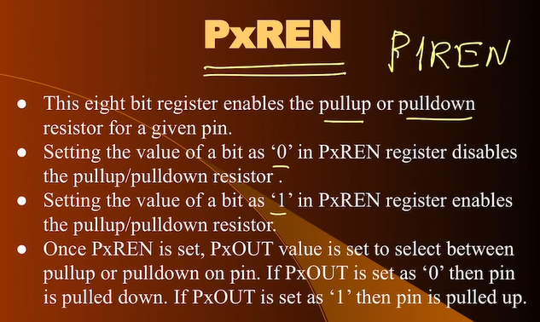

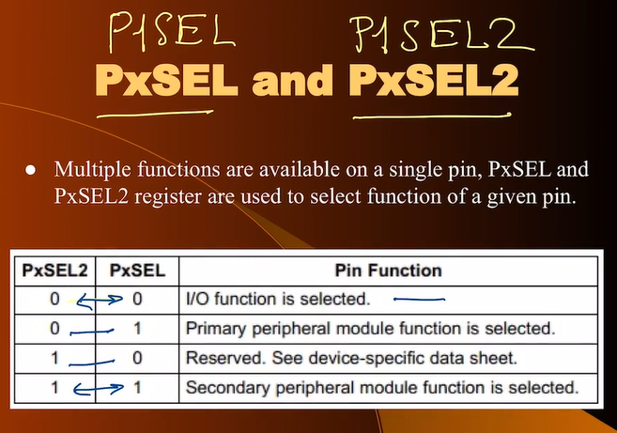

**PSEL and PSEL2 are not required for our programming if we want to make the INPUT and OUTPUT. They are default set to zero.**

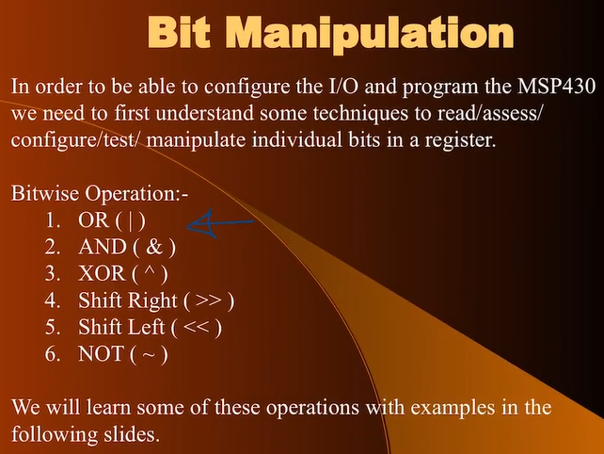

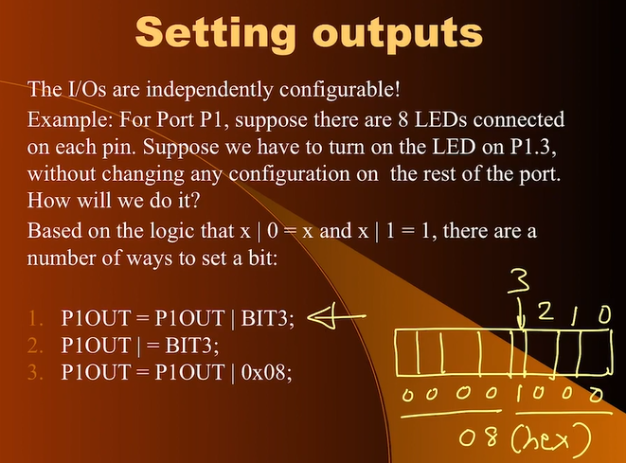

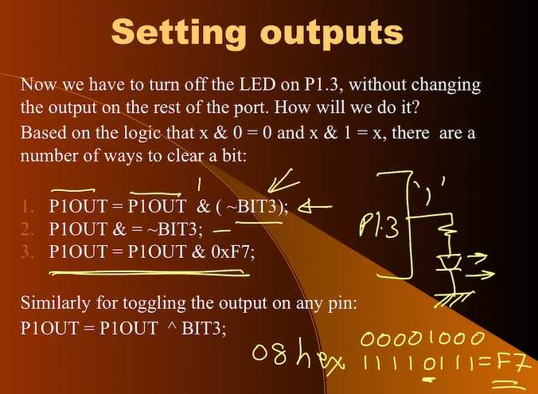

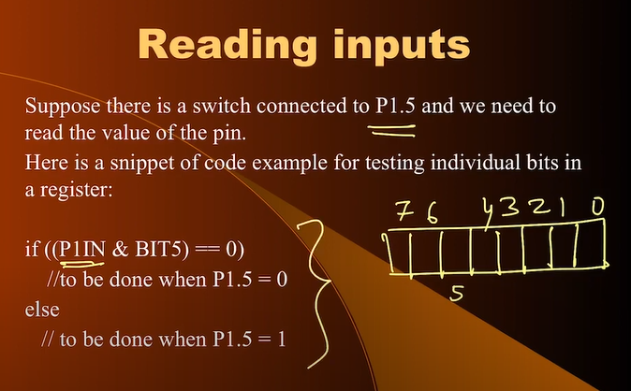

**HELLO LED (ON-BOARD LED ON PIN P1.7)**

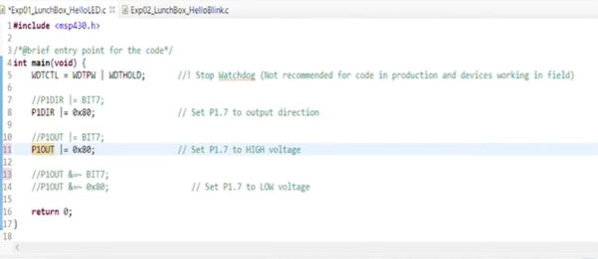

**Reset** turns on the WATCH DOG TIMER. If it is ON it will reset very quickly. We do not want it to STOP what we are doing.

**Each PORT has 8 pin and we are connecting LED to pin 7 so making it as OUTPUT pin**

1. **WATCH DOG OFF**
2. **DIR**
3. **HIGH or LOW**

**BLINK LED**

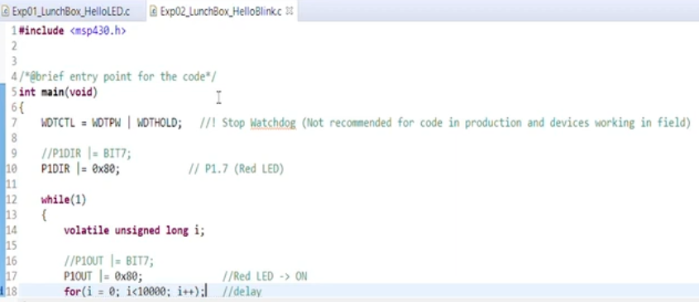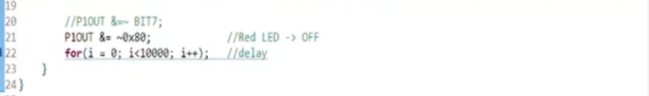

**SWITCH INFERFACING**

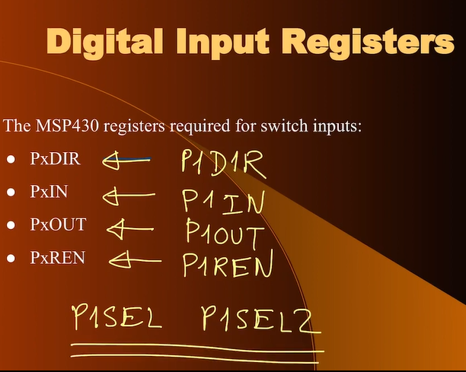

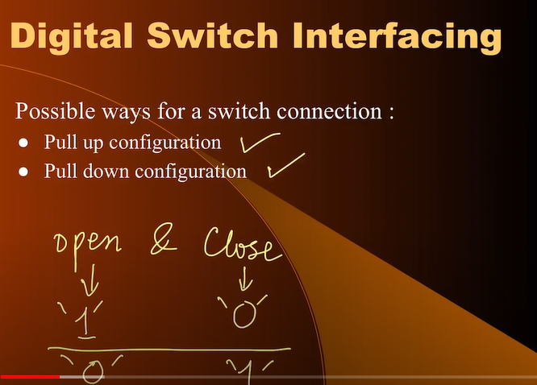

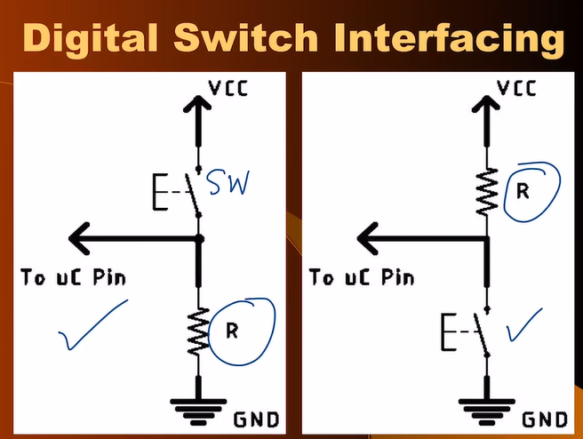

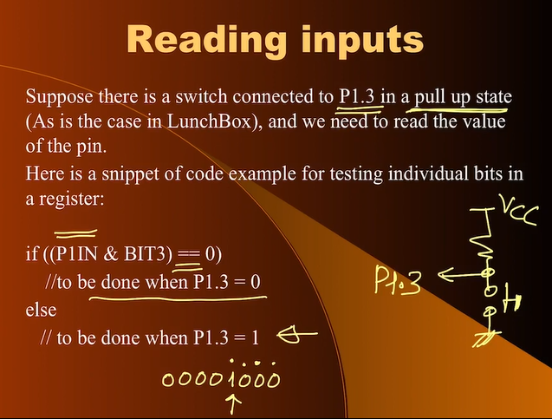

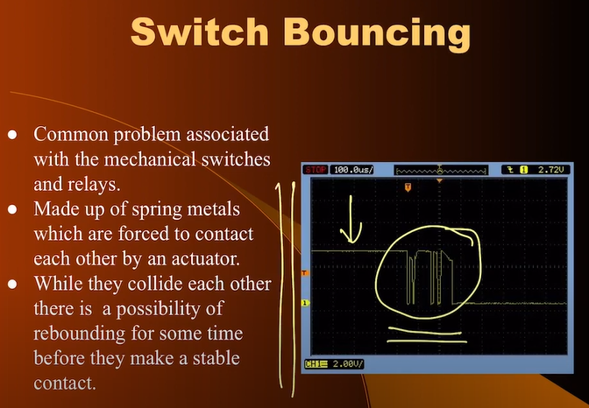

**TECHNIQUES FOR DEBOUNCING OF SWITCH**

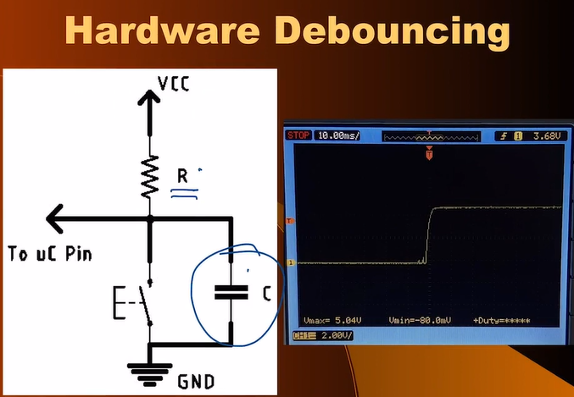

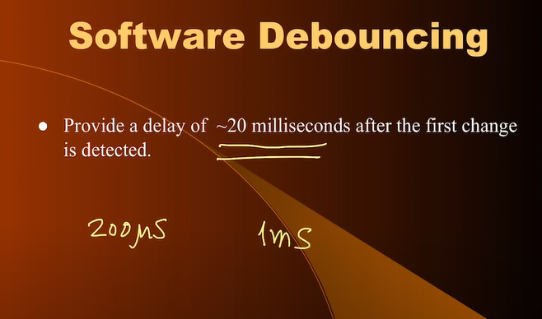

**PULL UP AND PULL DOWN using MSP430 Internal Resistor**

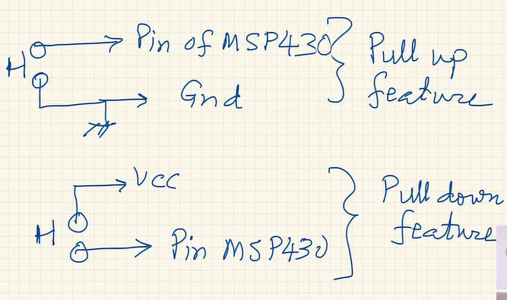

Switch is on the BREADBOARD

We are studying the following cases:-

1. Use of Internal Switch in MSP430 Lunchbox
2. Use of Switch Without Debounce
3. Use of External Switch in Pull Up Mode
4. Use of External Switch in Pull Down Mode

**SWITCH INTERFACING CODE – ON BOARD SWITCH AT P1.3 WHICH IS CONNECTED TO EXTERNAL PULL UP RESISTOR**

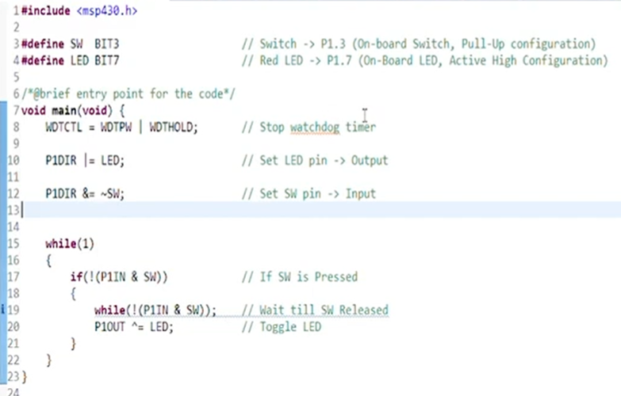

**SWITCH INTERFACING CODE – ON BOARD SWITCH AT P1.3 WHICH IS CONNECTED TO EXTERNAL PULL UP RESISTOR WITH DEBOUNCE**

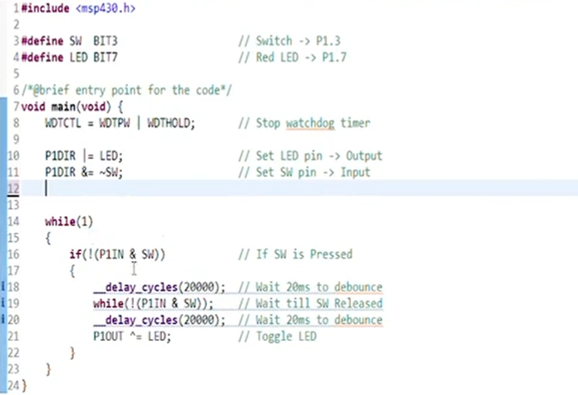

The main program is itself an infinite loop. As in HELLO LED experiment it keeps on executing the instructions. Microcontroller is still working but it is doing NOTHING. It keeps on waiting. In this case it is EXPLICIT as while(1)

**SWITCH INTERFACING CODE – EXTERNAL SWITCH AT P1.4 WHICH IS CONNECTED TO INTERNAL PULL UP RESISTOR WITH DEBOUNCE LOGIC**

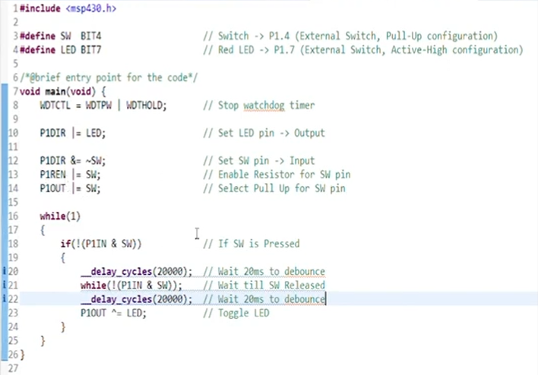

**SWITCH INTERFACING CODE – EXTERNAL SWITCH AT P1.4 WHICH IS CONNECTED TO INTERNAL PULL DOWN RESISTOR WITH DEBOUNCE LOGIC**

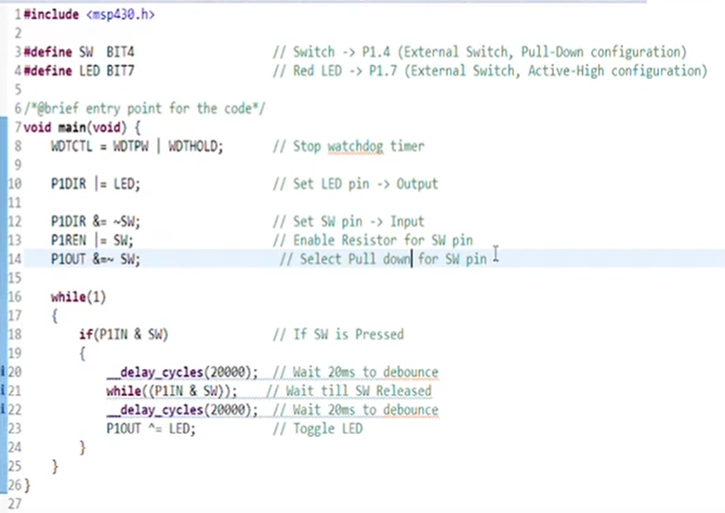

**WEEK 8**

Microcontroller is an example of Synchronous Digital Circuit. Synchronous means it will use CLK. Freq HIGH more instructions will be executed per second BUT power dissipation is directly proportional to frequency

**CLOCKING OF MSP430**

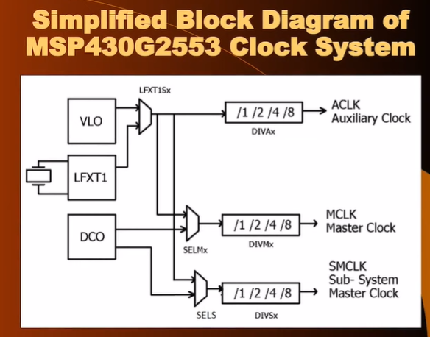

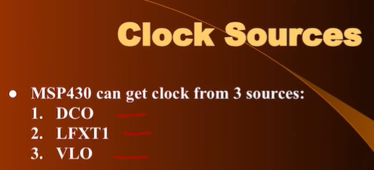

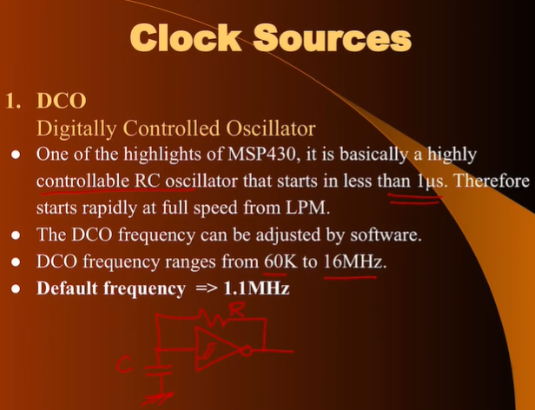

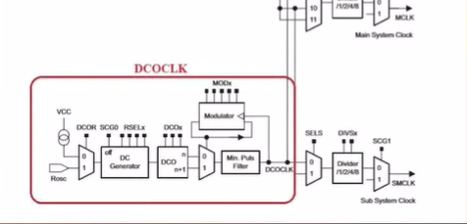

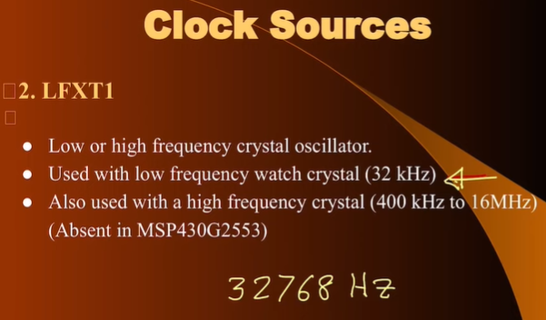

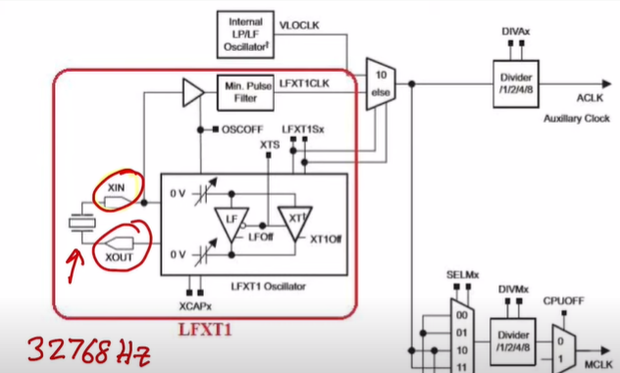

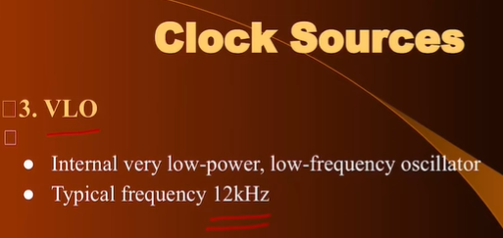

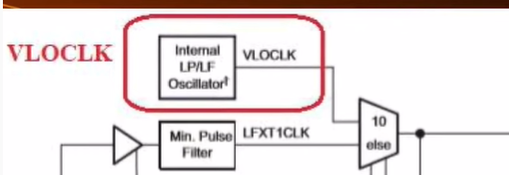

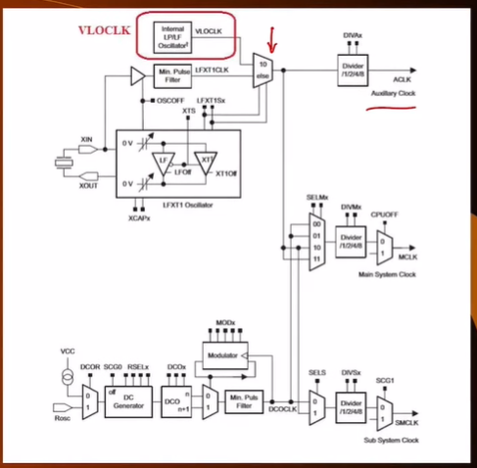

**WHY SO MANY CLOCKS?**

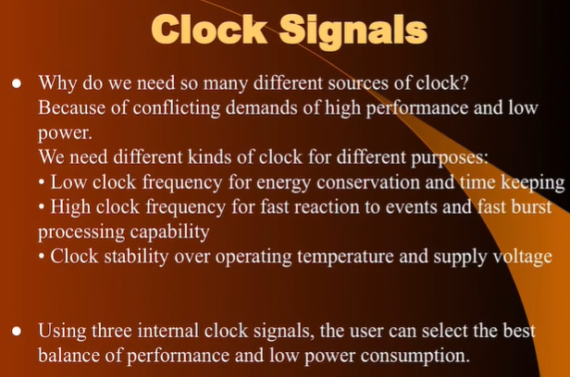

**Crystal Based Oscillator -> BEST FOR STABLE CLOCK**

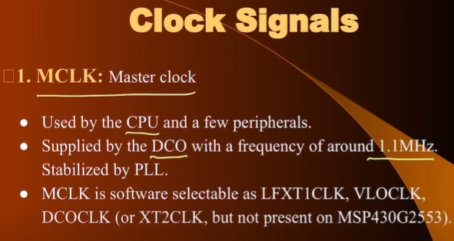

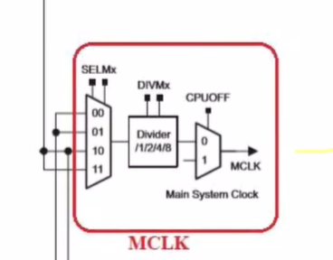

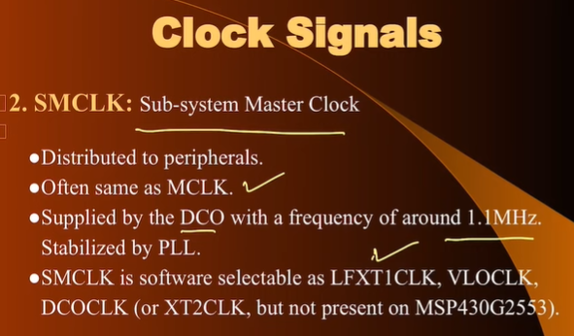

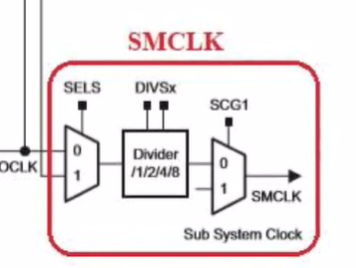

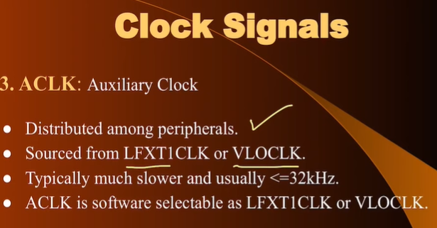

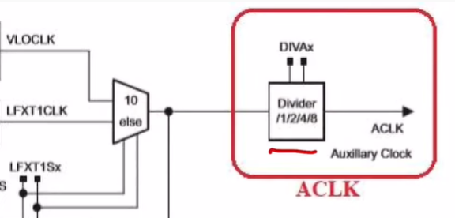

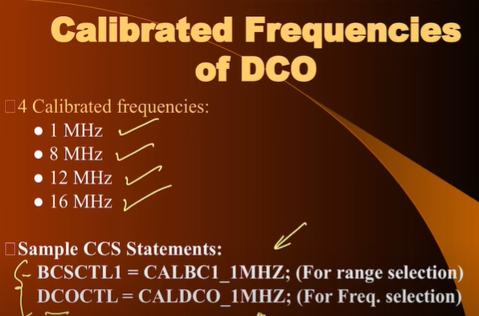

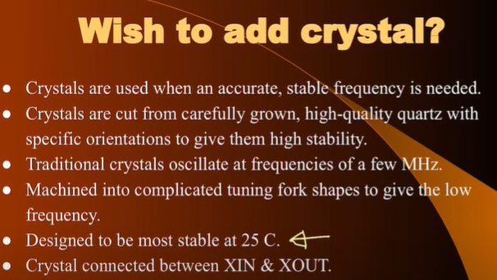

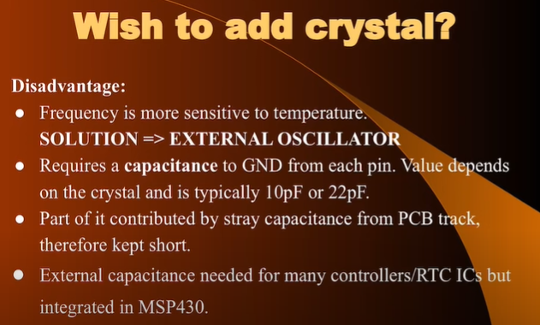

**FOR THE REGISTERS OF REFER THE SLIDES OF WEEK 8**

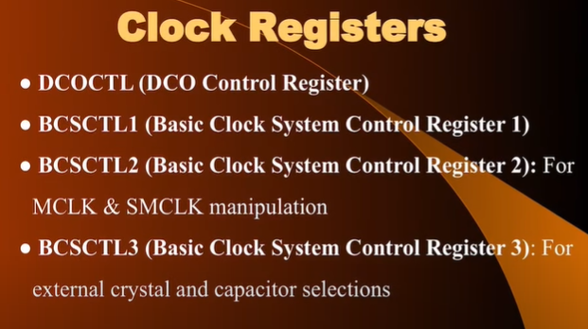

**In BCSCTL1 – rw0 and rw(0) are different things and XT2OFF is not present in MSP430 are there is no HIGH frequency**

**USING VLO as MASTER CLOCK FOR MSP430. Code for seeing the dynamic clock stability using MSP430**

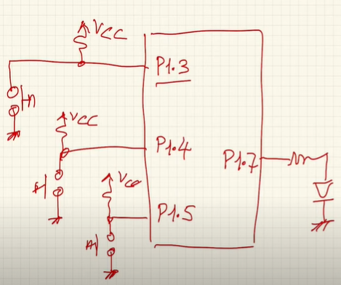

**Pressing the switches and dividing the frequency of the VLO by 1 , 4 , 8 we will know it by BLINKING the LED**

**Freq reduces then ON/OFF duration increases**

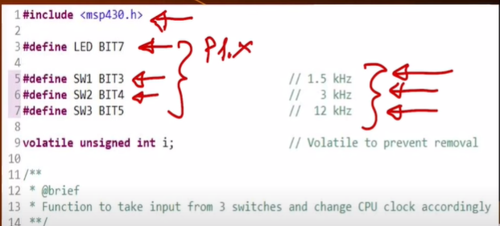

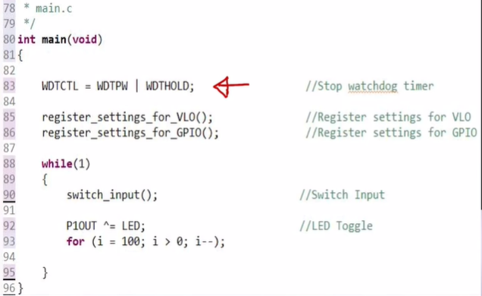

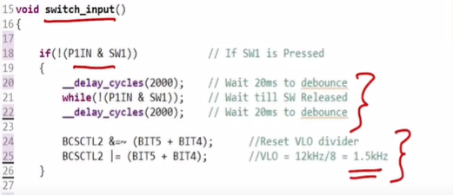 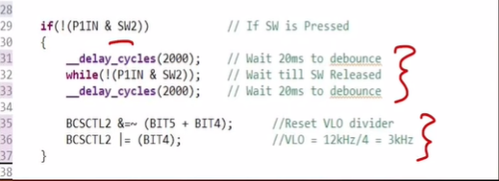

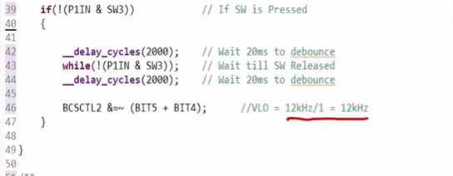 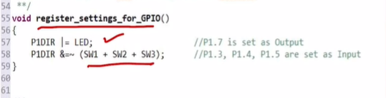 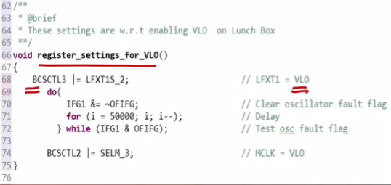

Line 68 --- Selecting the VLO from multiplexer

Line 74 --- VLO as Master

**MSP430 RESETS**

**Refer Slides**. As the microcontroller is a logic circuit so it uses flip flops and we need to reset the arbitatry values on the flip flop to function the circuit as we want There are 2 type of reset on MSP430

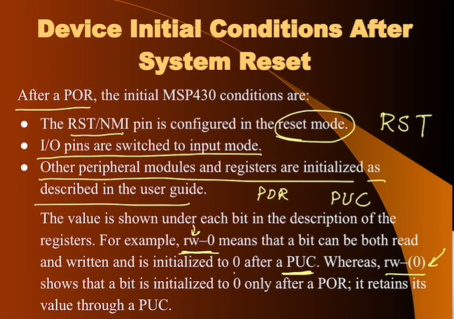

Important slide above

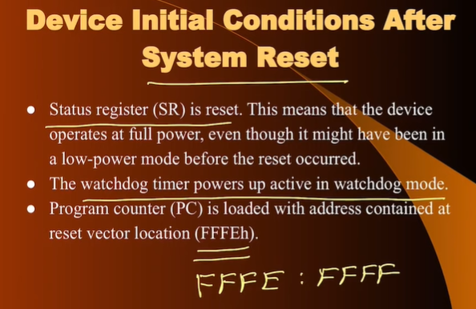

Watch Dog timer is a general-purpose timer. It can function as watch dog timer or normal timer

Watch Dog timer – UP COUNTER --- OVERFLOW which will reset the system PC at reset vector. Frequently reset the Watch Dog Timer

Can count 2 to power 15 (32768)

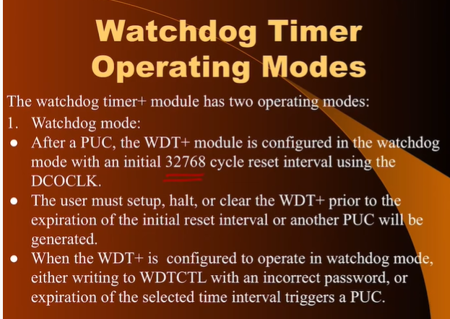

8-bit password and other 8 bit are effective

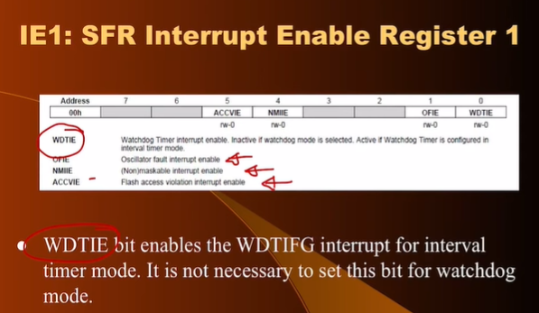

RESGISTER TO CHECK THE SORCE OF RESET (IMP)

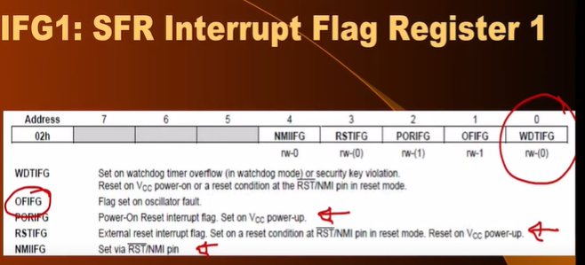

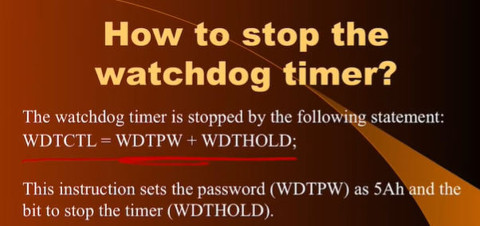

**PROGRAM TO CHECK THE SOURCE OF RESET**

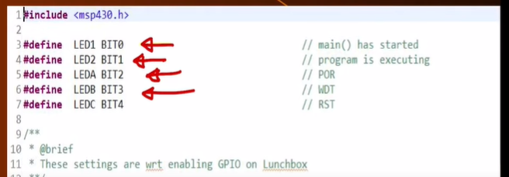

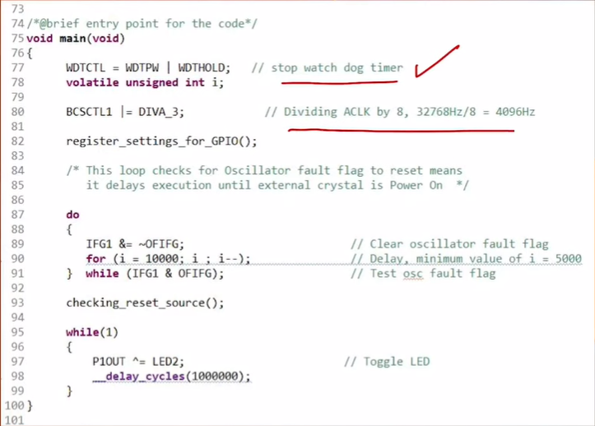

4096 freq is geven to the watch dog timer to slow the process of counting so that we can s ee the other 2 rests

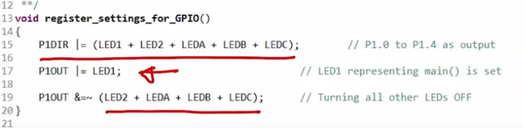

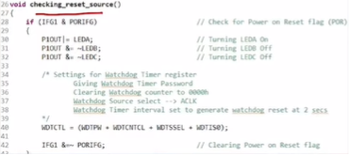

**INTERUPPTS IN MSP430**

Performing Several functions at same time. Responding to external events.

Polling --> waiting for an event to happen

When number of external inputs are large in number then we use some interrupts.

For example --- students having queries in classroom and teaching is asking them one by one from left to right -----this is poling

For example, the students are very large --- each student will have to wait a lot--- poling is not a good idea ----- use interrupts (students raising hands to ask query but teacher will answer one question at a time)

Idea of raising hand is very much similar to interrupts

Interrupts is a mechanism by which a microcontroller or digital system can look at external events whenever they happen, they can respond to that events

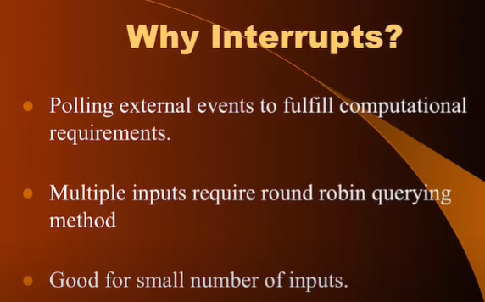

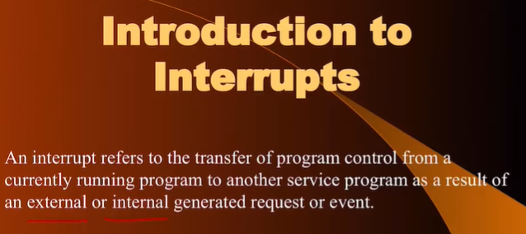

**MSP430 --- Time to execute instructions**

Considering avg ---- 250ns (4 Machine Cycle for each instruction avg)

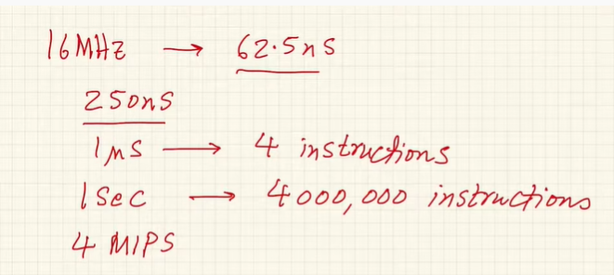

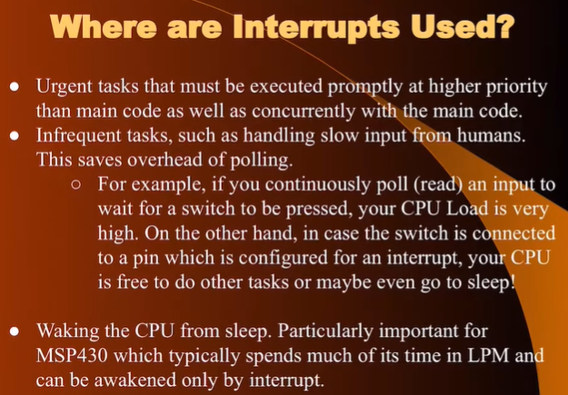

Specific for MSP430 ---- a lot of power saving modes (4 - 5)

Interrupts are used to comeback of the LPM in MSP430

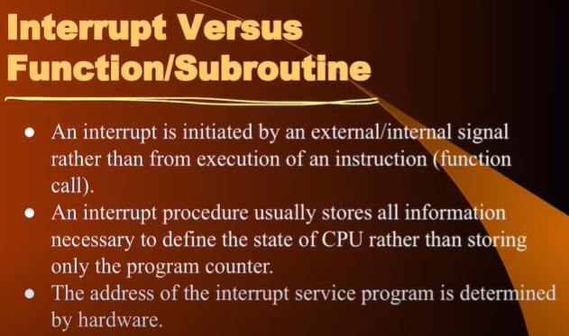

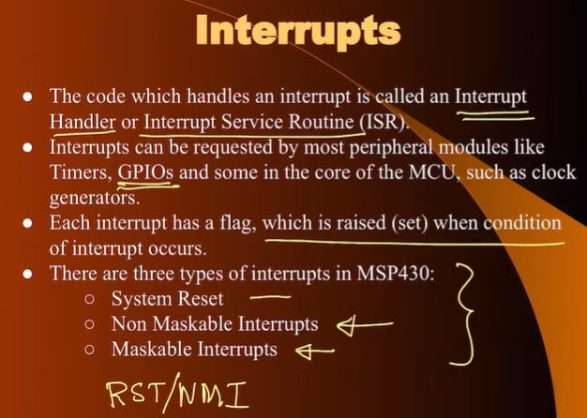

No liberty to ignore --- **Non-Maskable (They can be disabled in case of MSP430)**

Others --- **Maskable** which can be ignored/suspended ---no response let them wait

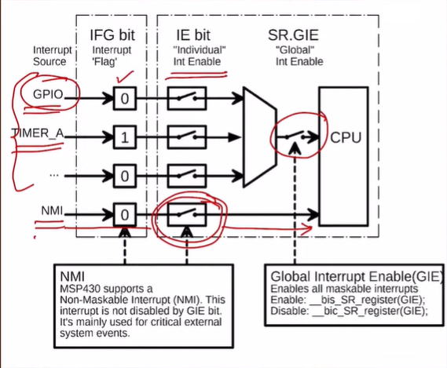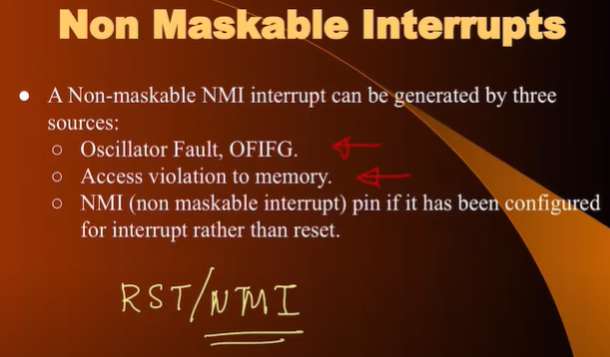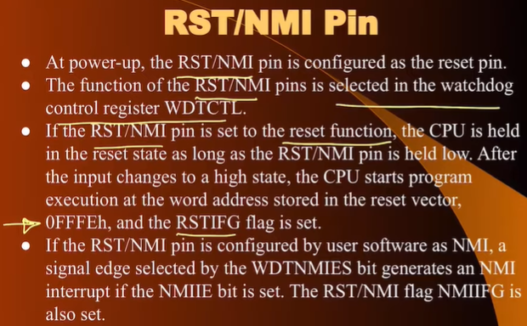

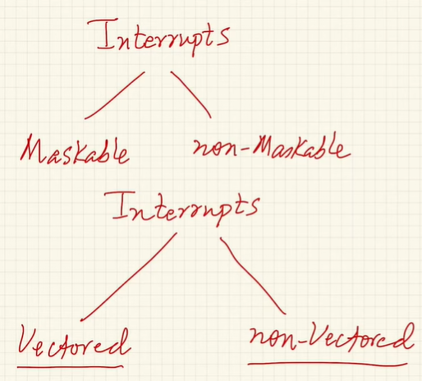

**Vectored** ---- MSP430 knows the location of ISR (source supplies the address)

**Non-Vectored** ---- Someone needs to provide location

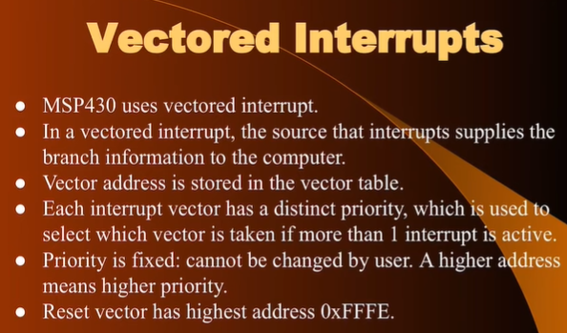

Port 1 and Port 2 🡪 Interrupt YES

Port 3 🡪 Interrupt NO

Priority Order 🡪 given in the data sheet

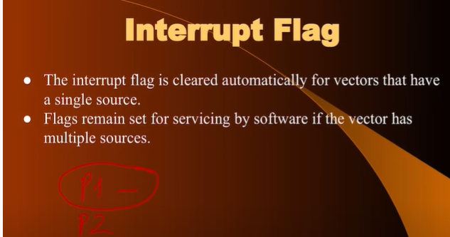

When we are executing the subroutine interrupt by default all the maskable are disabled. Interrupt are asynchronous to the execution of the main program.

**Interrupt Appetence**

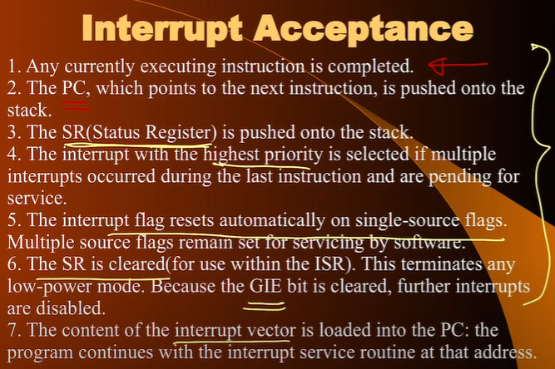

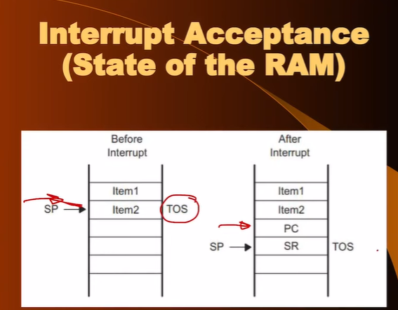

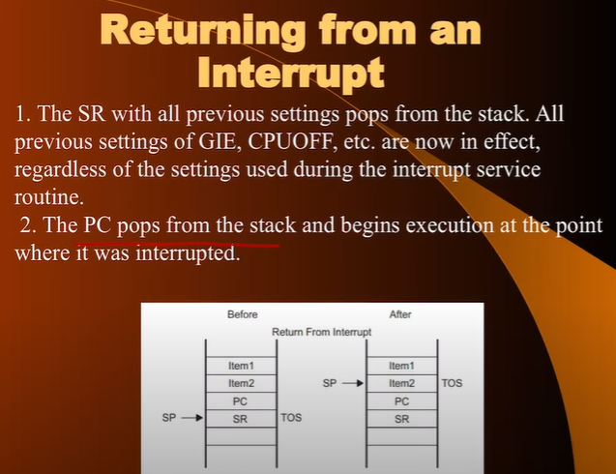

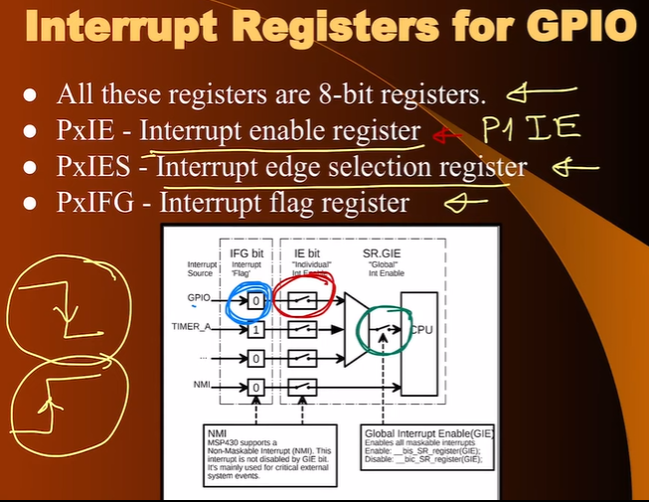

**All are 8 BIT RESGITERS**

For Interrupt to be enable we have – **Blue as 1 Red ON Green ON**

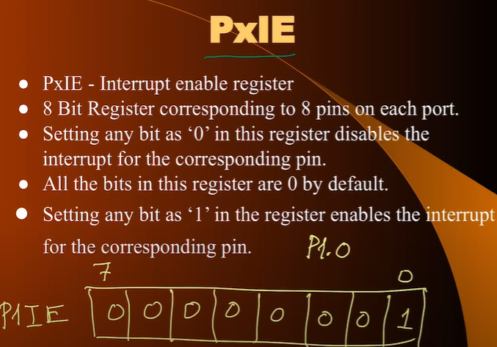

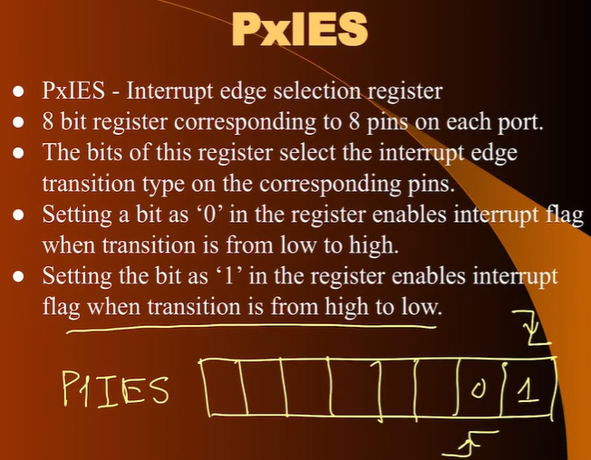

PxIFG ==== 1 only when both are 1 both refers to **PxIES and PxIE**

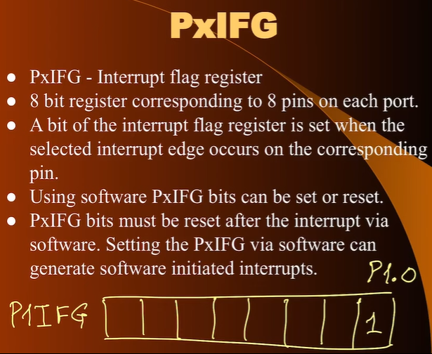

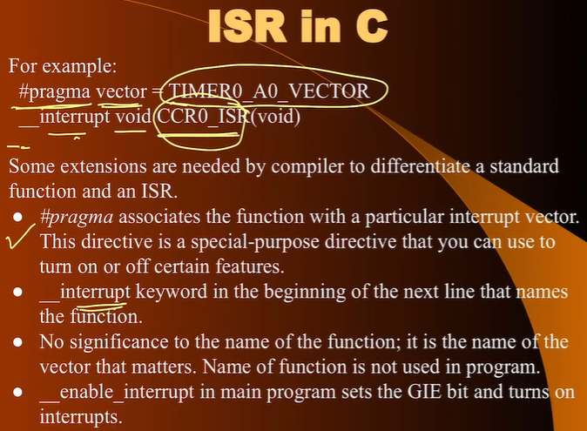

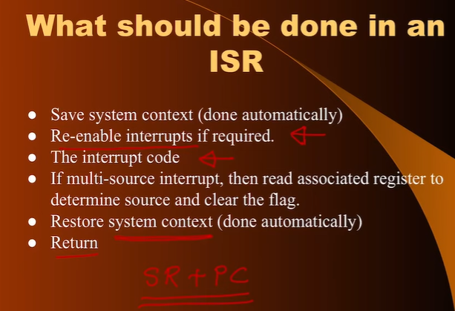

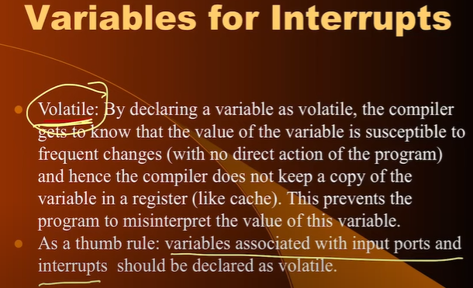

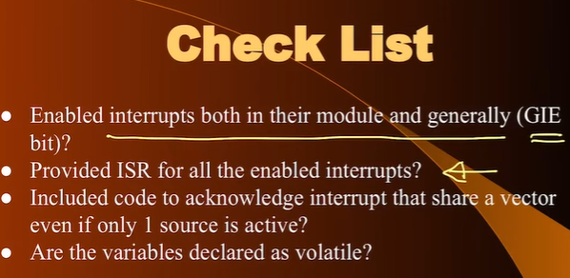

[**https://www.youtube.com/watch?v=oiCMlloWTQ0&list=PLp6ek2hDcoNAxTQ7uyp68N_RpuULV-zrX&index=27**](https://www.youtube.com/watch?v=oiCMlloWTQ0&list=PLp6ek2hDcoNAxTQ7uyp68N_RpuULV-zrX&index=27) **-- > Interrupt Example in CODE --- from 28 mins**

**HARDWARE DEBOUNCE using Capacitor**

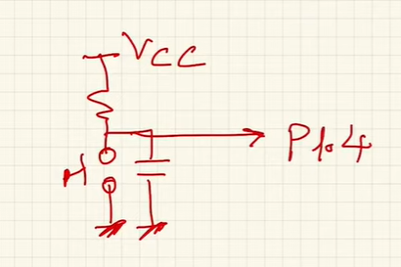

**WEEK 9**

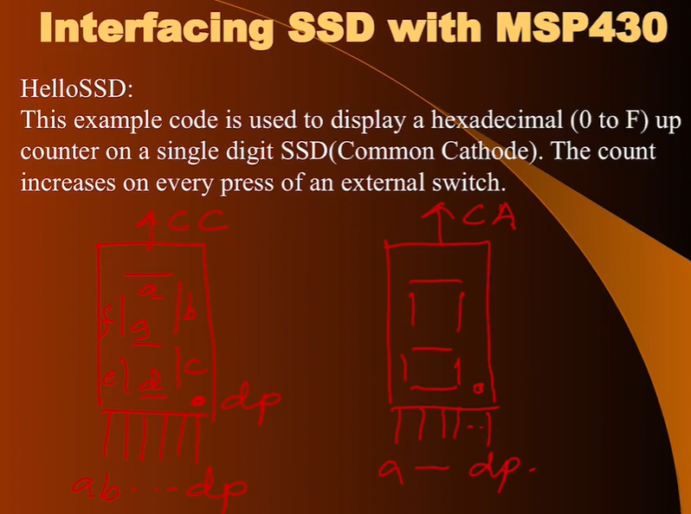

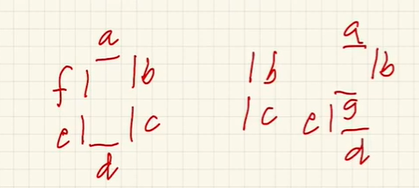

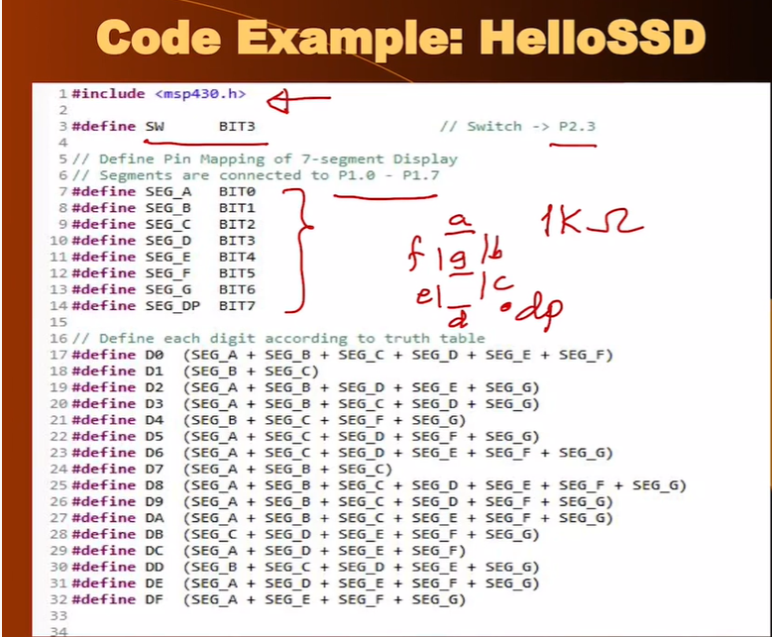

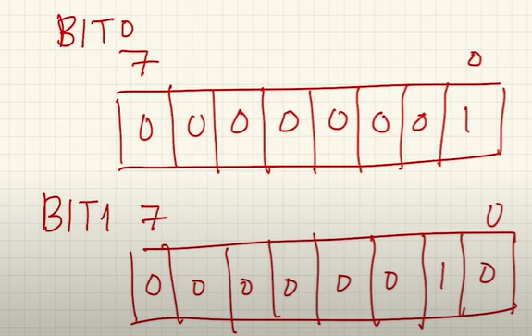

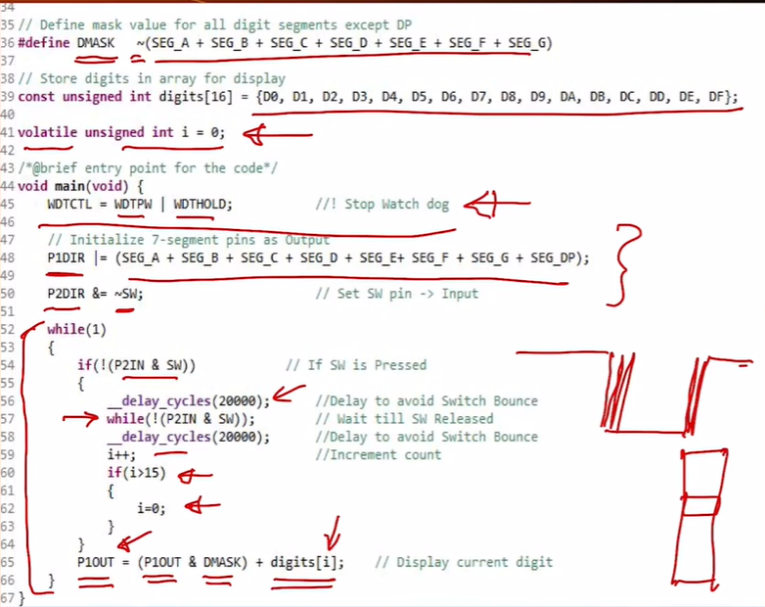

P1OUT & with DMASK to clear the previous glowing LED to turn them off

**DISPLAYING 2 DIGITS (To be discussed later)**

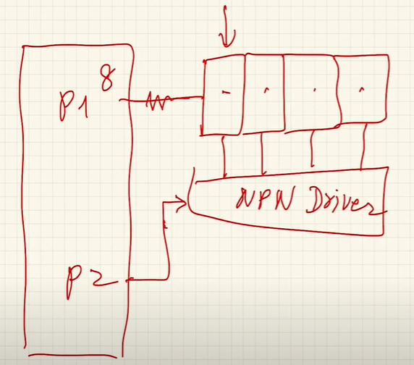

**ABLITITY OF MSP430 to switch between LOW POWER MODES and ACTIVE MODE**

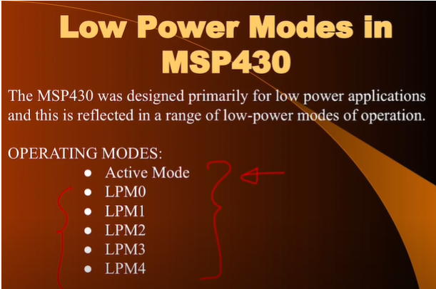

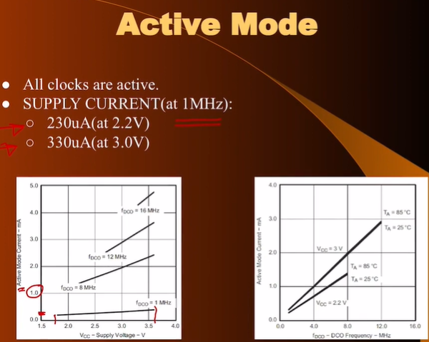

**Finding current consumed using the frequency and voltage using the above graphs (ACTIVE REGION)**

**The DC generator bias the DCO. Turns ON the DCO quickly**





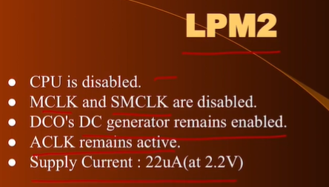

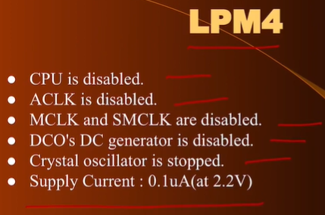

**In LPM4 only the content of the register will be saved NOTHING ELSE least power consuming**

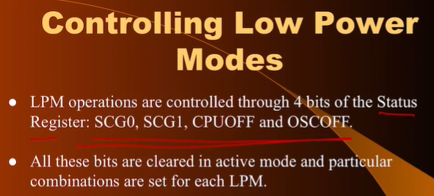

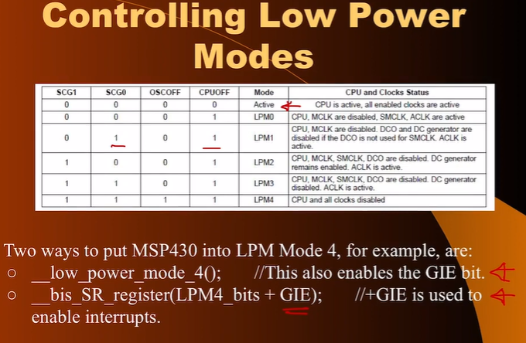

**Interrrupts are used to come out of LPM and come to ACTIVE MODE so GIE should be turned 1**

**Insturction on line 23 will not be executed as MSP entered LPM**

[**https://www.youtube.com/watch?v=gyOnGEZzXaY&list=PLp6ek2hDcoNAxTQ7uyp68N_RpuULV-zrX&index=28**](https://www.youtube.com/watch?v=gyOnGEZzXaY&list=PLp6ek2hDcoNAxTQ7uyp68N_RpuULV-zrX&index=28)

**CODE of LPM from 30 mins**

**Interfacing LCD Display**

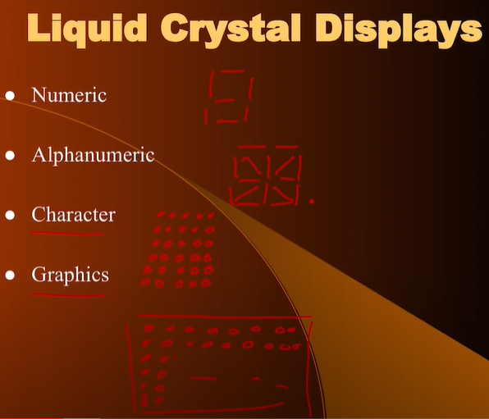

**LED – Emitting Light (generate light)**

**LCD – No mechanism to display light(manipulating light ONLY) it can operate at much lower level of voltage than LED as no light is generated in LCD**

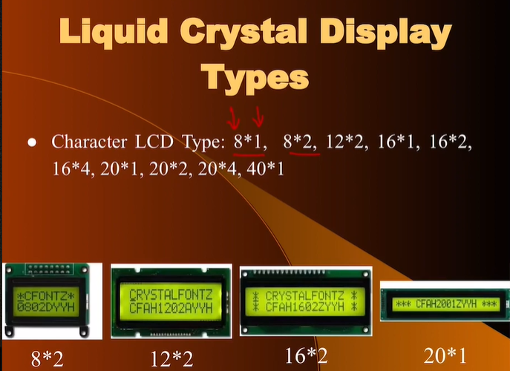

**8 – characters 2 – lines**

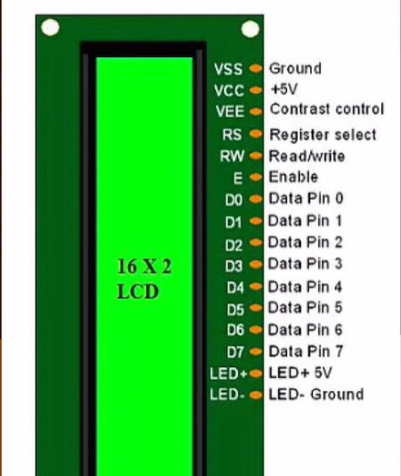

**Total Pixels in 16x2 LCD**



**LCD will do the multiplexing on our behalf(it has single purpose computer)**

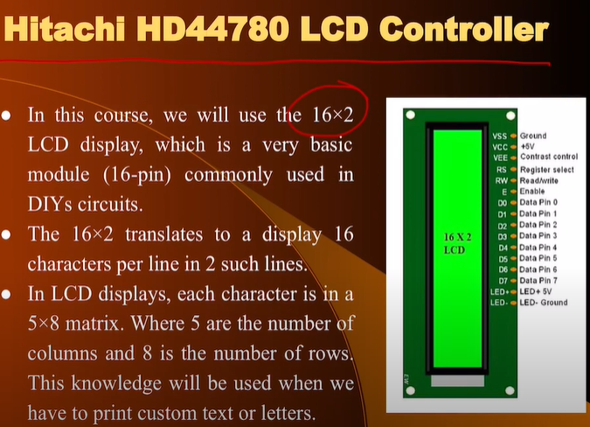

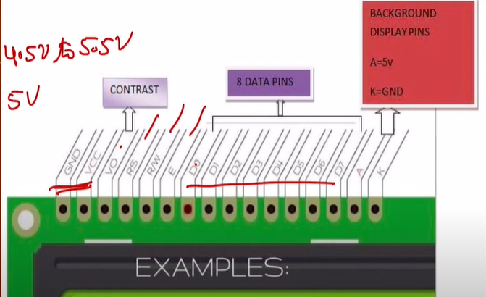

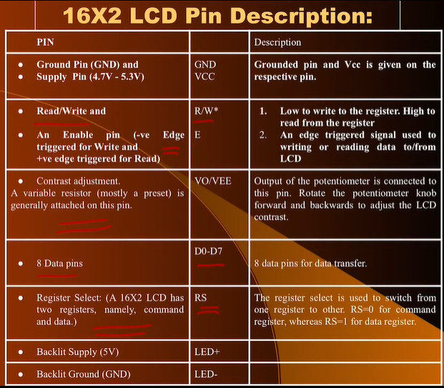

**LCD 16x2 use Command Codes from Internet**

**Using chunks of 4bit each (Higher nibble and Lower nibble)**

**Using just 4 data lines OFTEN 4 bits are used(4 bit Mode)**

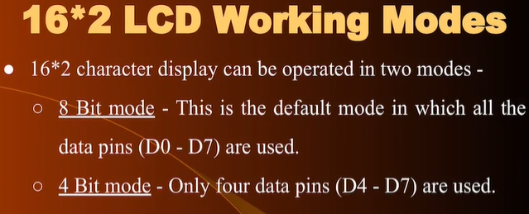

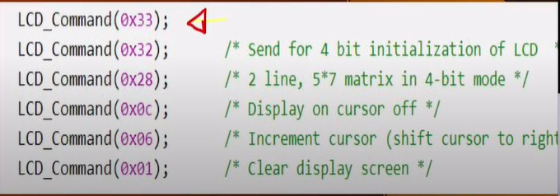

**Interfacing MSP430 with LCD(Only write mode)**

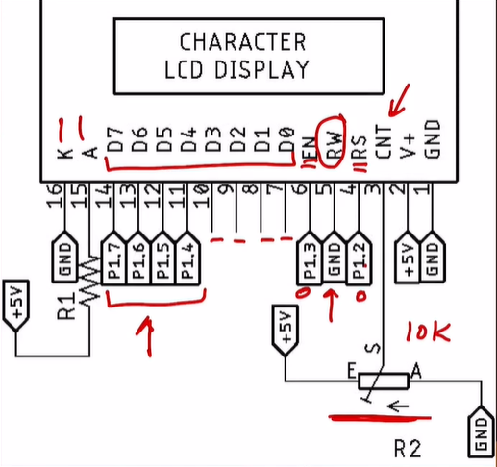

**MSP430 does not have 5V and LCD needs 5V. Methods to do so**

1. **Using USB cable. Cut it and see 5 wires. Black and Red (GND and 5V) –Refer LCD Slides**

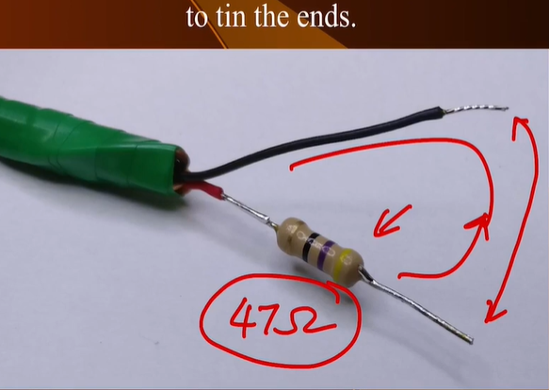

**LCD CODE ---** [**https://www.youtube.com/watch?v=nLkxUn6tLhA&list=PLp6ek2hDcoNAxTQ7uyp68N_RpuULV-zrX&index=29**](https://www.youtube.com/watch?v=nLkxUn6tLhA&list=PLp6ek2hDcoNAxTQ7uyp68N_RpuULV-zrX&index=29)

**From 24:30 mins**

**Contrast Pin of LED === Potentiometer**

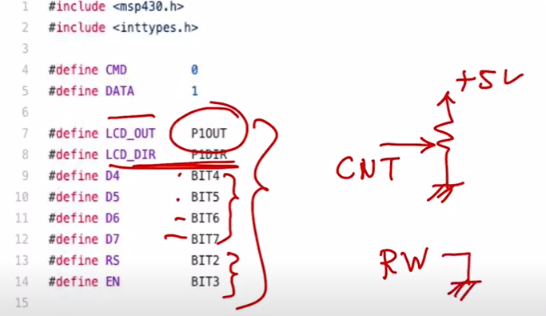

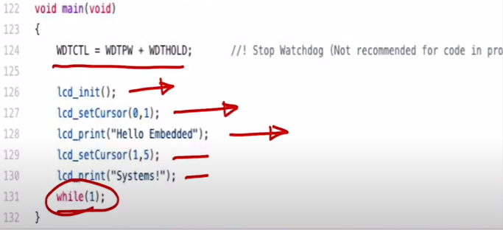

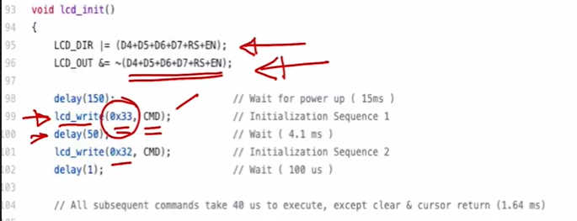

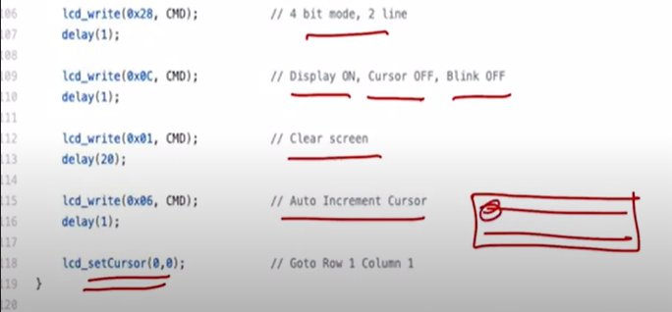

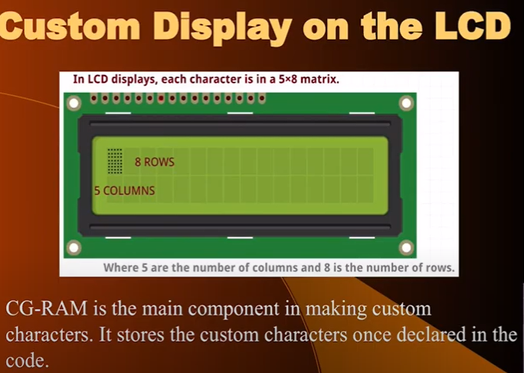

**Read the custom display code its is easy to implement**

**TIMER/COUNTERS in MSP430**

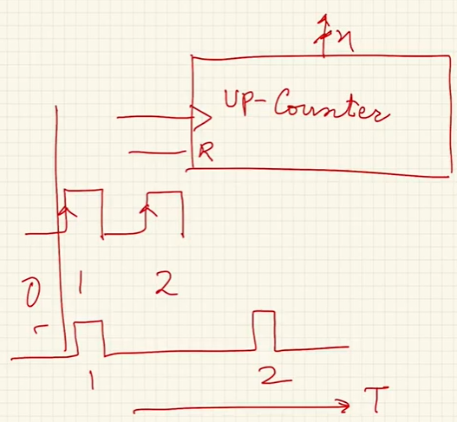

**If we do not know the frequency then we can not know how much time is elapsed. THIS IS COUNTER**

**Case 2:** **(1350 is count of the counter i.e no. of pulses counted by the counter)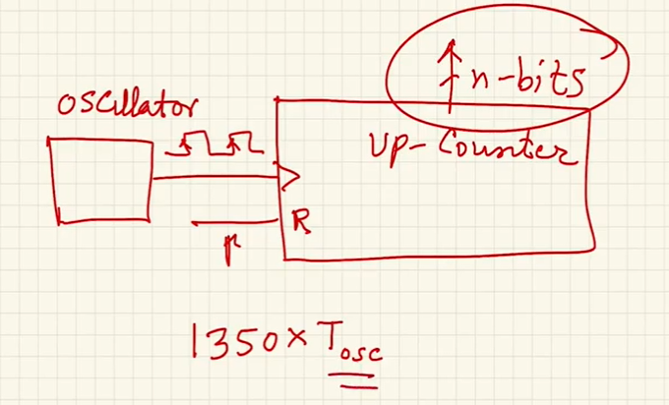Now we will be able to calculate the time elapsed as we know the t period of the oscillator. THIS IS TIMER**



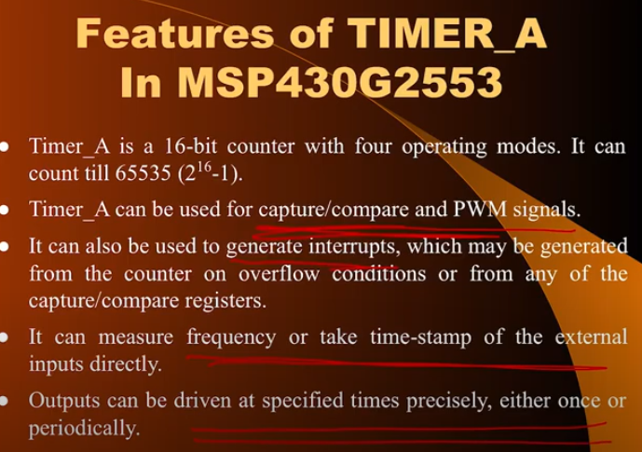

**TAR –TimerA Register**

**CCR0 CCR1 CCR2 --- Capture Compare Register (3 CCR with one channel)**

**Timer can be derived from ACLK SMCLK and TACLK is a pin i.e. it is used to clock the timer and timer can count the pulses of external event**

**We know the frequency of ACLK and SMCLK so it acts as TIMER –telling us how much time is elapsed**

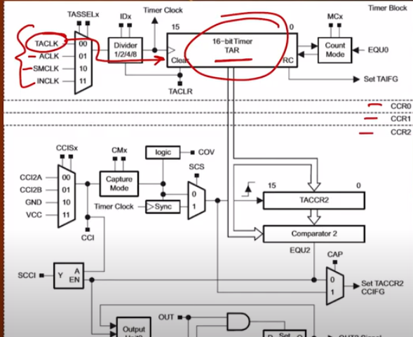

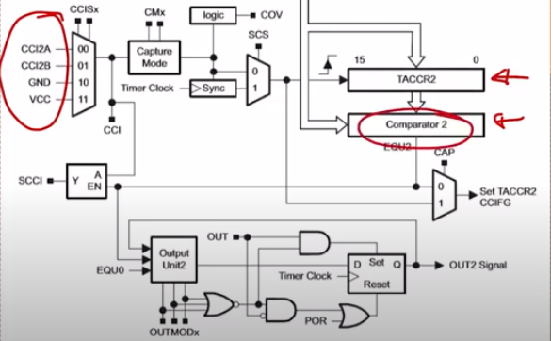

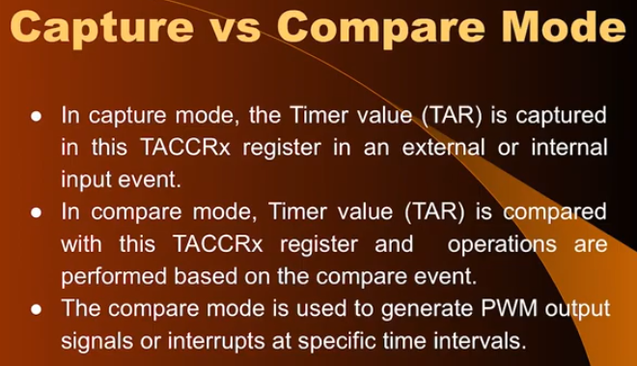

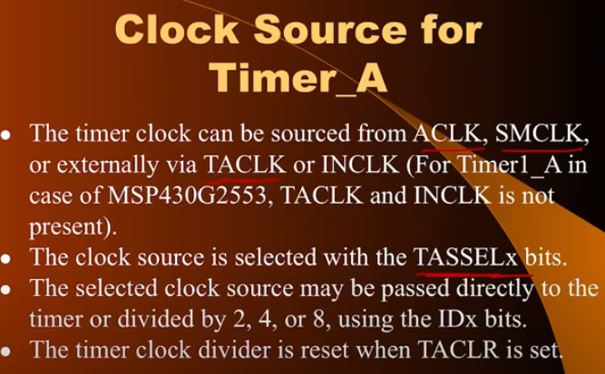

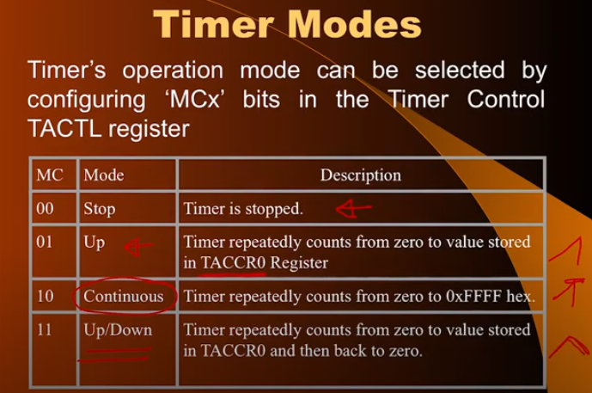

**CHECK SLIDES for more information on Modes of TIMER**

**CHECK SLIDES for more information on registers of TIMER**

[**https://www.youtube.com/watch?v=sVXmEYEMH3A&list=PLp6ek2hDcoNAxTQ7uyp68N_RpuULV-zrX&index=30**](https://www.youtube.com/watch?v=sVXmEYEMH3A&list=PLp6ek2hDcoNAxTQ7uyp68N_RpuULV-zrX&index=30)

**Code/ Program --- 18:45 mins**

**BINARY LEDS --- counting increment by one after every one second interrupt is generated. To show that this counting is not done by CPU but by the TIMER**

**WEEK – 10**

Creating ANALOG Waveforms using Digital Control. One such way is TIMER.

GENRATING THE ANALOG VOLTAGES using TIMERS

Both methods – Hardware (Timer operation PWM mechanism) and Software (CPU is busy)

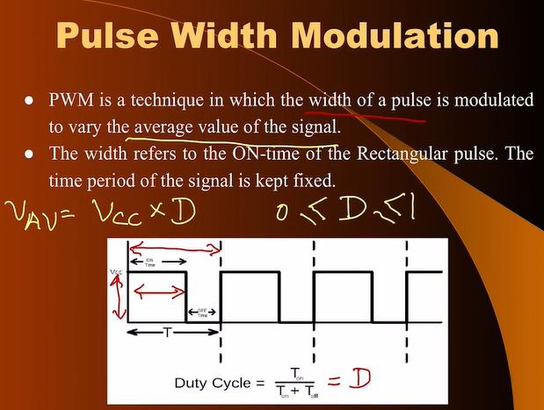

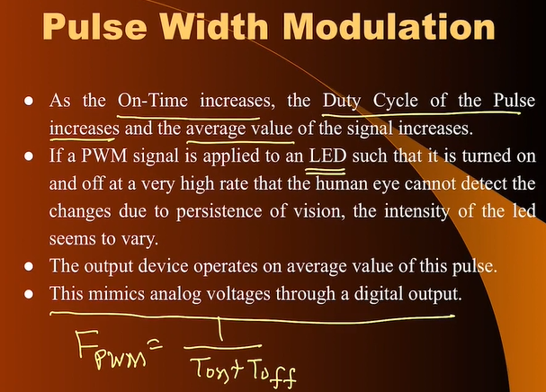

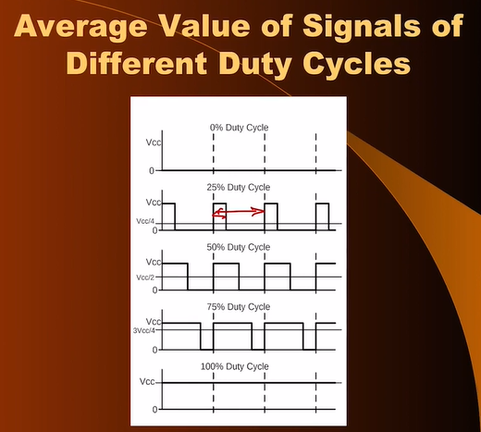

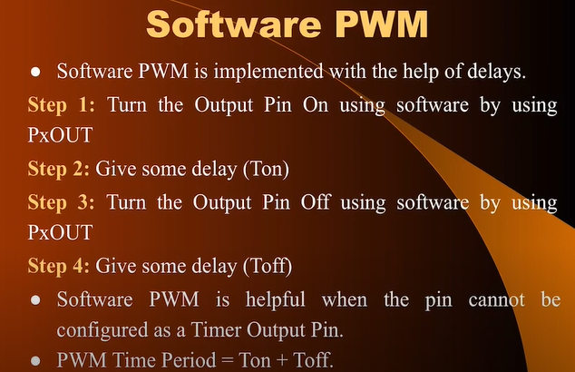

Defining DUTY CYCLE using n where maximum value of n is 256

RESOLUTION is 1/256 === ON for only n = 1

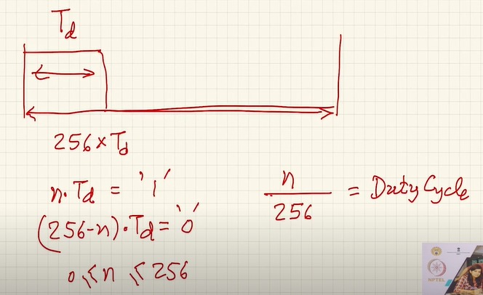

MINIMUM voltage that can be generated is 1/256*Vcc 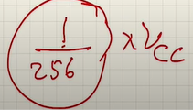

1. **Generating SOFTWARE PWM**

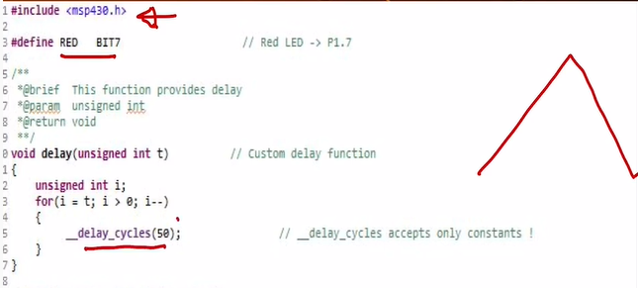

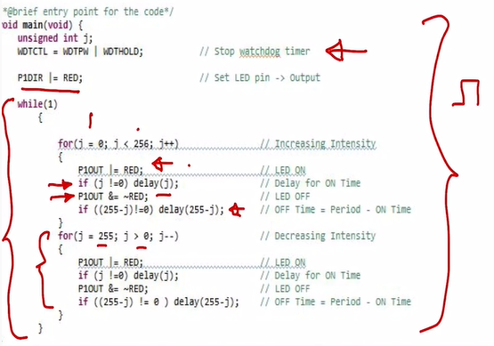

PERIOD OF PWM === 256 * Delay time function

RC Low Pass Filter --> 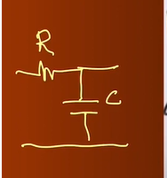

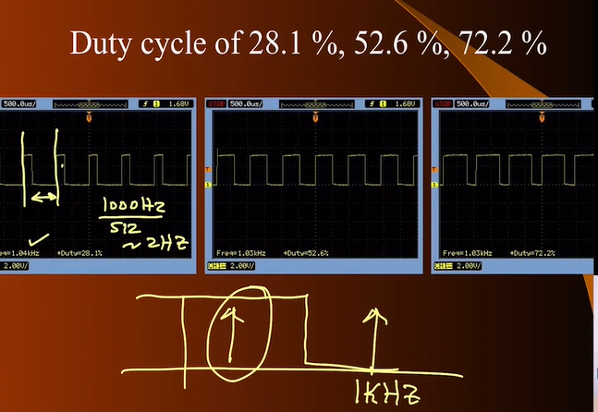

For the PWM freq we are changing the value of DUTY CYCLE again and again for 512 times(0 to 255 then 255 to 0)--- so (PWM freq) / 512 === to get this we need LPF

There should be large gap between the PWM frequency(also called carrier frequency ) and the signal frequency which is you message – to extract it from LPF

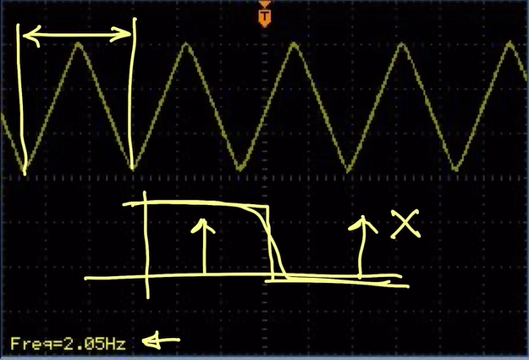

1. **TIMER is performing PWM**

MSP430 TIMER’s have special features for generating PWM. We can specify the following --

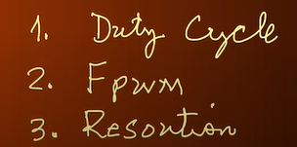

**Resolution** – What is the minimum variation in the duty cycle that we can achieve in the entire period

If 8-bit counter ----- 1/256 --- 1 count in 256

If 16-bit counter ----- 1/65536 --- 1 in 65536 – (MSP430)

Fpwm should be HIGH -- so that it can pass through LPF easily . Fpwm is largely determined by the system frequency

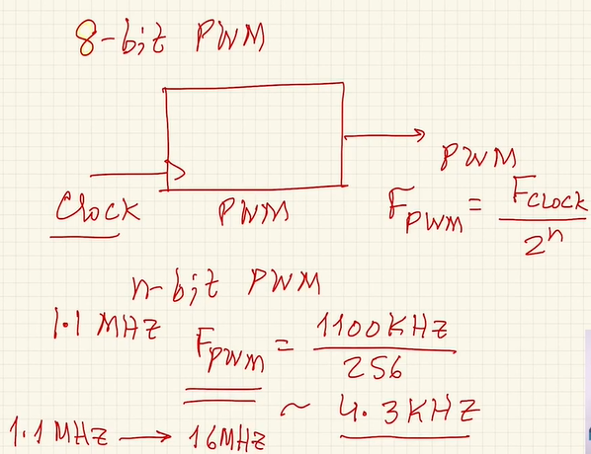

If Fclock is 16Mhz then

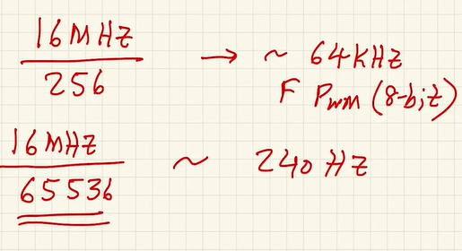

**NOTE --** If we consider HIGHER RESOLUTION like 16 bit then FPWM will be LOW. But keep in mind that it is HIGH enough that it is out of the passband of LPF so that we can easily filter the message signal from PWM…. There is a trade-off between HIGHER RESOLUTION and FPWM… If FPWM is not suitable then choose lower resolution and give high FPWM

**MSP430 --- TIMERS --- PWM**

CCR0 – storing the value till which we have to count

CCR1 and CCR2 – capture the value of the timer or captured value could be compared with value stored in those registers

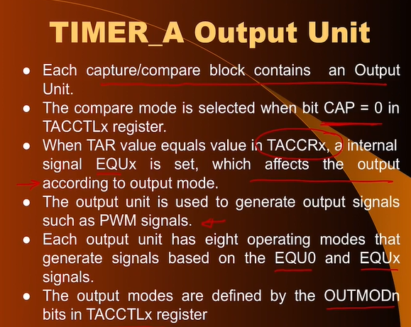

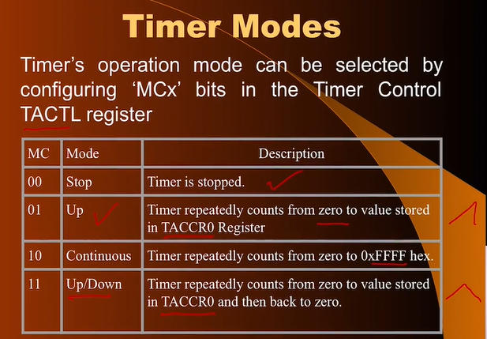

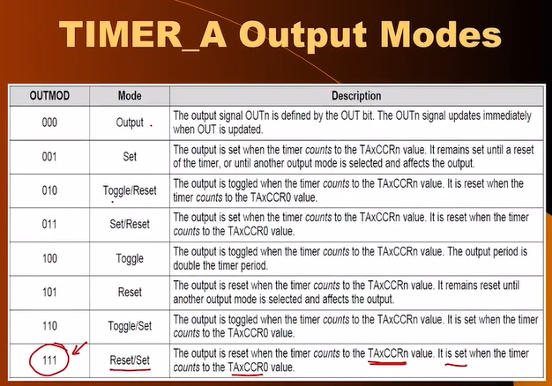

TACCR0 --- Resolution

If TACCR0 is 256 --- Resolution will be 8-bit

If TACCR0 is 65536 --- Resolution will be 16-bit

Increasing TACCR0 will increase the time period therby decreasing the FPWM increasing resolution and decreasing TACCR0 will decrease the time period increasing the FPWM decreasing the resolution

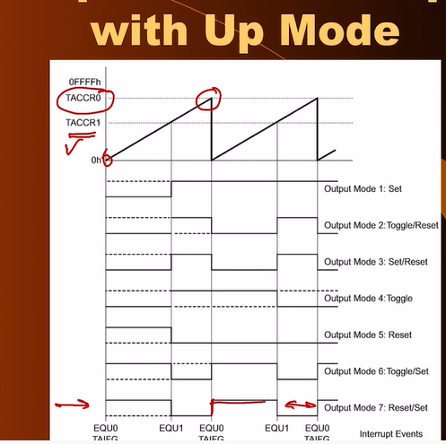

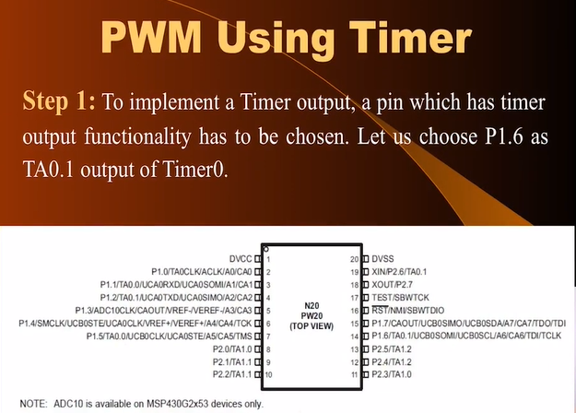

Route It on pin 1.6 – TA0.1 (for timer 0)

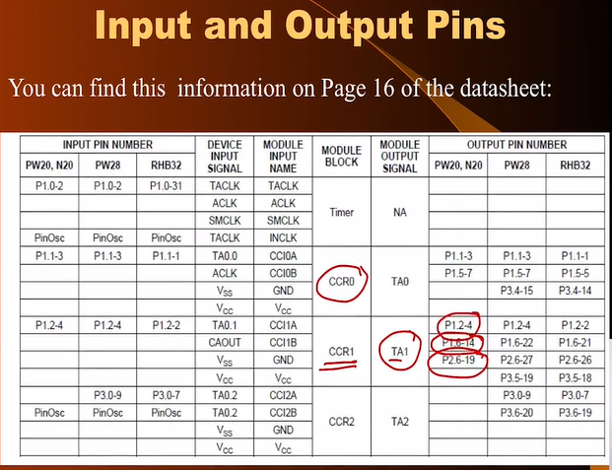

FOR USING TIMER 1

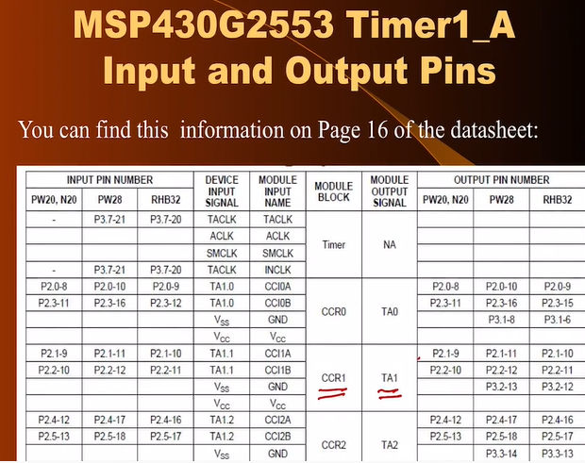

To function P1.6 as TIMER



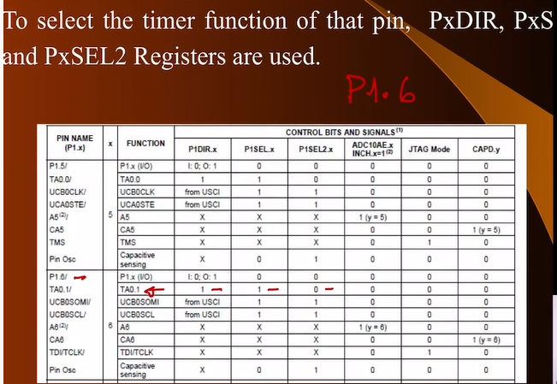

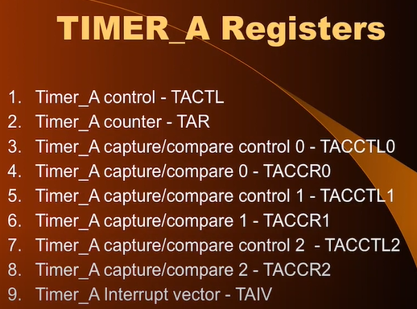

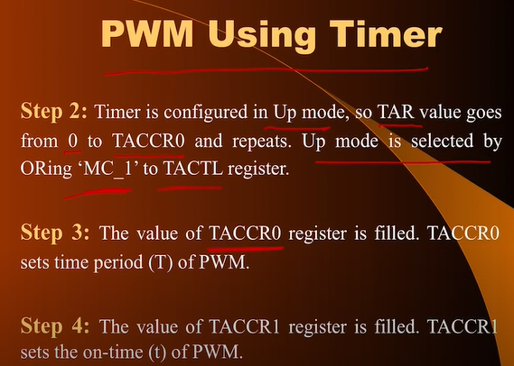

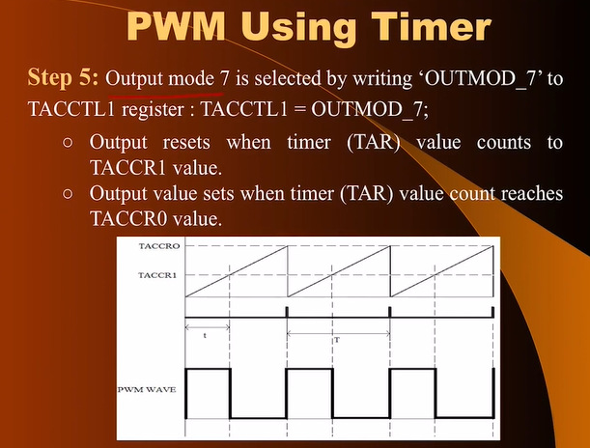

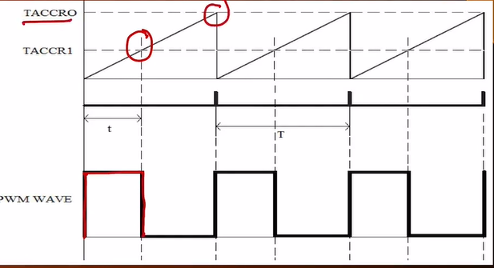

CCR1 will decide the duty cycle or the Ton time of PWM

When CCR1 is 0 (Duty Cycle is 0) When CCR1 is 255( Duty Cycle is 100%)

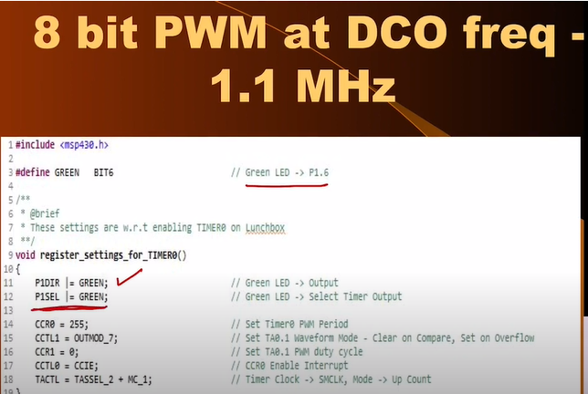

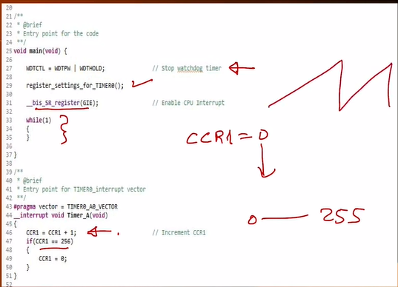

F(PWM) = Fclock / 2^8 (Fclock is DC0 freq i.e 1.1MHz) equals 4.35KHz

Fsignal = F(PWM)/256 beacus we go from 0 to 255 levels equals 16.9Hz

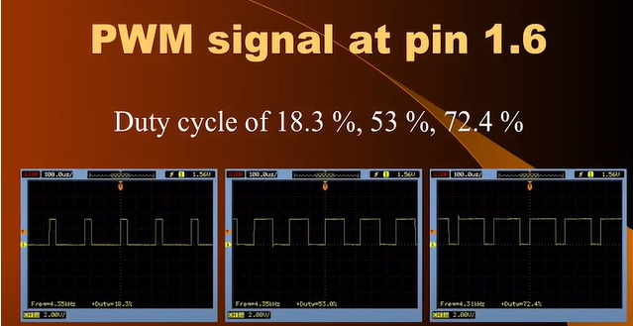

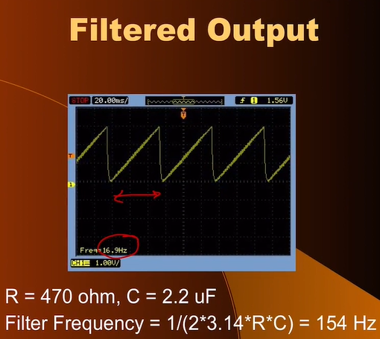

FILTERING the signal frequency using RC LPF with cutoff as 154Hz as the FPWM >> FSIG then it can be easily filtered

Freq of LPF should be >> than Freq SIG and much <<< than Freq PWM to filter

2nd CODE in the we have changed DCO as 16MHz and 16 bit RESOLUTION. CHECK IT IN SLIDES

**ANALOG TO DIGITAL CONVERTERS**

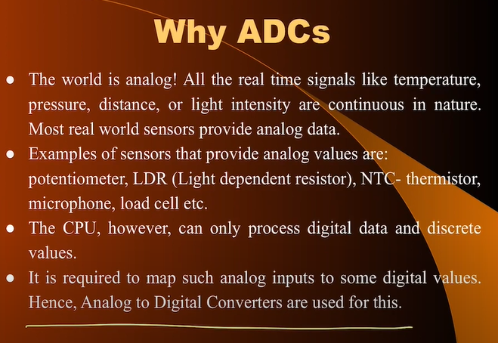

Input is asynchronous but while conversion process we do not want the value to change till the conversion is done so we use HOLD circuit

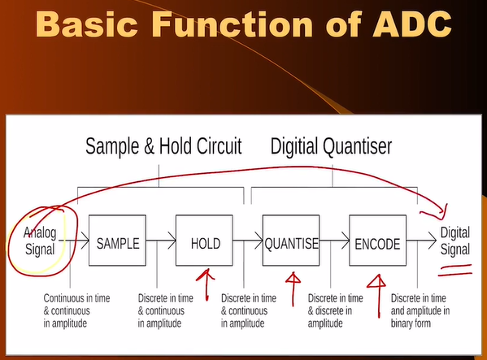

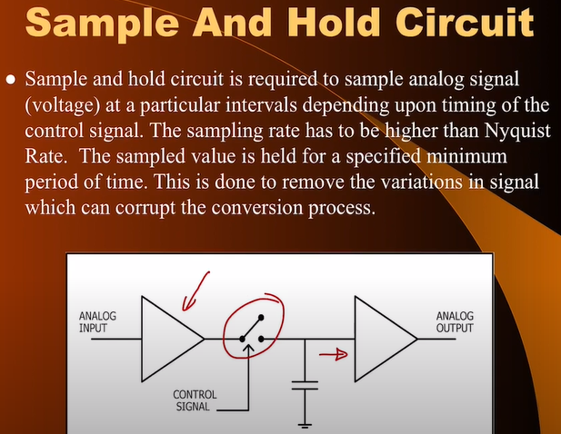

**Quantization** --- Signal is discrete in time but continuous in time . We need to have a reference voltage to which this voltage will be compared and will be divided in small discrete steps and from there on its is converted to a number

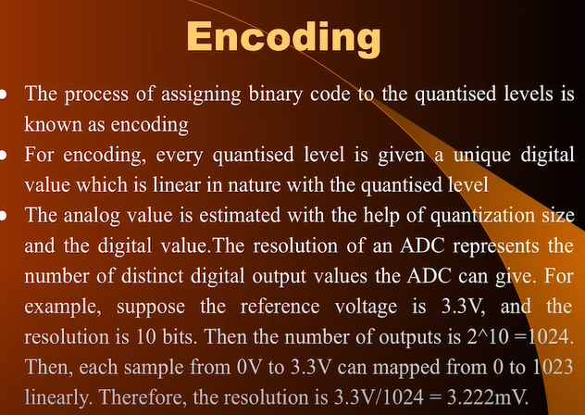

Most simple type is **COUNTER TYPE ADC**

MSP430 has **SUCCESSIVE APPROXIMATION TYPE ADC.** Most common type

**DUAL SLOPE ADC** Type of COUNTER TYPE ADC but there are 2 slopes charging and discharging.

**FLASH ADC (very fast but consume a lot POWER) DSO** uses ADC’s after the amplifiers

**SIGMA-DELTA TYPE ADC –** used in voice encoding

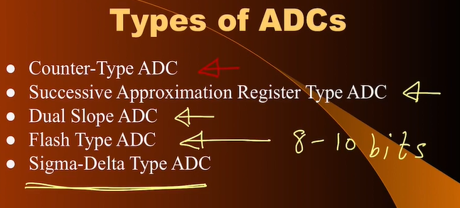

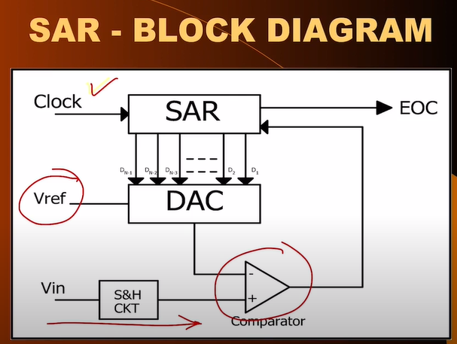

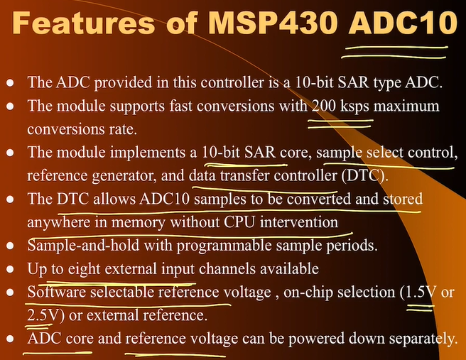

**Check the BLOCK DIAGRAM OF ADC10 on SLIDES (WEEK 10)**

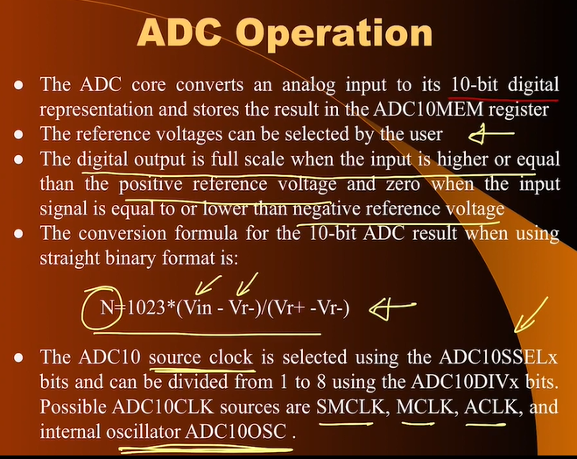

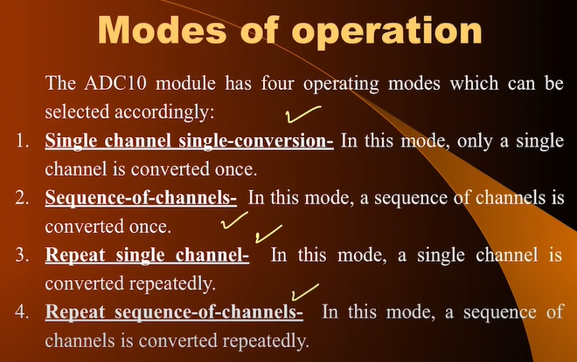

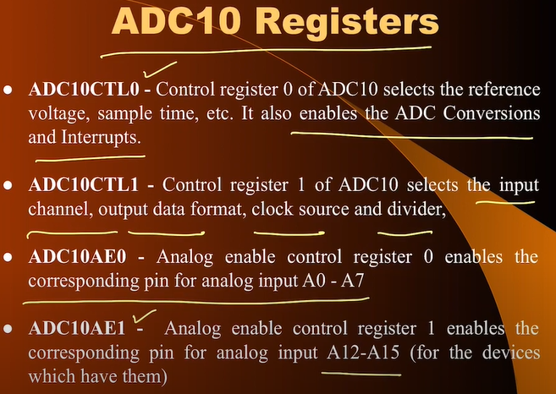

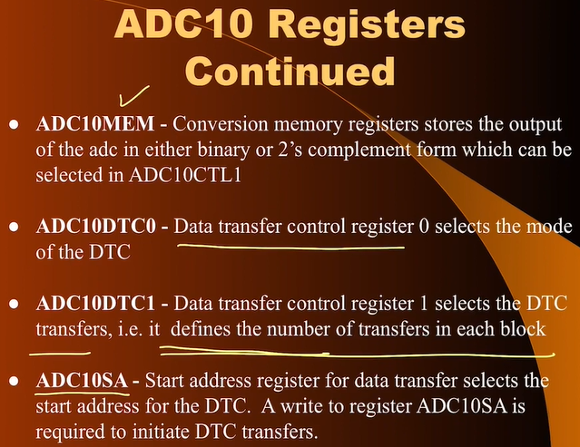

**Code Examples from 18:03**

[(6) mod10lec31 - YouTube](https://www.youtube.com/watch?v=4DrOn_waYMk&list=PLp6ek2hDcoNAxTQ7uyp68N_RpuULV-zrX&index=32)